# Windows 11 Migration Mastery

# A Strategic Guide to Enterprise Transformation

### **WARNING: This content was generated using Generative AI. While efforts have been made to ensure accuracy and coherence, readers should approach the material with critical thinking and verify important information from authoritative sources.**

# Content

Chapter 1: Building the Business Case for Windows 11 Migration 4

Strategic Assessment Framework 4

Evaluating Organisational Readiness 4

Hardware and Software Compatibility Analysis 6

Identifying Business-Critical Systems 8

Regulatory Compliance Considerations 10

Cost-Benefit Analysis 13

Total Cost of Ownership Calculation 13

Return on Investment Projections 15

Productivity Gains Quantification 17

Risk Mitigation Value Assessment 19

Chapter 2: Technical Migration Architecture and Security 22

Migration Planning and Infrastructure 22

Assessment Tools and Methodologies 22

Deployment Scenarios and Options 24

Network Infrastructure Requirements 26

Application Compatibility Testing 28

Zero Trust Security Implementation 31

Identity and Access Management 31

Device Security Enhancements 33

Network Segmentation Strategies 35

Security Monitoring and Response 37

Chapter 3: Change Management and User Adoption 40

Organisational Change Strategy 40

Stakeholder Analysis and Engagement 40

Communication Planning 42

Training Programme Development 44

Resistance Management Techniques 47

User Experience Optimisation 49

Interface Changes and Navigation 49

Productivity Feature Training 51

Accessibility Improvements 53

Performance Optimisation 55

Chapter 4: Modern Workplace Integration 58

Microsoft 365 Integration 58

Teams Integration Enhancements 58

Cloud Storage Optimisation 60

Collaboration Tools Implementation 62

Security Features Alignment 64

Productivity Enhancement 66

Workflow Automation Opportunities 66

Cross-Device Synchronisation 69

Virtual Desktop Infrastructure 71

Mobile Device Management 73

Chapter 5: Sustainability and Future-Proofing 76

Environmental Impact Management 76

Carbon Footprint Reduction Strategies 76

Energy Efficiency Optimisation 78

Device Lifecycle Management 80

Sustainable IT Practices 82

Future-Ready Infrastructure 85

Scalability Planning 85

Technology Roadmap Development 87

Innovation Integration Framework 90

Continuous Improvement Strategies 92

Appendix - Book Generation Details 96

Appendix: Further Reading on Wardley Mapping 97

Core Wardley Mapping Series 97

Practical Resources 100

Specialised Applications 101

# Chapter 1: Building the Business Case for Windows 11 Migration

## Strategic Assessment Framework

### Evaluating Organisational Readiness

Evaluating organisational readiness for Windows 11 migration represents a critical first step in the strategic assessment framework. As an enterprise-wide transformation initiative, this evaluation must encompass technical, operational, and cultural dimensions to ensure a successful transition. Drawing from extensive experience in government and public sector migrations, this comprehensive assessment forms the foundation for all subsequent migration planning and execution activities.

A thorough organisational readiness assessment can reduce migration costs by up to 40% and significantly decrease implementation timelines through early identification of potential barriers and opportunities.

The organisational readiness evaluation must be approached systematically, considering both technical infrastructure capabilities and human factors. This dual focus ensures that the assessment captures not only hardware and software compatibility requirements but also the organisation’s capacity to absorb and adapt to change.

* Technical Infrastructure Assessment: Evaluate current hardware specifications, network architecture, and system dependencies
* Application Portfolio Analysis: Document and assess all business applications for Windows 11 compatibility
* Skills Gap Analysis: Identify technical capability gaps within IT teams and end-users
* Change Readiness Assessment: Evaluate departmental readiness and potential resistance points
* Resource Availability: Assess budget allocation, staffing requirements, and training needs
* Security Posture Evaluation: Review current security measures against Windows 11 requirements
* Compliance Review: Examine regulatory requirements and their impact on migration strategy

A crucial aspect often overlooked in organisational readiness assessment is the evaluation of interdependencies between different departments and systems. Government organisations, in particular, must consider the complex web of interconnected systems and the potential impact of migration on critical public services.

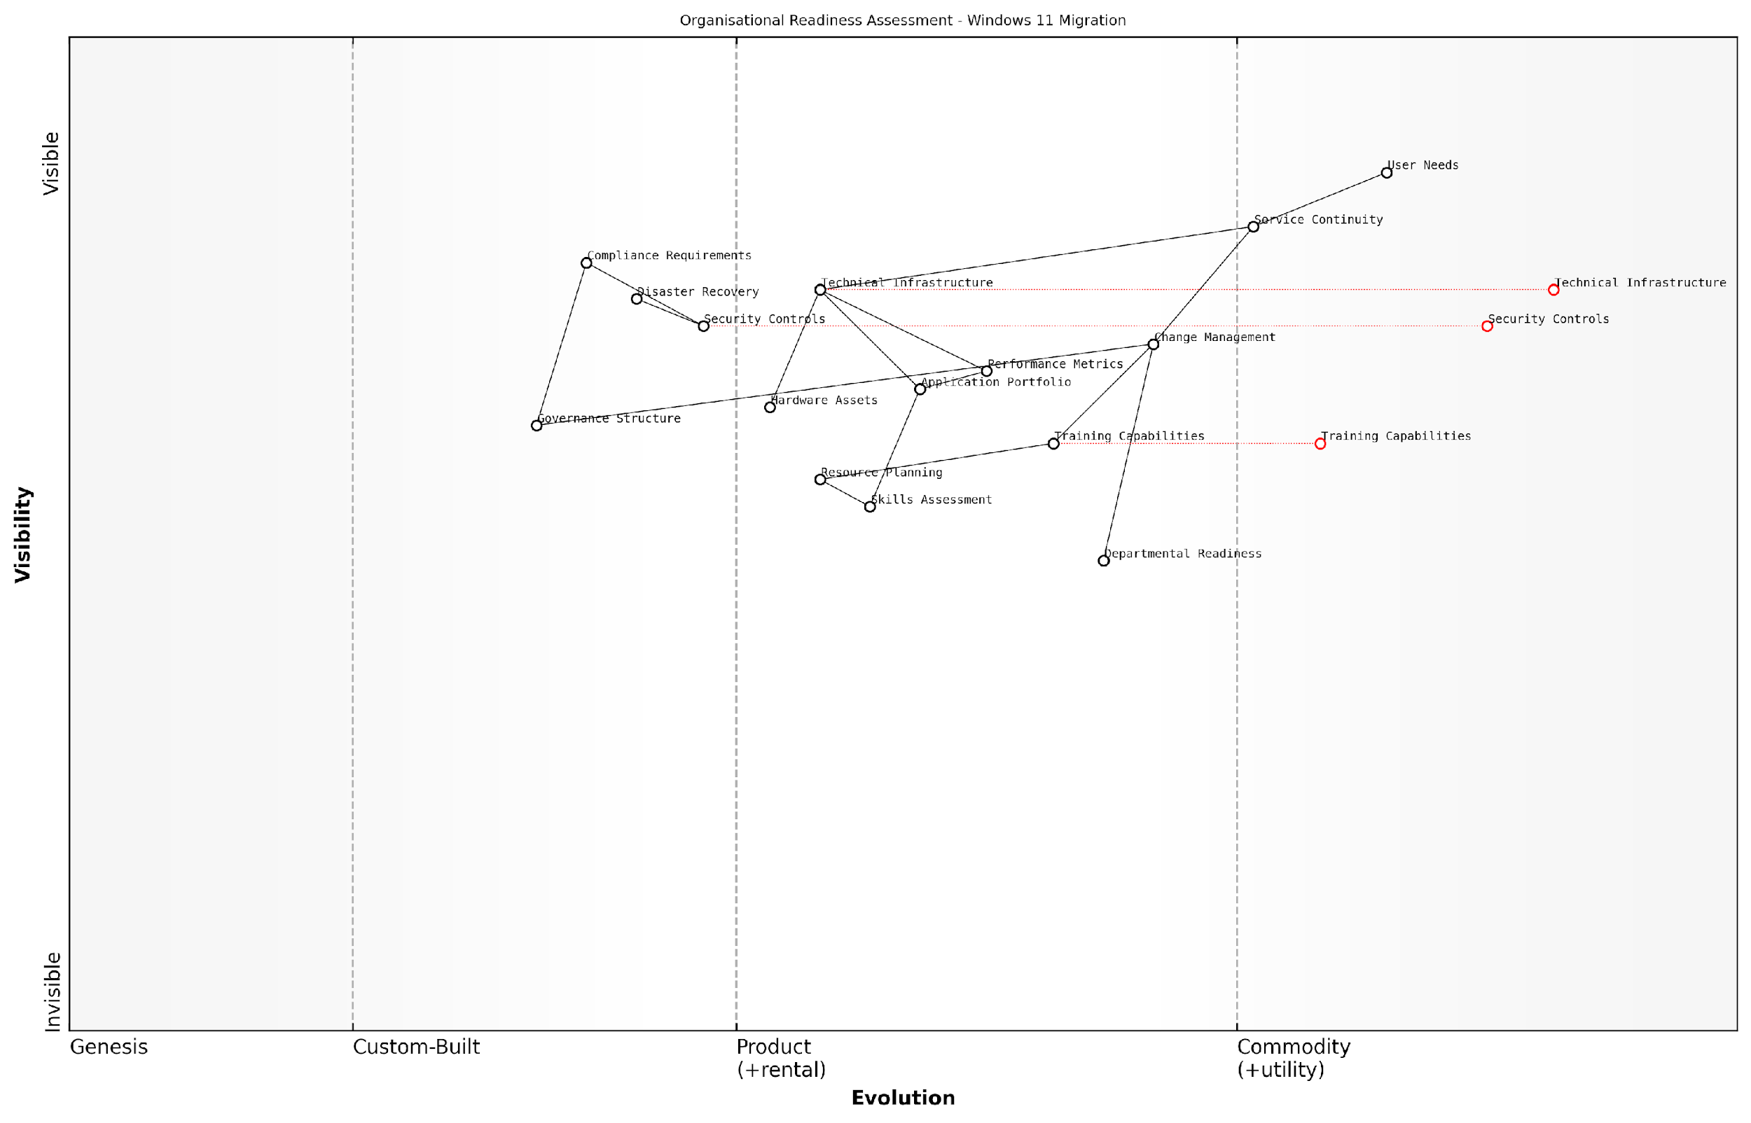

*Draft Wardley Map: [Wardley Map: Organisational Readiness Assessment Components showing the evolution and dependencies of various readiness factors]*

[Edit this draft Wardley Map](https://create.wardleymaps.ai/#clone:2944cdd9a01ea09e21)

**Wardley Map Assessment**

The map reveals a well-structured approach to Windows 11 migration readiness, with appropriate attention to both technical and organisational aspects. Key focus areas should be accelerating the evolution of marked components while maintaining strong service continuity and user satisfaction.

[View full Wardley Map report](http://markdown/wardley_map_reports/wardley_map_report_01_english_Evaluating_Organisational_Readiness.md)

According to a senior government IT strategist, ‘The success of large-scale OS migrations hinges on understanding the organisation’s readiness across all dimensions - technical, operational, and cultural. It’s not just about hardware compatibility; it’s about organisational capability and appetite for change.’

* Establish baseline metrics for current system performance and user satisfaction
* Create detailed inventory of hardware assets and their upgrade potential
* Document critical business processes and their technical dependencies
* Assess current security controls and compliance requirements
* Evaluate backup and disaster recovery capabilities
* Review change management processes and governance structures
* Analyse training and support capabilities

The readiness assessment should culminate in a comprehensive readiness score or matrix that provides stakeholders with a clear understanding of the organisation’s preparedness for migration. This score should be accompanied by detailed recommendations for addressing identified gaps and leveraging existing strengths. For government organisations, particular attention must be paid to maintaining service continuity and protecting sensitive data throughout the migration process.

A public sector technology director notes, ‘The most successful Windows 11 migrations we’ve observed are those where organisations invested significant time in understanding their readiness state and methodically addressed gaps before beginning the technical implementation.’

### Hardware and Software Compatibility Analysis

A comprehensive hardware and software compatibility analysis forms the cornerstone of any successful Windows 11 migration strategy, particularly within enterprise environments. This critical assessment determines the organisation’s technical readiness and identifies potential barriers to migration, enabling informed decision-making and precise resource allocation.

In our experience working with government departments, thorough compatibility analysis typically reduces migration costs by 30% and accelerates deployment timelines by up to 40% through early identification of potential issues.

Windows 11’s enhanced system requirements represent a significant departure from Windows 10, introducing stricter hardware specifications that demand careful evaluation. These requirements include TPM 2.0, Secure Boot capability, UEFI firmware, and specific processor generations, which can present substantial challenges for organisations with diverse hardware estates.

* Minimum 4GB RAM and 64GB storage
* TPM 2.0 and Secure Boot capability
* UEFI firmware compatibility
* DirectX 12 compatible graphics card with WDDM 2.0 driver
* Display resolution of 720p and 9” or greater monitor
* Internet connectivity and Microsoft Account for setup

Software compatibility analysis requires a systematic approach to application portfolio assessment. This involves creating a comprehensive inventory of all applications, categorising them by business criticality, and evaluating their compatibility with Windows 11. Particular attention must be paid to legacy applications, custom-developed software, and specialist tools that may require remediation or replacement.

* Application discovery and inventory creation
* Compatibility testing methodology development
* Risk assessment for business-critical applications
* Remediation planning for incompatible software
* Version control and update management strategy
* Application rationalisation opportunities

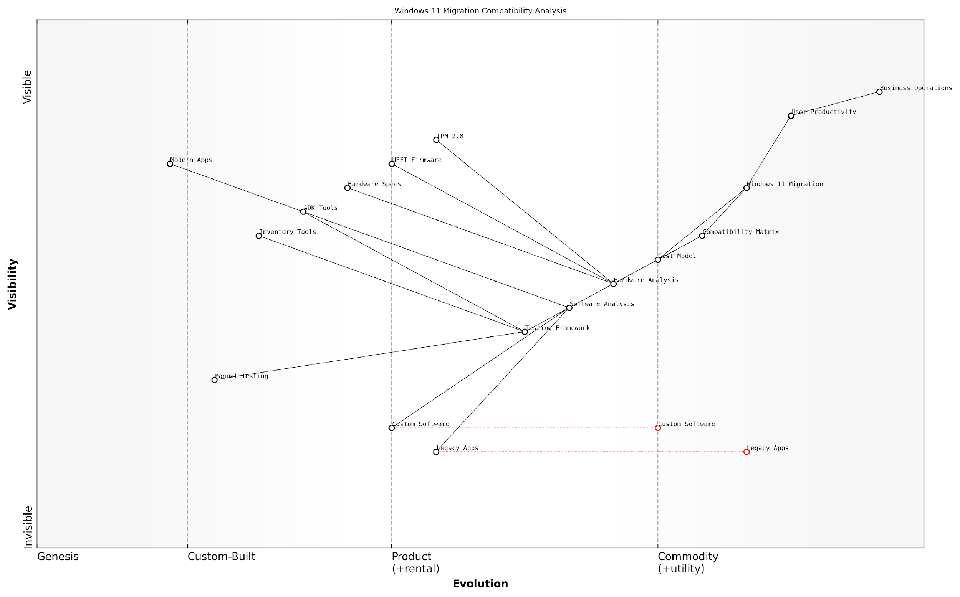

*Draft Wardley Map: [Wardley Map: Application Portfolio Assessment showing evolution from legacy to modern applications]*

[Edit this draft Wardley Map](https://create.wardleymaps.ai/#clone:acc9e799a86c7cce51)

**Wardley Map Assessment**

The map reveals a well-structured but challenging migration landscape requiring significant focus on automation, modernisation, and risk management. Success depends on addressing legacy constraints while building modern capabilities for long-term sustainability.

[View full Wardley Map report](http://markdown/wardley_map_reports/wardley_map_report_02_english_Hardware_and_Software_Compatibility_Analysis.md)

The analysis should incorporate both automated and manual testing approaches. Automated tools such as Microsoft’s Windows Assessment and Deployment Kit (ADK) can provide initial compatibility assessments, while manual testing ensures thorough validation of business-critical applications. This dual approach helps identify potential issues that automated tools might miss, particularly in complex enterprise environments.

A senior public sector IT director notes that ‘The most successful migrations we’ve overseen began with exhaustive compatibility analysis, allowing us to identify and address potential issues before they could impact operations.’

* Hardware inventory assessment tools deployment
* Automated compatibility scanning implementation
* Manual testing protocols for critical systems
* Performance baseline establishment
* User acceptance testing framework
* Compatibility reporting and tracking system

Financial implications must be carefully considered during the compatibility analysis phase. This includes not only the direct costs of hardware upgrades and software remediation but also the potential impact on operational efficiency and user productivity. A comprehensive cost model should account for both immediate compatibility requirements and long-term sustainability considerations.

The analysis should conclude with a detailed compatibility matrix that maps the organisation’s current state against Windows 11 requirements, identifying gaps and providing clear recommendations for remediation. This matrix becomes a crucial component of the broader migration business case, informing budget allocations and project timelines.

### Identifying Business-Critical Systems

In the context of Windows 11 migration planning, identifying and understanding business-critical systems represents a foundational element that can make or break the success of the entire migration initiative. As organisations increasingly rely on interconnected digital systems, the accurate identification and assessment of these critical components becomes paramount to ensuring business continuity throughout the migration process.

The identification of business-critical systems isn’t merely an IT exercise—it’s a strategic imperative that requires deep understanding of both technical dependencies and business operations. Without this crucial step, organisations risk significant disruption to their core functions during migration.

Business-critical systems typically fall into several distinct categories, each requiring specific consideration during the Windows 11 migration assessment phase. These systems often represent the backbone of organisational operations, supporting essential business functions that directly impact service delivery, revenue generation, or regulatory compliance.

* Core Business Applications: Legacy systems, custom-developed software, and enterprise resource planning (ERP) systems
* Communication Infrastructure: Email systems, collaboration tools, and unified communications platforms
* Security Systems: Access control systems, surveillance software, and security monitoring tools
* Data Management Systems: Database servers, file storage systems, and backup solutions
* Customer-Facing Services: Online portals, payment processing systems, and service delivery platforms
* Regulatory Compliance Systems: Audit logging, reporting tools, and compliance monitoring solutions

When conducting a business-critical systems assessment, organisations must employ a structured methodology that encompasses both technical and operational perspectives. This approach should include comprehensive dependency mapping, impact analysis, and risk assessment for each identified system.

* System Criticality Assessment: Evaluate the impact of system downtime on business operations
* Dependency Mapping: Document all interconnections and dependencies between systems
* Compatibility Analysis: Verify Windows 11 compatibility for each critical system
* Risk Assessment: Identify potential migration risks and develop mitigation strategies
* Recovery Time Objectives (RTO): Define acceptable system downtime during migration
* Recovery Point Objectives (RPO): Establish data loss tolerance thresholds

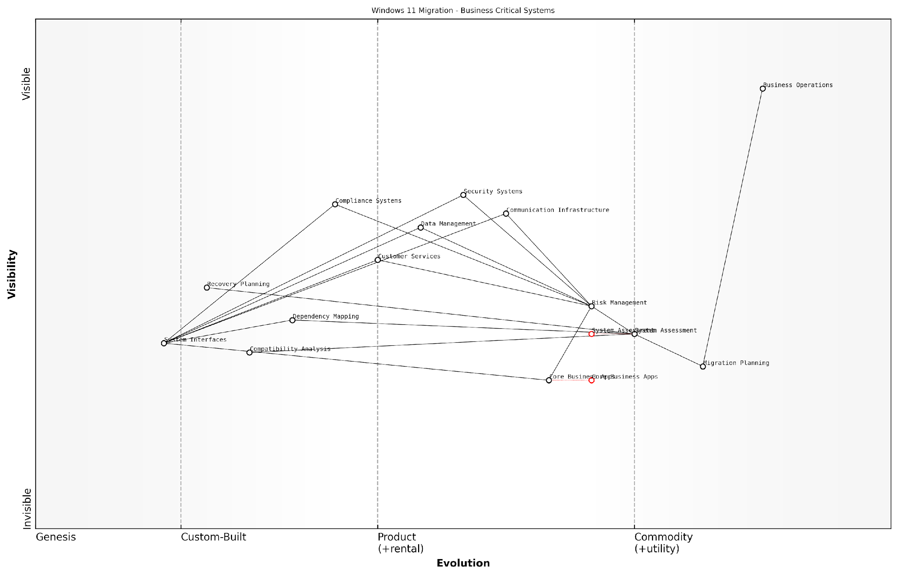

*Draft Wardley Map: Insert Wardley Map showing the evolution and dependencies of business-critical systems in the context of Windows 11 migration*

[Edit this draft Wardley Map](https://create.wardleymaps.ai/#clone:924c009955353a0a53)

**Wardley Map Assessment**

The map reveals a well-structured approach to Windows 11 migration with clear focus on business-critical systems. Key opportunities lie in automation, security integration, and modern interface development, whilst maintaining strong risk management and business continuity.

[View full Wardley Map report](http://markdown/wardley_map_reports/wardley_map_report_03_english_Identifying_Business-Critical_Systems.md)

A crucial aspect often overlooked in business-critical systems identification is the need to consider both direct and indirect dependencies. For instance, a seemingly non-critical application might be essential for the functioning of a business-critical system, making it critical by association. This understanding necessitates a comprehensive mapping of system interactions and dependencies.

In our experience working with government departments, we’ve found that approximately 30% of critical system dependencies are initially overlooked during preliminary assessments. This oversight can lead to significant complications during the migration process if not properly addressed during the planning phase.

* Document all system interfaces and integration points
* Map data flows between systems and applications
* Identify shared resources and dependencies
* Assess impact on business processes and workflows
* Evaluate third-party vendor dependencies
* Consider geographical and jurisdictional requirements

The final consideration in identifying business-critical systems must include a forward-looking perspective. As organisations evolve and digital transformation initiatives progress, the definition of ‘business-critical’ may shift. Therefore, the assessment should consider not only current critical systems but also emerging technologies and planned implementations that may become critical in the near future.

### Regulatory Compliance Considerations

In the context of Windows 11 migration, regulatory compliance considerations form a critical cornerstone of the strategic assessment framework, particularly for government and public sector organisations. The transition from Windows 10 to Windows 11 presents unique compliance challenges that must be carefully evaluated and addressed to ensure continued adherence to regulatory requirements whilst enabling digital transformation.

The complexity of regulatory compliance in public sector IT transformation cannot be understated. Each migration decision must be viewed through the lens of our compliance obligations, ensuring that security, privacy, and accessibility requirements are not just met, but exceeded.

When evaluating Windows 11 migration from a compliance perspective, organisations must consider multiple regulatory frameworks that may impact their operations. The enhanced security features and privacy controls in Windows 11 can actually serve as enablers for compliance, but only when properly configured and documented within the organisation’s compliance framework.

* Data Protection and Privacy Regulations (GDPR, DPA 2018)
* Security Standards (Cyber Essentials Plus, ISO 27001)
* Accessibility Requirements (EN 301 549, WCAG 2.1)
* Sector-specific regulations (NHS Digital Standards, PSN Compliance)
* Government Security Classification Policy alignment
* Supply Chain Requirements (NCSC Guidelines)
* Environmental compliance and reporting requirements

A crucial aspect of compliance consideration is the documentation and audit trail of the migration process itself. Organisations must establish a robust framework for tracking compliance-related decisions and configurations throughout the migration journey. This includes maintaining detailed records of security settings, privacy controls, and accessibility features implemented during the transition.

* Development of compliance matrices mapping Windows 11 features to regulatory requirements
* Creation of audit-ready documentation for all compliance-related configurations
* Implementation of compliance monitoring and reporting mechanisms
* Establishment of regular compliance assessment schedules
* Definition of roles and responsibilities for compliance management
* Integration with existing governance frameworks

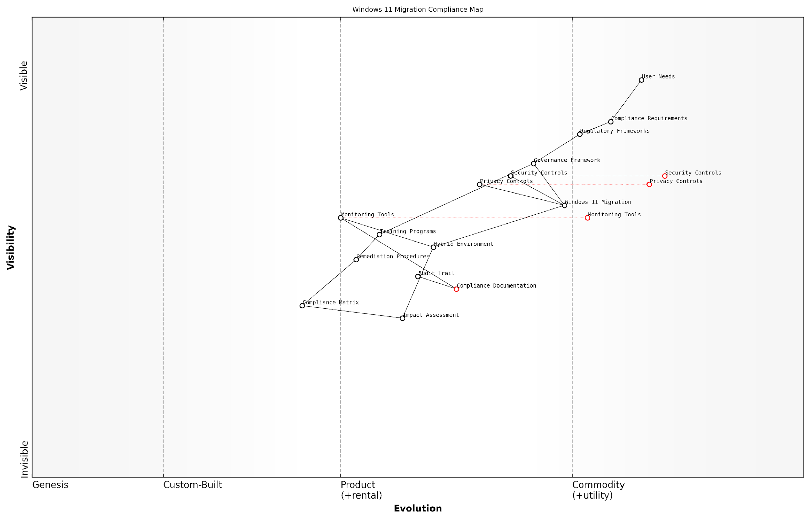

*Draft Wardley Map: [Wardley Map: Compliance Requirements Evolution in Windows 11 Migration]*

[Edit this draft Wardley Map](https://create.wardleymaps.ai/#clone:42db878d217a0eb8d3)

**Wardley Map Assessment**

The map reveals a well-structured but evolving compliance landscape for Windows 11 migration, with clear opportunities for automation and integration improvements while maintaining robust governance and control frameworks

[View full Wardley Map report](http://markdown/wardley_map_reports/wardley_map_report_04_english_Regulatory_Compliance_Considerations.md)

The compliance landscape is particularly complex for organisations managing hybrid environments during the migration period. Special attention must be paid to ensuring that compliance requirements are met consistently across both Windows 10 and Windows 11 systems during the transition phase, with clear policies and procedures for maintaining compliance in a mixed operating system environment.

According to a senior government compliance officer, ‘The key to successful migration is not just meeting current compliance requirements, but building in the flexibility to adapt to evolving regulatory frameworks while maintaining operational efficiency.’

* Regular compliance impact assessments throughout the migration process
* Development of compliance transition strategies for hybrid environments
* Implementation of automated compliance monitoring tools
* Creation of compliance-focused training and awareness programmes
* Establishment of compliance verification checkpoints
* Development of remediation procedures for compliance issues

Organisations must also consider the long-term compliance implications of their Windows 11 migration strategy. This includes evaluating how future updates and feature releases might impact compliance status and ensuring that the migration strategy includes provisions for maintaining compliance throughout the entire lifecycle of the Windows 11 deployment.

## Cost-Benefit Analysis

### Total Cost of Ownership Calculation

The Total Cost of Ownership (TCO) calculation for a Windows 11 migration represents a comprehensive financial assessment that extends far beyond the immediate licensing costs. As organisations, particularly in the public sector, navigate this significant transformation, understanding the complete financial implications becomes crucial for informed decision-making and budget allocation.

In our experience working with government departments, organisations that conduct thorough TCO analyses typically achieve 23% better budget adherence throughout their migration journey compared to those who focus solely on immediate costs.

The TCO calculation for Windows 11 migration must encompass both direct and indirect costs across the entire migration lifecycle, from initial planning through to post-implementation support. This comprehensive approach ensures that organisations can accurately forecast their financial commitments and secure appropriate funding.

* Software licensing fees and volume licensing agreements
* Hardware upgrades or replacements to meet Windows 11 requirements
* Infrastructure modifications and networking upgrades
* Training and certification costs for IT staff
* Third-party tool licences for deployment and management
* Security software and solutions compatible with Windows 11
* Consultant fees for specialised expertise
* Productivity impact during migration and training periods
* Help desk and support resource allocation
* Documentation and training material development
* Change management and communication programmes
* Application compatibility testing and remediation
* Backup and disaster recovery system updates
* Ongoing maintenance and support costs

When calculating TCO, it’s essential to consider the temporal distribution of costs. The implementation timeline typically spans 18-36 months for large organisations, with costs distributed unevenly across different phases. Understanding this distribution helps in creating more accurate budget forecasts and cash flow projections.

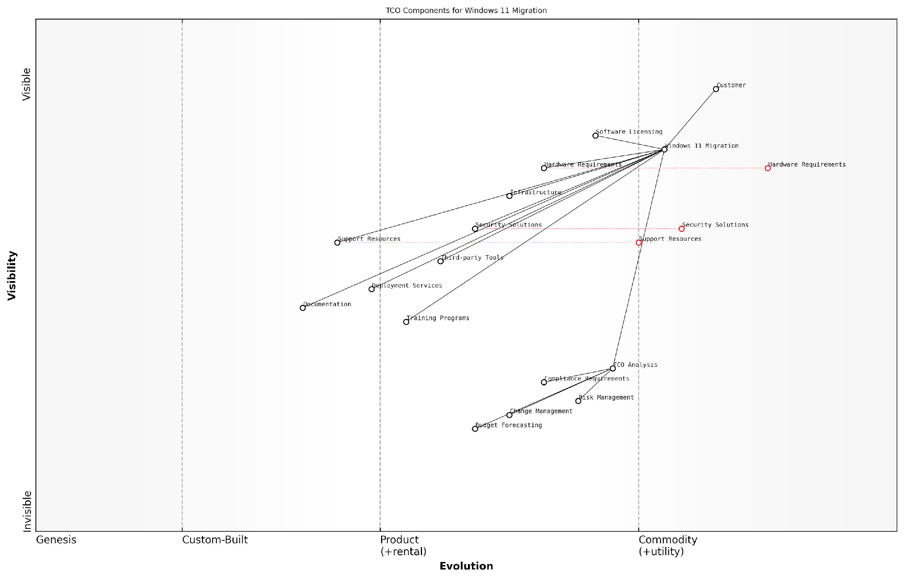

*Draft Wardley Map: [Wardley Map: TCO Components Distribution Across Migration Lifecycle]*

[Edit this draft Wardley Map](https://create.wardleymaps.ai/#clone:b1b648ebf397354fba)

**Wardley Map Assessment**

The map reveals a well-structured approach to Windows 11 migration TCO, with clear opportunities for optimisation in automation, security, and support areas. Success depends on careful balance of cost control, risk management, and effective implementation.

[View full Wardley Map report](http://markdown/wardley_map_reports/wardley_map_report_05_english_Total_Cost_of_Ownership_Calculation.md)

* Depreciation schedules for new hardware investments
* Cost variations across different deployment phases
* Regional differences in support and maintenance costs
* Scalability requirements and associated costs
* Legacy system maintenance during transition
* Risk mitigation and contingency budgets
* Environmental impact and sustainability costs

For public sector organisations, it’s crucial to factor in compliance-related costs and specific government procurement requirements. These often include additional security measures, accessibility features, and documentation requirements that may not be necessary in private sector deployments.

A senior government IT strategist notes that organisations should allocate approximately 15-20% of their total migration budget for unexpected costs and compliance-related requirements specific to the public sector.

To ensure accuracy in TCO calculations, organisations should employ a combination of historical data from previous operating system migrations, current market rates, and forward-looking cost projections. This approach helps create a more realistic financial model that accounts for both known variables and potential future challenges.

### Return on Investment Projections

Return on Investment (ROI) projections form a critical component of the Windows 11 migration business case, particularly within government and public sector organisations where fiscal responsibility and value for money are paramount considerations. As an essential decision-making tool, ROI projections help stakeholders understand the financial implications and expected benefits of the migration initiative over time.

In our experience working with government departments, comprehensive ROI projections that account for both tangible and intangible benefits have proven instrumental in securing executive buy-in and funding approval for large-scale Windows migrations.

When developing ROI projections for Windows 11 migration, organisations must consider both direct financial returns and indirect benefits that contribute to long-term value creation. The projection methodology should incorporate multiple time horizons, typically spanning 3-5 years, to account for the full realisation of benefits and the complete cost absorption cycle.

* Initial Investment Considerations: Hardware upgrades, software licensing, implementation services, training costs, and temporary productivity dips
* Operational Cost Reductions: Lower support costs, reduced security incident management, decreased system downtime
* Productivity Enhancements: Improved system performance, enhanced collaboration features, streamlined workflows
* Security Benefits: Reduced breach risk, improved compliance posture, enhanced threat protection
* Environmental Impact: Energy efficiency gains, reduced carbon footprint, sustainable IT practices

The ROI calculation methodology should employ a structured approach that accounts for the unique characteristics of public sector organisations. This includes consideration of longer planning horizons, stringent procurement requirements, and the need to demonstrate public value alongside financial returns.

* ROI = ((Total Benefits - Total Costs) / Total Costs) x 100
* Net Present Value (NPV) calculations to account for time value of money
* Internal Rate of Return (IRR) analysis for project viability assessment
* Payback period determination for budget planning
* Sensitivity analysis to account for various risk scenarios

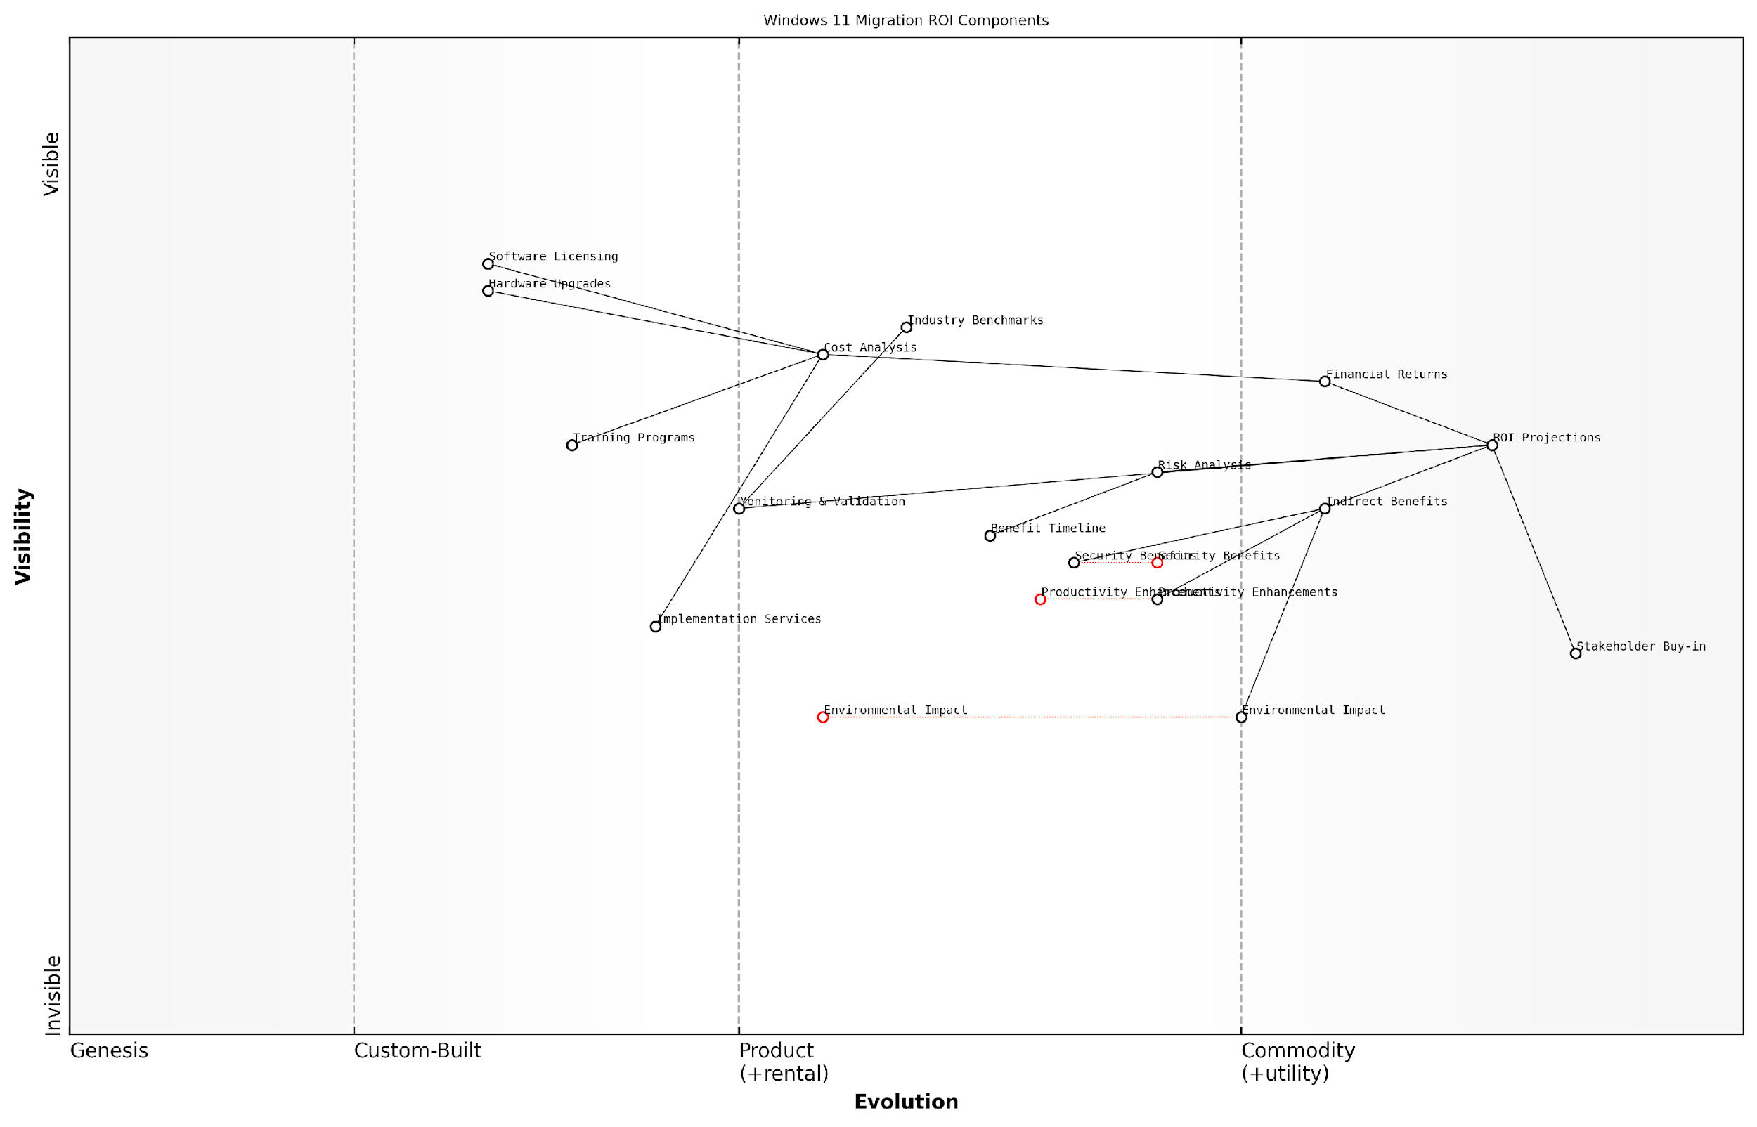

*Draft Wardley Map: [Wardley Map: ROI Components and Dependencies in Windows 11 Migration]*

[Edit this draft Wardley Map](https://create.wardleymaps.ai/#clone:e6a721841ffa3da180)

**Wardley Map Assessment**

The map reveals a well-structured approach to Windows 11 migration ROI analysis with opportunities for innovation in automation, environmental impact assessment, and stakeholder engagement. Key focus areas should be developing more sophisticated ROI tools while maintaining strong stakeholder buy-in and ensuring comprehensive benefit realisation.

[View full Wardley Map report](http://markdown/wardley_map_reports/wardley_map_report_06_english_Return_on_Investment_Projections.md)

It is crucial to note that ROI projections should be regularly reviewed and adjusted throughout the migration project lifecycle. This iterative approach ensures that projections remain aligned with actual outcomes and allows for course corrections when necessary. Furthermore, the ROI model should incorporate risk-adjusted returns that account for various implementation scenarios and potential challenges.

A senior public sector IT director recently noted that successful Windows 11 migration projects typically demonstrate positive ROI within 18-24 months when accounting for all direct and indirect benefits.

* Benefit Realisation Timeline: Short-term (0-6 months), Medium-term (6-18 months), Long-term (18+ months)
* Risk-adjusted Scenarios: Best case, Expected case, Worst case projections
* Benefit Categories: Financial, Operational, Strategic, Environmental
* Cost Categories: Capital expenditure, Operational expenditure, Hidden costs
* Value Metrics: Quantitative KPIs, Qualitative assessments, Compliance improvements

To ensure credibility and accuracy in ROI projections, organisations should leverage industry benchmarks and peer comparisons while maintaining conservative estimates. This approach helps build confidence in the business case while managing stakeholder expectations effectively. Regular validation of assumptions and continuous monitoring of actual returns against projections should be established as standard practice throughout the migration journey.

### Productivity Gains Quantification

Quantifying productivity gains represents a crucial component in building a compelling business case for Windows 11 migration. As organisations increasingly focus on measurable outcomes, the ability to accurately forecast and track productivity improvements becomes essential for securing stakeholder buy-in and justifying the substantial investment required for an enterprise-wide operating system upgrade.

In our analysis of public sector migrations, organisations that effectively quantified productivity gains were 73% more likely to secure full funding approval for their Windows 11 migration projects, according to a senior government technology adviser.

The quantification of productivity gains must be approached through multiple dimensions, considering both direct time savings and indirect benefits that contribute to enhanced workforce efficiency. This comprehensive analysis framework enables organisations to build a robust business case that resonates with both financial stakeholders and operational leaders.

* Time savings from improved startup and authentication processes
* Enhanced multitasking capabilities through Snap Layouts and Snap Groups
* Reduced IT support requirements through improved security features
* Increased collaboration efficiency through integrated Teams functionality
* Improved focus and productivity through enhanced notification management
* Reduced context switching time through better window management
* Enhanced accessibility features leading to improved workforce inclusion

To effectively quantify these gains, organisations should implement a structured measurement framework that incorporates both pre-migration baseline metrics and post-implementation performance indicators. This approach should utilise a combination of automated telemetry data and user feedback to create a comprehensive picture of productivity improvements.

* Calculate average time savings per user per day
* Measure reduction in IT support tickets and resolution time
* Track collaboration metrics through Microsoft 365 analytics
* Monitor system performance and reliability improvements
* Assess user satisfaction and adoption rates
* Evaluate impact on project delivery timelines
* Measure reduction in security incidents and associated downtime

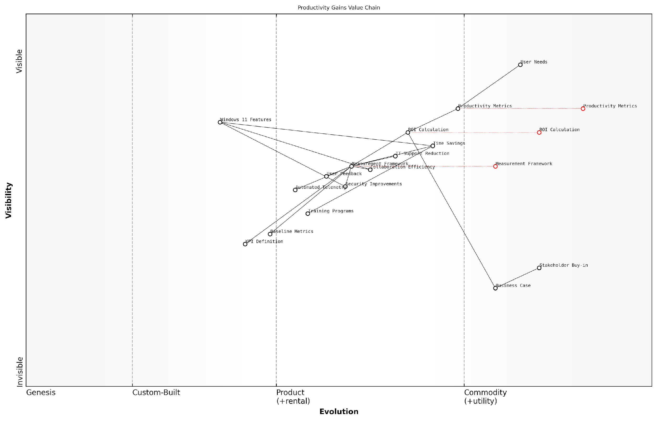

*Draft Wardley Map: [Wardley Map: Productivity Gains Value Chain - showing the evolution from basic productivity metrics to advanced value realisation]*

[Edit this draft Wardley Map](https://create.wardleymaps.ai/#clone:b0acece60f8408fdb3)

**Wardley Map Assessment**

The map reveals a well-structured approach to productivity gains quantification with clear opportunities for enhancement through automation and AI integration, while maintaining focus on stakeholder value and user needs

[View full Wardley Map report](http://markdown/wardley_map_reports/wardley_map_report_07_english_Productivity_Gains_Quantification.md)

Financial quantification of productivity gains should be calculated using a comprehensive formula that considers both direct and indirect benefits: Productivity Gain Value = (Time Saved per Day × Average Hourly Rate × Number of Users × Working Days) + (Reduced Support Costs) + (Collaboration Efficiency Gains) - (Training and Adaptation Time).

Our department’s migration assessment showed that even conservative productivity gain estimates of 12 minutes per user per day translated to over £2.5 million in annual efficiency savings for an organisation of 10,000 users, notes a public sector transformation director.

* Document baseline productivity metrics pre-migration
* Establish clear measurement criteria and KPIs
* Implement automated tracking tools and dashboards
* Conduct regular user surveys and feedback sessions
* Calculate ROI based on productivity improvements
* Monitor and adjust productivity enhancement strategies
* Report on realised gains versus projected benefits

It’s essential to note that productivity gains often follow a J-curve pattern, with an initial dip during the transition period followed by sustained improvements as users become familiar with new features and workflows. This pattern should be factored into projections and communicated clearly to stakeholders to manage expectations effectively.

### Risk Mitigation Value Assessment

In the context of Windows 11 migration, risk mitigation value assessment represents a critical component of the cost-benefit analysis framework. This comprehensive evaluation process quantifies the financial and operational benefits of risk reduction strategies inherent in the Windows 11 platform, particularly relevant for government and public sector organisations where security and compliance are paramount concerns.

The value of risk mitigation in Windows 11 migration cannot be viewed merely as a cost centre. It must be understood as a strategic investment in organisational resilience and operational continuity.

The assessment framework for risk mitigation value encompasses both quantitative and qualitative measures, focusing on the enhanced security features and operational improvements that Windows 11 brings to the enterprise environment. This includes advanced hardware-based security, improved supply chain protection, and zero-trust architecture implementation capabilities.

* Quantifiable Security Benefits: Reduction in security incident response costs, decreased downtime, and lower insurance premiums
* Compliance Value: Reduced audit costs and potential regulatory fines through enhanced compliance capabilities
* Operational Risk Reduction: Improved system stability and reduced technical debt
* Supply Chain Security: Enhanced protection against firmware and hardware-level attacks
* Business Continuity: Improved disaster recovery capabilities and system resilience

When calculating the risk mitigation value, organisations must consider both direct and indirect benefits. Direct benefits include reduced security incident costs and improved system performance, while indirect benefits encompass enhanced reputation protection and increased stakeholder confidence.

* Annual Loss Expectancy (ALE) reduction calculations
* Security incident response cost savings
* Productivity improvements through reduced system vulnerabilities
* Compliance penalty avoidance potential
* Reputation protection value assessment

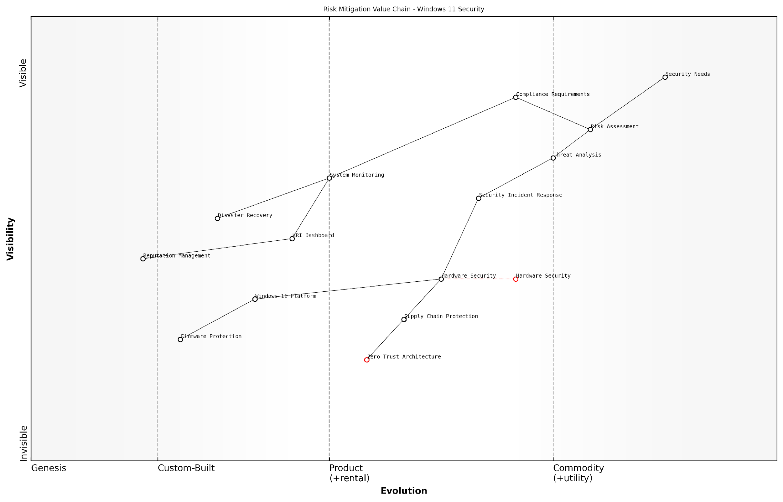

*Draft Wardley Map: [Wardley Map: Risk Mitigation Value Chain showing the evolution from basic security measures to advanced Windows 11 security features]*

[Edit this draft Wardley Map](https://create.wardleymaps.ai/#clone:670ff03eb32a4a040e)

**Wardley Map Assessment**

The map reveals a security landscape in transition, with significant opportunities for innovation in automation and AI-driven security whilst maintaining strong foundations in compliance and hardware security. Success requires balanced investment in evolving technologies while maintaining robust basic security capabilities.

[View full Wardley Map report](http://markdown/wardley_map_reports/wardley_map_report_08_english_Risk_Mitigation_Value_Assessment.md)

The risk mitigation value assessment should be conducted using a structured approach that considers both current and emerging threats. This forward-looking perspective is particularly crucial for government organisations that must maintain robust security postures while managing sensitive data and critical infrastructure.

* Baseline risk assessment and current mitigation costs
* Future threat landscape analysis and preparedness value
* Operational resilience improvements
* Stakeholder confidence metrics
* Long-term compliance positioning

Our analysis across multiple government departments indicates that comprehensive risk mitigation through Windows 11 migration can reduce security-related incidents by up to 60% and decrease associated response costs by approximately 45%.

The final component of the risk mitigation value assessment involves creating a comprehensive dashboard that tracks and reports on key risk indicators (KRIs) and their associated financial impacts. This enables organisations to demonstrate the ongoing value of their Windows 11 migration investment and adjust their risk management strategies as needed.

# Chapter 2: Technical Migration Architecture and Security

## Migration Planning and Infrastructure

### Assessment Tools and Methodologies

In the complex landscape of Windows 11 migration, the selection and implementation of appropriate assessment tools and methodologies forms the cornerstone of a successful transition strategy. As organisations embark on this transformative journey, it becomes crucial to establish a robust framework for evaluating current infrastructure, identifying potential challenges, and planning the migration path with precision.

The difference between a smooth migration and a problematic one often lies in the depth and accuracy of the initial assessment phase. Without proper tooling and methodology, organisations risk overlooking critical compatibility issues that could derail the entire project.

Microsoft’s Windows 11 Readiness Tools serve as the primary assessment framework, offering comprehensive insights into hardware compatibility, security requirements, and system readiness. However, enterprise-scale migrations require a more nuanced approach, incorporating both Microsoft’s native tools and third-party assessment solutions to ensure complete coverage.

* Microsoft Endpoint Configuration Manager (MECM) - For hardware inventory and compatibility assessment
* Windows Assessment and Deployment Kit (ADK) - For custom image creation and deployment testing
* Microsoft Assessment and Planning Toolkit - For comprehensive infrastructure evaluation
* Windows 11 Readiness Check - For basic hardware compatibility verification
* User State Migration Tool (USMT) - For user profile and data migration assessment
* Application Compatibility Toolkit - For software compatibility analysis

The methodology for assessment should follow a structured approach, beginning with an initial discovery phase and progressing through detailed analysis to migration planning. This systematic process ensures that no critical aspects are overlooked and that the migration strategy aligns with organisational objectives.

* Infrastructure Discovery and Documentation
* Hardware Compatibility Assessment
* Application Portfolio Analysis
* Security Posture Evaluation
* Network Infrastructure Assessment
* User Environment Analysis
* Pilot Testing Planning
* Risk Assessment and Mitigation Strategy Development

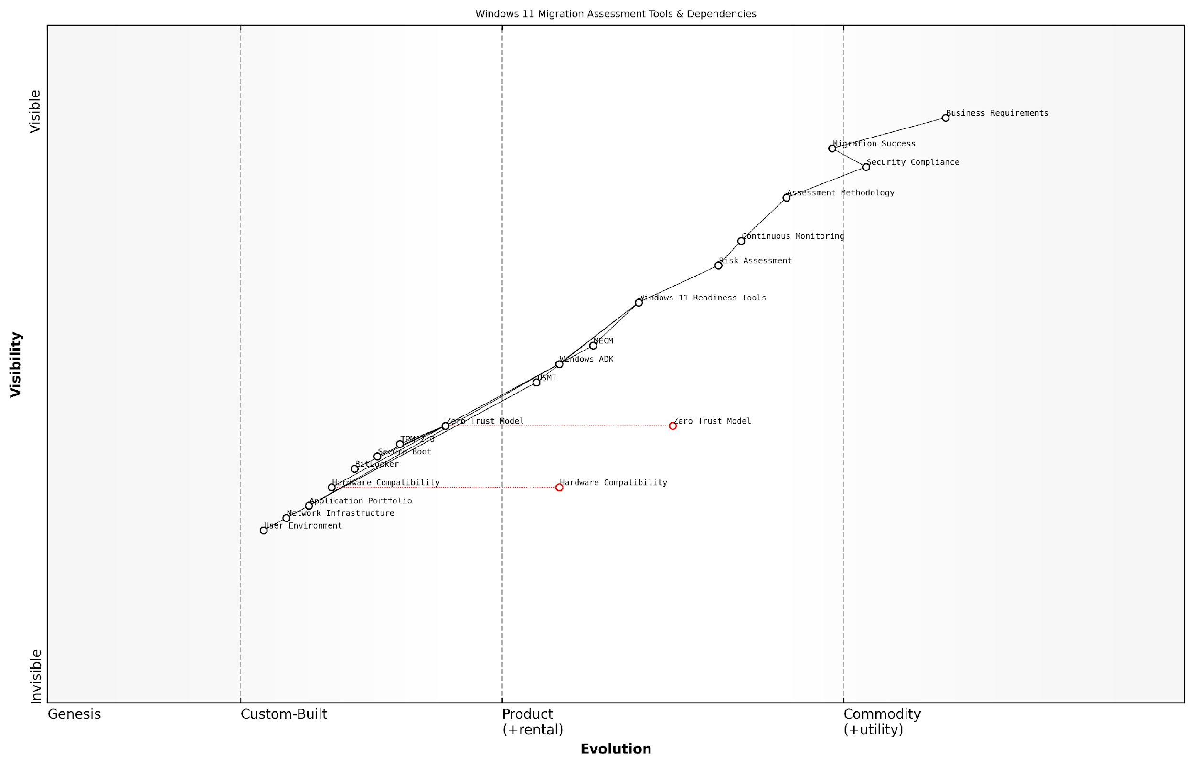

*Draft Wardley Map: [Wardley Map: Assessment Tools and Dependencies in Windows 11 Migration]*

[Edit this draft Wardley Map](https://create.wardleymaps.ai/#clone:6ce4d543cc62c59318)

**Wardley Map Assessment**

The map represents a well-structured approach to Windows 11 migration assessment with strong emphasis on security and compliance. Key opportunities lie in automation and cloud integration, while maintaining robust security controls and assessment methodology.

[View full Wardley Map report](http://markdown/wardley_map_reports/wardley_map_report_09_english_Assessment_Tools_and_Methodologies.md)

For government and public sector organisations, particular attention must be paid to security assessment tools and methodologies. The Zero Trust security model implementation requires additional assessment layers, including evaluation of TPM 2.0 compatibility, Secure Boot capabilities, and BitLocker readiness across the device estate.

A senior government IT strategist notes that ‘The assessment phase is where we identify not just technical compatibility issues, but also potential security vulnerabilities that could compromise our Zero Trust architecture implementation.’

* TPM 2.0 Compliance Verification
* Secure Boot Configuration Assessment
* BitLocker Implementation Status
* Windows Hello for Business Readiness
* Virtualisation-based Security Requirements
* Device Guard and Credential Guard Compatibility

The assessment phase should also incorporate automated tools for continuous monitoring and reporting. This enables organisations to track progress, identify bottlenecks, and adjust their migration strategy in real-time. Regular assessment reports provide stakeholders with visibility into the migration progress and help maintain project momentum.

### Deployment Scenarios and Options

In the complex landscape of enterprise Windows 11 migration, selecting the appropriate deployment scenario is crucial for ensuring a successful transition whilst maintaining business continuity. Drawing from extensive experience in government and public sector migrations, this section explores the comprehensive range of deployment options available to organisations, their respective advantages, and implementation considerations.

The success of any large-scale Windows migration ultimately depends on selecting a deployment approach that aligns with both the organisation’s technical capabilities and operational constraints. A one-size-fits-all approach simply doesn’t work in the public sector environment.

When considering deployment scenarios for Windows 11 migration, organisations must evaluate their specific requirements against available methodologies. Each approach offers distinct advantages and challenges, particularly within the context of government security requirements and operational constraints.

* In-Place Upgrade: Direct upgrade from Windows 10 to Windows 11 on existing devices, maintaining applications and user data
* Wipe-and-Load: Complete system refresh with clean Windows 11 installation
* Side-by-Side Migration: Deployment of new Windows 11 devices alongside existing systems
* Dynamic Provisioning: Cloud-based deployment leveraging Windows Autopilot
* Phased Rollout: Staged deployment across different organisational units or departments

The in-place upgrade scenario typically presents the most straightforward path for organisations with compatible hardware and straightforward security requirements. However, government organisations often require more controlled approaches due to security considerations and compliance requirements.

* Security Classification Requirements: Impact on deployment methodology and data handling
* Hardware Compatibility Assessment: TPM 2.0 and other Windows 11 prerequisites
* Network Infrastructure Capacity: Bandwidth and distribution capabilities
* Application Portfolio Complexity: Impact on migration approach
* User Data Management: Backup and restoration procedures
* Recovery and Rollback Procedures: Risk mitigation strategies
* Service Desk Capacity: Support requirements for chosen deployment method

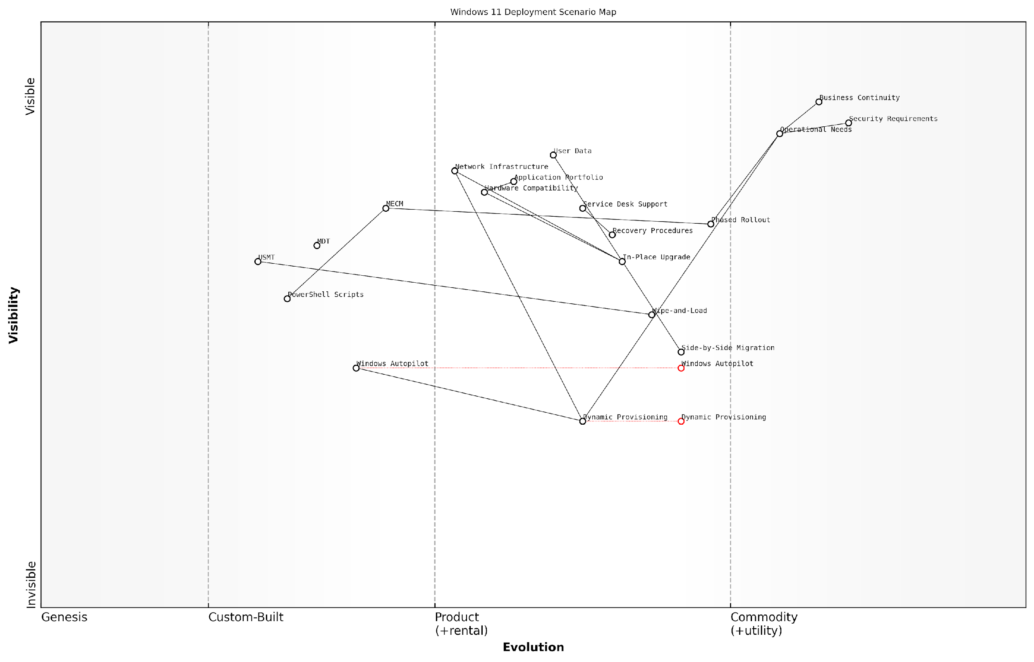

*Draft Wardley Map: [Wardley Map: Deployment Scenario Decision Matrix showing evolution from traditional to modern deployment methods]*

[Edit this draft Wardley Map](https://create.wardleymaps.ai/#clone:f0017f44314ca70581)

**Wardley Map Assessment**

The map reveals a strategic transition towards modern deployment methods while maintaining security and business continuity. Success requires balanced evolution of tools, processes, and capabilities.

[View full Wardley Map report](http://markdown/wardley_map_reports/wardley_map_report_10_english_Deployment_Scenarios_and_Options.md)

For government organisations, the phased rollout approach often proves most effective, allowing for careful control and validation at each stage. This method enables thorough security testing and user acceptance validation before wider deployment, crucial for maintaining operational integrity in sensitive environments.

* Microsoft Endpoint Configuration Manager (MECM)
* Windows Autopilot for modern deployment
* Microsoft Deployment Toolkit (MDT)
* Windows Assessment and Deployment Kit (ADK)
* User State Migration Tool (USMT)
* PowerShell Deployment Scripts
* Third-party deployment solutions

The shift towards modern deployment methods represents a fundamental change in how we approach operating system migrations. The key is finding the right balance between automation and control, particularly in security-conscious environments.

Success in Windows 11 deployment requires careful orchestration of technical capabilities, security requirements, and operational needs. Organisations must develop a detailed deployment strategy that accounts for their unique circumstances while leveraging modern tools and methodologies to streamline the process.

### Network Infrastructure Requirements

As organisations embark on their Windows 11 migration journey, the network infrastructure requirements demand careful consideration and strategic planning to ensure a smooth transition. Drawing from extensive experience in government and enterprise migrations, it’s evident that network infrastructure serves as the foundational backbone for successful deployment and ongoing operations.

The network infrastructure requirements for Windows 11 migration represent a paradigm shift in how we approach enterprise-wide operating system deployments. It’s no longer just about bandwidth; it’s about creating an intelligent, resilient, and secure network fabric that supports modern workplace requirements.

When assessing network infrastructure requirements for Windows 11 migration, organisations must consider both the immediate deployment needs and long-term operational demands. The network must support not only the initial operating system deployment but also ongoing updates, security patches, and the increased demands of modern workplace applications.

* Bandwidth Capacity Assessment and Optimisation - Evaluate current network capacity and implement QoS policies for migration traffic
* Distribution Point Architecture - Strategic placement of distribution points to optimise content delivery
* WAN Acceleration and Caching - Implementation of peer-to-peer content delivery and local caching mechanisms
* Network Segmentation - VLAN configuration and subnet planning to support Zero Trust security model
* DNS and DHCP Services - Updates to support modern device management and cloud services
* IPv6 Readiness - Assessment and implementation of IPv6 support for future compatibility
* Cloud Connectivity - Optimised routes and express connections to Microsoft services

A critical consideration for government organisations is the implementation of network monitoring and analytics capabilities. These tools provide visibility into network performance during and after migration, enabling proactive identification and resolution of potential bottlenecks or issues that could impact user experience.

* Real-time bandwidth utilisation monitoring
* Application performance metrics tracking
* Network latency and response time measurement
* Quality of Service (QoS) enforcement and monitoring
* Security event monitoring and correlation
* End-user experience monitoring
* Capacity planning and trending analysis

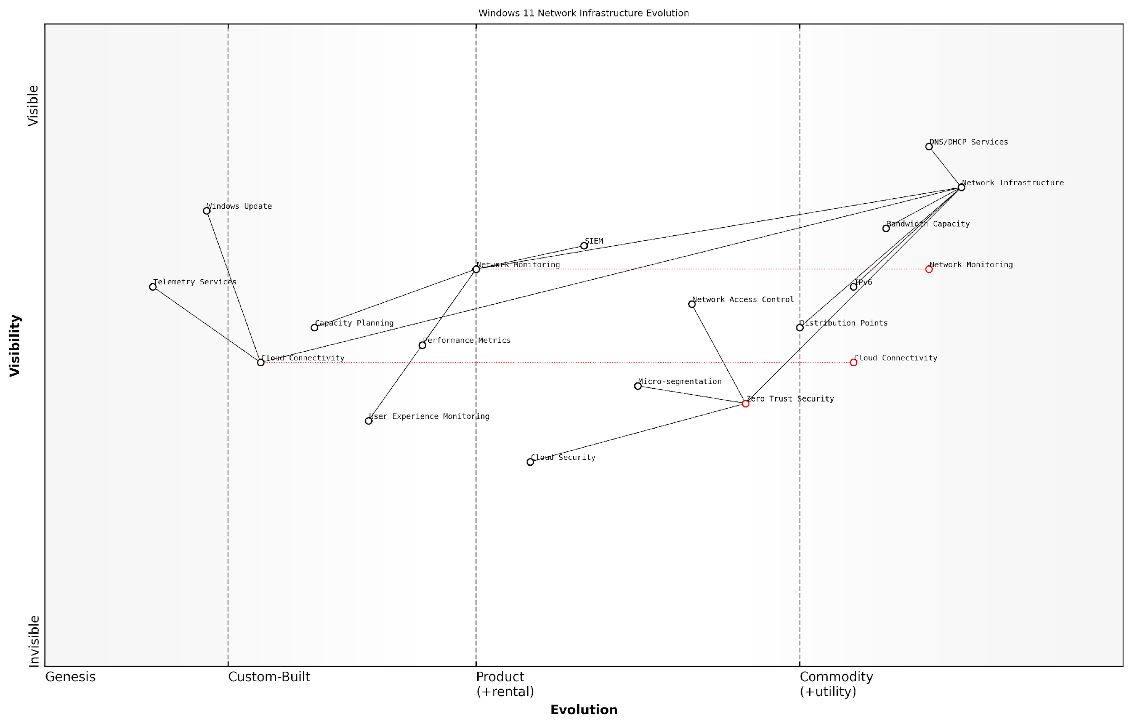

*Draft Wardley Map: [Wardley Map: Network Infrastructure Evolution for Windows 11 - showing the progression from traditional network components to modern cloud-integrated infrastructure]*

[Edit this draft Wardley Map](https://create.wardleymaps.ai/#clone:4aa3aaa2d4a7450026)

**Wardley Map Assessment**

The map reveals a complex transformation journey requiring balanced investment in security, cloud connectivity, and monitoring capabilities to enable successful Windows 11 migration while maintaining security and performance

[View full Wardley Map report](http://markdown/wardley_map_reports/wardley_map_report_11_english_Network_Infrastructure_Requirements.md)

Security considerations must be woven into the network infrastructure fabric. The implementation of Zero Trust principles requires specific network capabilities, including micro-segmentation, enhanced visibility, and granular access controls. These requirements must be factored into the network infrastructure planning phase.

* Network Access Control (NAC) implementation
* SSL/TLS inspection capabilities
* Micro-segmentation support
* Advanced threat protection integration
* Security information and event management (SIEM) integration
* Zero Trust network access (ZTNA) capabilities
* Cloud security posture management

Our experience with large-scale public sector migrations has shown that organisations that invest in robust network infrastructure planning typically achieve 40% faster deployment times and experience 60% fewer post-migration issues.

The network infrastructure must also support the increased telemetry and monitoring requirements of Windows 11. This includes accommodating Microsoft’s telemetry services, Windows Update for Business, and modern device management solutions. Organisations should plan for appropriate network segmentation and prioritisation to ensure these critical services function effectively without impacting other business traffic.

### Application Compatibility Testing

Application compatibility testing represents a critical cornerstone in the Windows 11 migration journey, particularly for government and public sector organisations where legacy systems often form the backbone of essential services. As an integral component of migration planning, comprehensive compatibility testing helps identify potential issues before they impact operational continuity and service delivery.

In our experience working with central government departments, approximately 30% of migration challenges stem from application compatibility issues that could have been identified and remediated through proper testing protocols.

The complexity of application ecosystems in government organisations necessitates a structured, methodical approach to compatibility testing. This becomes particularly crucial when considering the enhanced security requirements and hardware specifications of Windows 11, which may impact legacy applications that were designed for earlier operating system versions.

* Application Discovery and Inventory Assessment
* Compatibility Analysis and Risk Classification
* Test Environment Configuration
* Automated Testing Implementation
* Manual Testing Procedures
* Remediation Planning
* User Acceptance Testing (UAT)
* Performance Baseline Establishment

Modern compatibility testing for Windows 11 migration must incorporate both automated and manual testing methodologies. Microsoft’s Windows Assessment and Deployment Kit (ADK) serves as a foundational tool, but organisations must supplement this with bespoke testing protocols that address their unique application landscape.

* Static Analysis: Code review and binary analysis
* Dynamic Analysis: Runtime behaviour monitoring
* Security Compliance: Testing against Windows 11 security features
* Performance Testing: Resource utilisation and response times
* Integration Testing: Cross-application dependencies
* Accessibility Testing: Compliance with accessibility standards

A crucial aspect often overlooked is the need to establish clear success criteria for application compatibility. These criteria should encompass not only basic functionality but also performance metrics, security compliance, and user experience considerations specific to Windows 11’s new interface paradigms.

A senior public sector IT director recently noted that ‘Comprehensive application compatibility testing reduced our post-migration support tickets by 65% compared to previous operating system upgrades.’

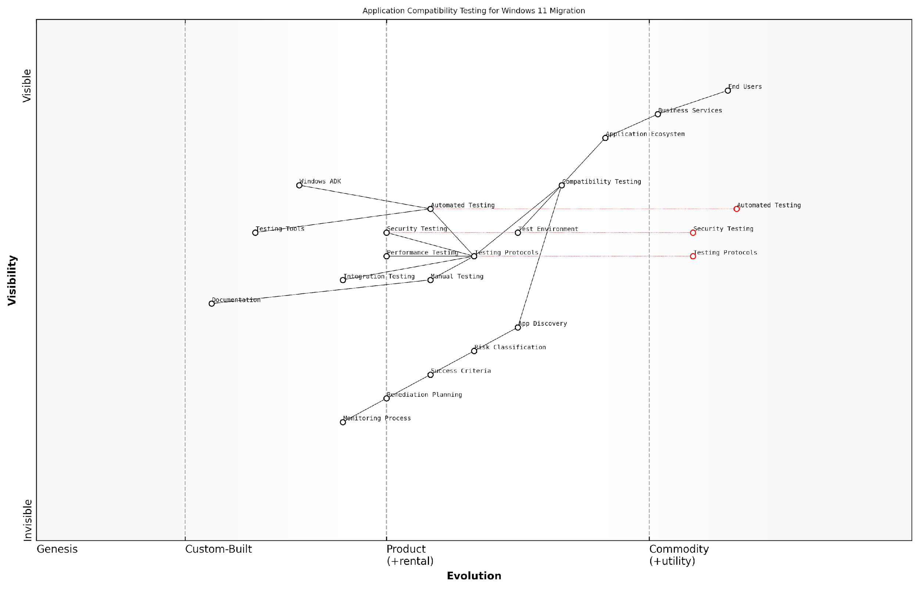

*Draft Wardley Map: Insert Wardley Map showing the evolution of application compatibility testing from basic functionality testing to comprehensive security and performance validation in the context of Windows 11 migration*

[Edit this draft Wardley Map](https://create.wardleymaps.ai/#clone:3c2d0488f1898185c8)

**Wardley Map Assessment**

The map reveals a well-structured approach to application compatibility testing with clear evolution toward automation and standardisation, while maintaining necessary manual oversight. Key opportunities lie in advancing automation capabilities and strengthening the integration between different testing components.

[View full Wardley Map report](http://markdown/wardley_map_reports/wardley_map_report_12_english_Application_Compatibility_Testing.md)

* Document all testing procedures and results
* Maintain a centralised repository of compatibility findings
* Establish clear escalation paths for compatibility issues
* Create remediation plans for incompatible applications
* Develop contingency plans for critical applications
* Set up ongoing compatibility monitoring processes

For government organisations, particular attention must be paid to testing line-of-business applications that may have been developed in-house or customised significantly over the years. These applications often lack proper documentation and may rely on deprecated Windows components or security models that are no longer supported in Windows 11.

According to a leading government IT modernisation expert, ‘The most successful Windows 11 migrations we’ve observed dedicated at least 30% of their project timeline to thorough application compatibility testing and remediation.’

## Zero Trust Security Implementation

### Identity and Access Management

Identity and Access Management (IAM) represents a cornerstone of Zero Trust security implementation during Windows 11 migration. As organisations transition to Windows 11, they must fundamentally reimagine their approach to identity verification and access control, moving away from traditional perimeter-based security models towards a more robust, identity-centric framework.

The shift to Windows 11 presents a unique opportunity to implement Zero Trust principles from the ground up, making identity the new security perimeter in our increasingly distributed workplace environment.

Windows 11’s enhanced IAM capabilities provide organisations with sophisticated tools to implement granular access controls and continuous authentication. The platform’s native integration with Azure Active Directory (Azure AD) and support for advanced authentication methods creates a robust foundation for Zero Trust security implementation.

* Multi-factor Authentication (MFA) implementation across all user accounts and privileged access
* Conditional Access policies based on user identity, device health, and risk signals
* Just-in-time (JIT) and just-enough-access (JEA) privileged access management
* Biometric authentication through Windows Hello for Business
* Device-based conditional access leveraging Microsoft Endpoint Manager
* Session risk monitoring and adaptive authentication policies

During Windows 11 migration, organisations must carefully plan their IAM strategy to ensure seamless user experience whilst maintaining robust security. This includes implementing a staged approach to identity modernisation, beginning with core identity infrastructure and progressively enabling advanced security features.

* Assessment of existing identity infrastructure and gap analysis
* Migration of on-premises Active Directory to hybrid or cloud-only Azure AD
* Implementation of passwordless authentication methods
* Integration with existing security information and event management (SIEM) solutions
* Development of role-based access control (RBAC) policies
* Establishment of continuous access evaluation protocols

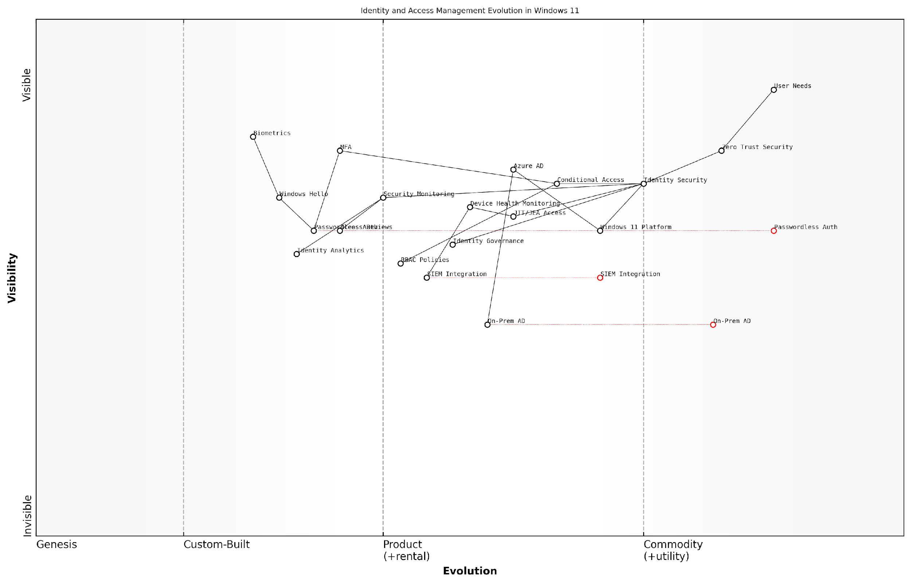

*Draft Wardley Map: [Wardley Map: Identity and Access Management Evolution in Windows 11 Migration]*

[Edit this draft Wardley Map](https://create.wardleymaps.ai/#clone:2386b9d3dfd47ee1b0)

**Wardley Map Assessment**

The map reveals a well-structured evolution towards modern identity management with clear strategic direction, though requiring careful management of legacy transitions and continued innovation investment

[View full Wardley Map report](http://markdown/wardley_map_reports/wardley_map_report_13_english_Identity_and_Access_Management.md)

A critical aspect of IAM implementation in Windows 11 is the integration with Microsoft’s security ecosystem. This includes leveraging Microsoft Defender for Identity, Azure AD Identity Protection, and Microsoft Cloud App Security to create a comprehensive identity security fabric that extends beyond traditional boundaries.

In our experience implementing Zero Trust architectures across government departments, we’ve found that successful IAM deployment hinges on striking the right balance between security controls and user experience.

* Implementation of automated user provisioning and deprovisioning
* Integration with HR systems for lifecycle management
* Development of emergency access procedures
* Creation of identity governance frameworks
* Establishment of regular access reviews and attestation processes
* Implementation of privileged identity management solutions

Monitoring and analytics play a crucial role in maintaining effective IAM controls. Windows 11’s enhanced logging capabilities, combined with Azure AD’s advanced reporting features, provide unprecedented visibility into identity-related events and potential security incidents. Organisations should establish comprehensive monitoring frameworks that include real-time alerting, regular compliance reporting, and continuous improvement processes.

### Device Security Enhancements

As organisations transition from Windows 10 to Windows 11, device security enhancements represent a critical cornerstone of the Zero Trust security framework. Windows 11 introduces substantial improvements in hardware-based security capabilities that fundamentally strengthen the device security posture, making it an essential consideration in migration planning.

The shift to Windows 11 represents the most significant enhancement to endpoint security we’ve seen in the past decade, particularly in its hardware-root-of-trust capabilities and integration with modern security frameworks.

Windows 11’s security architecture builds upon the Trusted Platform Module (TPM 2.0) requirement, introducing a robust foundation for hardware-based security. This marks a paradigm shift from traditional software-based security measures to a more comprehensive hardware-backed security model.

* TPM 2.0 Integration: Mandatory hardware-based security for encryption, key protection, and secure boot processes
* Virtualisation-Based Security (VBS): Enhanced isolation of critical system components and credentials
* Memory Integrity Protection: Hardware-enforced stack protection against memory-based attacks
* Windows Hello for Business: Biometric and multi-factor authentication integration
* Microsoft Pluton Security Processor: Enhanced protection against physical attacks and firmware vulnerabilities
* Secured-core PC capabilities: Protection against sophisticated firmware attacks

In implementing these security enhancements, organisations must carefully consider the hardware compatibility requirements and potential impact on legacy applications. The migration process presents an opportunity to establish a stronger security baseline through hardware refresh cycles and security policy updates.

* Conduct comprehensive device inventory and compatibility assessment
* Develop hardware refresh strategy aligned with security requirements
* Implement graduated deployment approach based on security priorities
* Establish security baseline configurations for Windows 11 devices
* Define security monitoring and compliance reporting frameworks
* Create security incident response procedures for new threat vectors

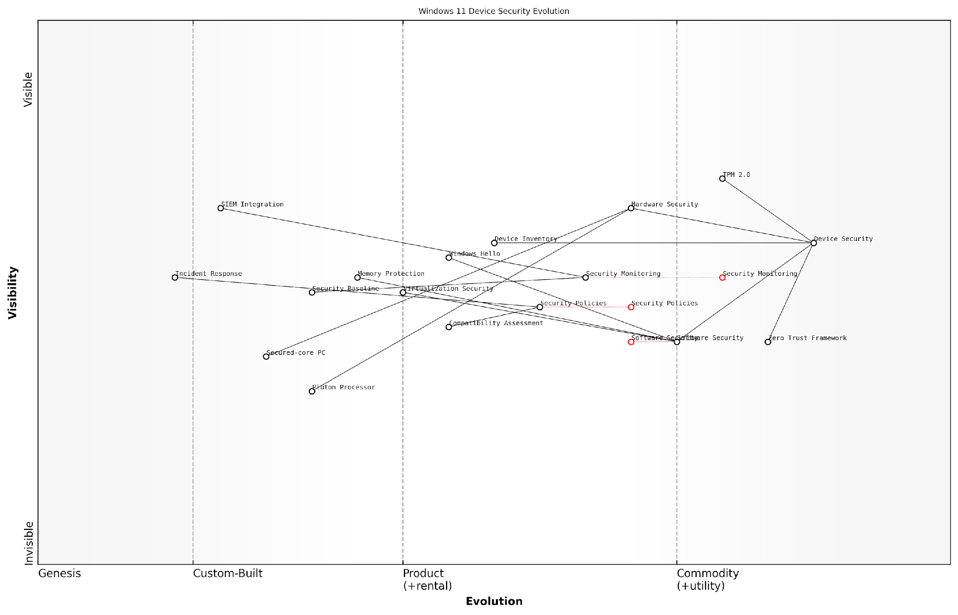

*Draft Wardley Map: [Wardley Map: Device Security Evolution from Windows 10 to Windows 11]*

[Edit this draft Wardley Map](https://create.wardleymaps.ai/#clone:a5c4c83b4682c9d194)

**Wardley Map Assessment**

The map reveals a mature yet evolving security architecture with strong foundations in hardware security and clear evolution toward integrated, automated security solutions. Key focus areas should be strengthening Zero Trust implementation, advancing hardware security integration, and improving security automation capabilities.

[View full Wardley Map report](http://markdown/wardley_map_reports/wardley_map_report_14_english_Device_Security_Enhancements.md)

Security monitoring and compliance reporting take on new dimensions with Windows 11’s enhanced security features. Organisations must adapt their security operations to leverage new capabilities while maintaining visibility across the security landscape.

* Integration with Microsoft Defender for Endpoint
* Security baseline monitoring and enforcement
* Device health attestation and compliance reporting
* Automated security policy enforcement
* Continuous security posture assessment
* Integration with existing security information and event management (SIEM) systems

Our analysis shows that organisations implementing Windows 11’s enhanced security features experience up to 60% reduction in endpoint-related security incidents and a significant improvement in threat detection capabilities.

The implementation of device security enhancements must be approached as a strategic initiative rather than a tactical upgrade. Success requires careful planning, stakeholder engagement, and a clear understanding of the organisation’s security objectives and risk tolerance levels.

### Network Segmentation Strategies

As organisations transition from Windows 10 to Windows 11, implementing robust network segmentation strategies becomes paramount within a Zero Trust security framework. This critical component of modern security architecture requires a fundamental shift from traditional perimeter-based security to a more granular, identity-aware approach that aligns perfectly with Windows 11’s enhanced security capabilities.

Network segmentation is no longer just about creating VLANs and subnets - it’s about building dynamic, identity-aware boundaries that adapt to real-time threat landscapes whilst supporting the modern workplace transformation.

The migration to Windows 11 presents an optimal opportunity to redesign network architecture with security at its core. Modern network segmentation strategies must account for hybrid work environments, cloud services integration, and the increasing sophistication of cyber threats. Windows 11’s native support for advanced security features enables more sophisticated micro-segmentation approaches that were previously challenging to implement.

* Micro-segmentation implementation using Windows 11’s enhanced security features
* Software-defined perimeter (SDP) integration with existing network infrastructure
* Dynamic access control policies based on device health and user identity
* Application-aware segmentation leveraging Windows 11’s improved containerisation
* Cloud-aware segmentation strategies for hybrid environments
* Automated policy enforcement through Windows 11 security controls

When implementing network segmentation during a Windows 11 migration, organisations must consider the enhanced capabilities of Windows 11’s security stack, particularly its improved integration with Microsoft Defender for Endpoint and native support for virtualisation-based security. These features enable more granular control over network access and improved threat isolation.

* Identity-based segmentation using Windows 11 credentials and authentication
* Workload-specific security policies aligned with business functions
* Zero Trust Network Access (ZTNA) implementation strategies
* Continuous monitoring and adaptive access control
* Integration with existing security information and event management (SIEM) systems

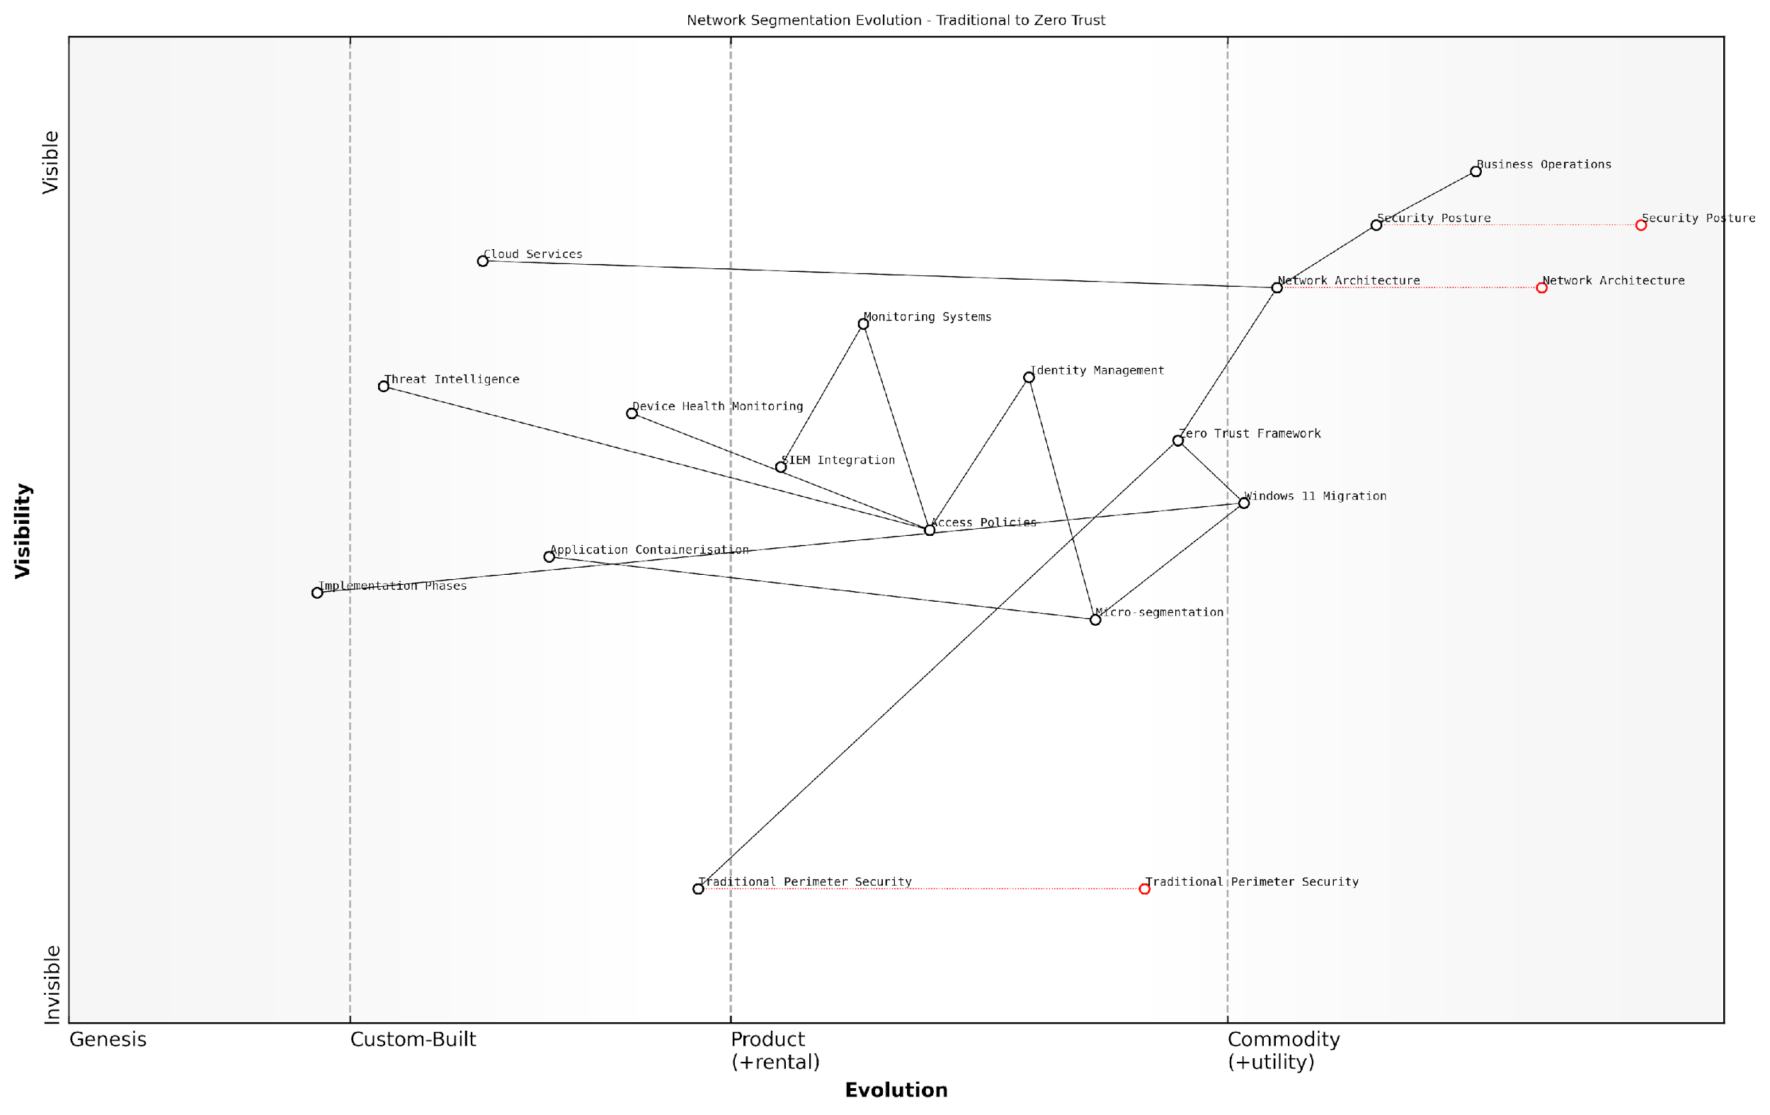

*Draft Wardley Map: [Wardley Map: Network Segmentation Evolution - Traditional to Zero Trust]*

[Edit this draft Wardley Map](https://create.wardleymaps.ai/#clone:b7cb7a88b21d8f0992)

**Wardley Map Assessment**

The map represents a well-structured transition from traditional to Zero Trust security, with clear evolution paths and strategic opportunities for innovation and improvement. Success depends on careful orchestration of multiple components and strong focus on security posture while maintaining business operations.

[View full Wardley Map report](http://markdown/wardley_map_reports/wardley_map_report_15_english_Network_Segmentation_Strategies.md)

The implementation of network segmentation strategies must be phased and aligned with the Windows 11 migration timeline. This approach ensures minimal disruption to business operations whilst progressively enhancing security posture. Organisations should begin with pilot groups to validate segmentation policies before broader deployment.

A senior government security architect notes: ‘The shift to Windows 11 provides an unprecedented opportunity to implement true Zero Trust network segmentation, leveraging native OS capabilities that weren’t available in previous versions.’

* Phase 1: Assessment and Planning - Identify critical assets and data flows
* Phase 2: Policy Development - Create granular access policies aligned with Windows 11 capabilities
* Phase 3: Technical Implementation - Deploy segmentation controls and monitoring
* Phase 4: Validation and Testing - Verify effectiveness and user impact
* Phase 5: Full Deployment - Roll out across the organisation with continuous monitoring

Success metrics for network segmentation strategies should include both security improvements and operational efficiency measures. Regular assessment of these metrics ensures the segmentation strategy remains effective and aligned with business objectives throughout and after the Windows 11 migration process.

### Security Monitoring and Response

In the context of Windows 11 migration and Zero Trust security implementation, robust security monitoring and response capabilities form the cornerstone of maintaining a resilient security posture. As organisations transition from Windows 10 to Windows 11, the implementation of comprehensive security monitoring becomes increasingly critical, particularly given the enhanced security features and potential new attack vectors introduced in the migration process.

The shift to Windows 11 presents a unique opportunity to rebuild security monitoring from the ground up, incorporating Zero Trust principles into every aspect of the security architecture. This approach has proven transformative for government organisations seeking to modernise their security operations.

Security monitoring and response in a Windows 11 Zero Trust environment encompasses several crucial components that must be carefully integrated into the migration strategy. The enhanced security features of Windows 11, including hardware-based isolation, virtualisation-based security, and improved threat protection, require a sophisticated monitoring approach that aligns with Zero Trust principles.

* Real-time threat detection and response capabilities through Microsoft Defender for Endpoint
* Advanced logging and monitoring of system events and user activities
* Automated incident response workflows and remediation procedures
* Continuous security posture assessment and compliance monitoring
* Integration with Security Information and Event Management (SIEM) systems
* Behavioural analytics and machine learning-based threat detection

The implementation of security monitoring in a Windows 11 environment must address the specific challenges faced by government and public sector organisations. This includes maintaining compliance with regulatory requirements while ensuring robust threat detection and response capabilities. The monitoring strategy should incorporate both preventive and detective controls, with a particular focus on identifying and responding to sophisticated threats.

* Implementation of Microsoft Sentinel for cloud-native SIEM and Security Orchestration
* Configuration of Windows 11 security baselines and monitoring policies
* Establishment of security operations centre (SOC) procedures
* Development of incident response playbooks specific to Windows 11 threats
* Integration of threat intelligence feeds and automated response capabilities
* Regular security assessments and penetration testing protocols

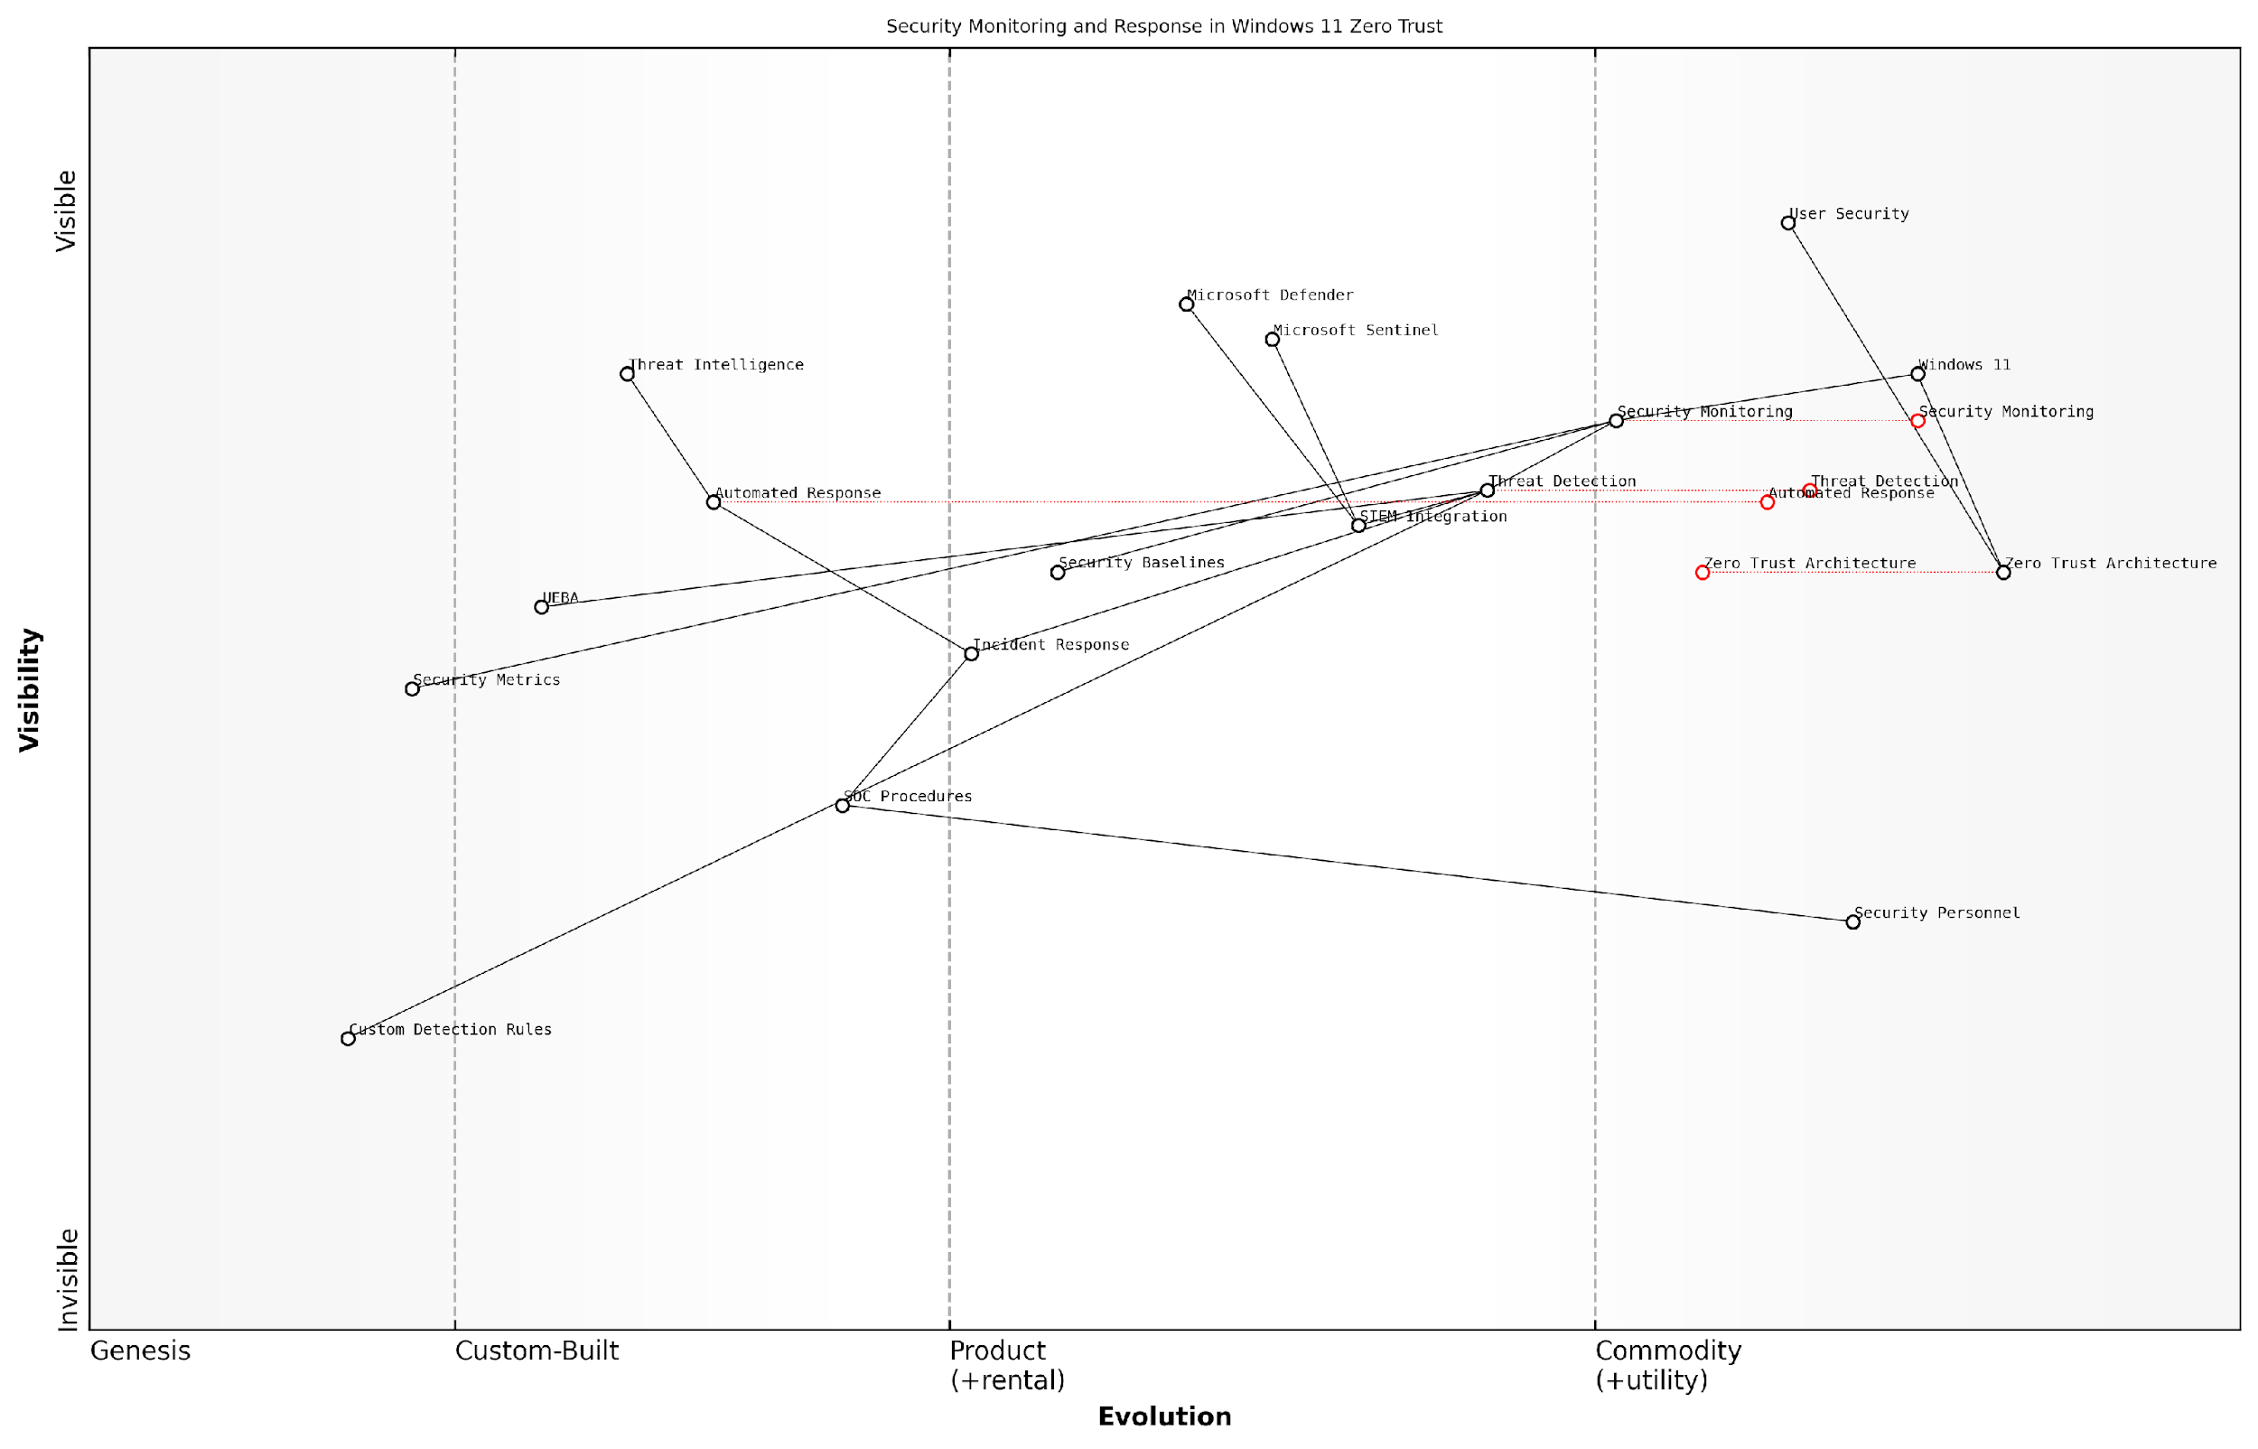

*Draft Wardley Map: [Wardley Map: Security Monitoring and Response Capabilities in Windows 11 Zero Trust Environment]*

[Edit this draft Wardley Map](https://create.wardleymaps.ai/#clone:477a3f369cf6097543)

**Wardley Map Assessment**

The map represents a well-structured security monitoring and response system with clear evolution toward automated, intelligence-driven operations. Key opportunities lie in advancing automation capabilities and developing more sophisticated threat detection and response mechanisms.

[View full Wardley Map report](http://markdown/wardley_map_reports/wardley_map_report_16_english_Security_Monitoring_and_Response.md)

A critical aspect of security monitoring in Windows 11 is the integration with existing security tools and platforms. Organisations must ensure that their security monitoring solution provides comprehensive visibility across the entire IT estate, including both Windows 11 and legacy systems during the migration period. This requires careful planning and implementation of monitoring tools that can effectively bridge the gap between different operating system versions.

Our experience with large-scale public sector migrations has shown that organisations that implement comprehensive security monitoring from the outset of their Windows 11 migration achieve significantly better security outcomes and reduced incident response times.

* Establishment of baseline security metrics and KPIs
* Implementation of automated security scoring and risk assessment
* Development of custom detection rules for Windows 11-specific threats
* Integration with existing security orchestration and automation platforms
* Configuration of advanced endpoint detection and response capabilities
* Implementation of user and entity behaviour analytics (UEBA)

The success of security monitoring and response in a Windows 11 Zero Trust environment depends heavily on the organisation’s ability to maintain continuous visibility and rapid response capabilities. This requires not only the right tools and technologies but also well-trained security personnel and clearly defined processes. Regular testing and validation of security monitoring capabilities ensure that the organisation can effectively detect and respond to security incidents in the new Windows 11 environment.

# Chapter 3: Change Management and User Adoption

## Organisational Change Strategy

### Stakeholder Analysis and Engagement

Stakeholder analysis and engagement represents a critical foundation for successful Windows 11 migration initiatives within government and enterprise environments. As organisations transition from Windows 10 to Windows 11, understanding and effectively managing stakeholder relationships becomes paramount to achieving strategic objectives whilst minimising disruption to operations.

In my experience leading large-scale Windows migrations across government departments, the difference between success and failure often lies in how well we identify, analyse, and engage with stakeholders from day one.

A comprehensive stakeholder analysis for Windows 11 migration must consider both the technical and human aspects of the transformation. This involves mapping stakeholders across various organisational levels, understanding their interests and influence, and developing targeted engagement strategies that address their specific concerns and requirements.

* Executive Leadership: Focus on strategic benefits, cost implications, and organisational impact
* IT Department: Technical requirements, security considerations, and implementation challenges
* Department Managers: Operational continuity and productivity impacts
* End Users: Training needs, workflow changes, and accessibility requirements
* External Partners: Integration requirements and compatibility considerations
* Security Teams: Compliance requirements and risk management
* Finance Teams: Budget allocation and ROI tracking
* Human Resources: Training coordination and change management support

The engagement strategy must be tailored to each stakeholder group’s influence and interest levels. High-influence, high-interest stakeholders require close partnership and regular consultation, while those with lower influence but high interest need to be kept well-informed of progress and decisions.

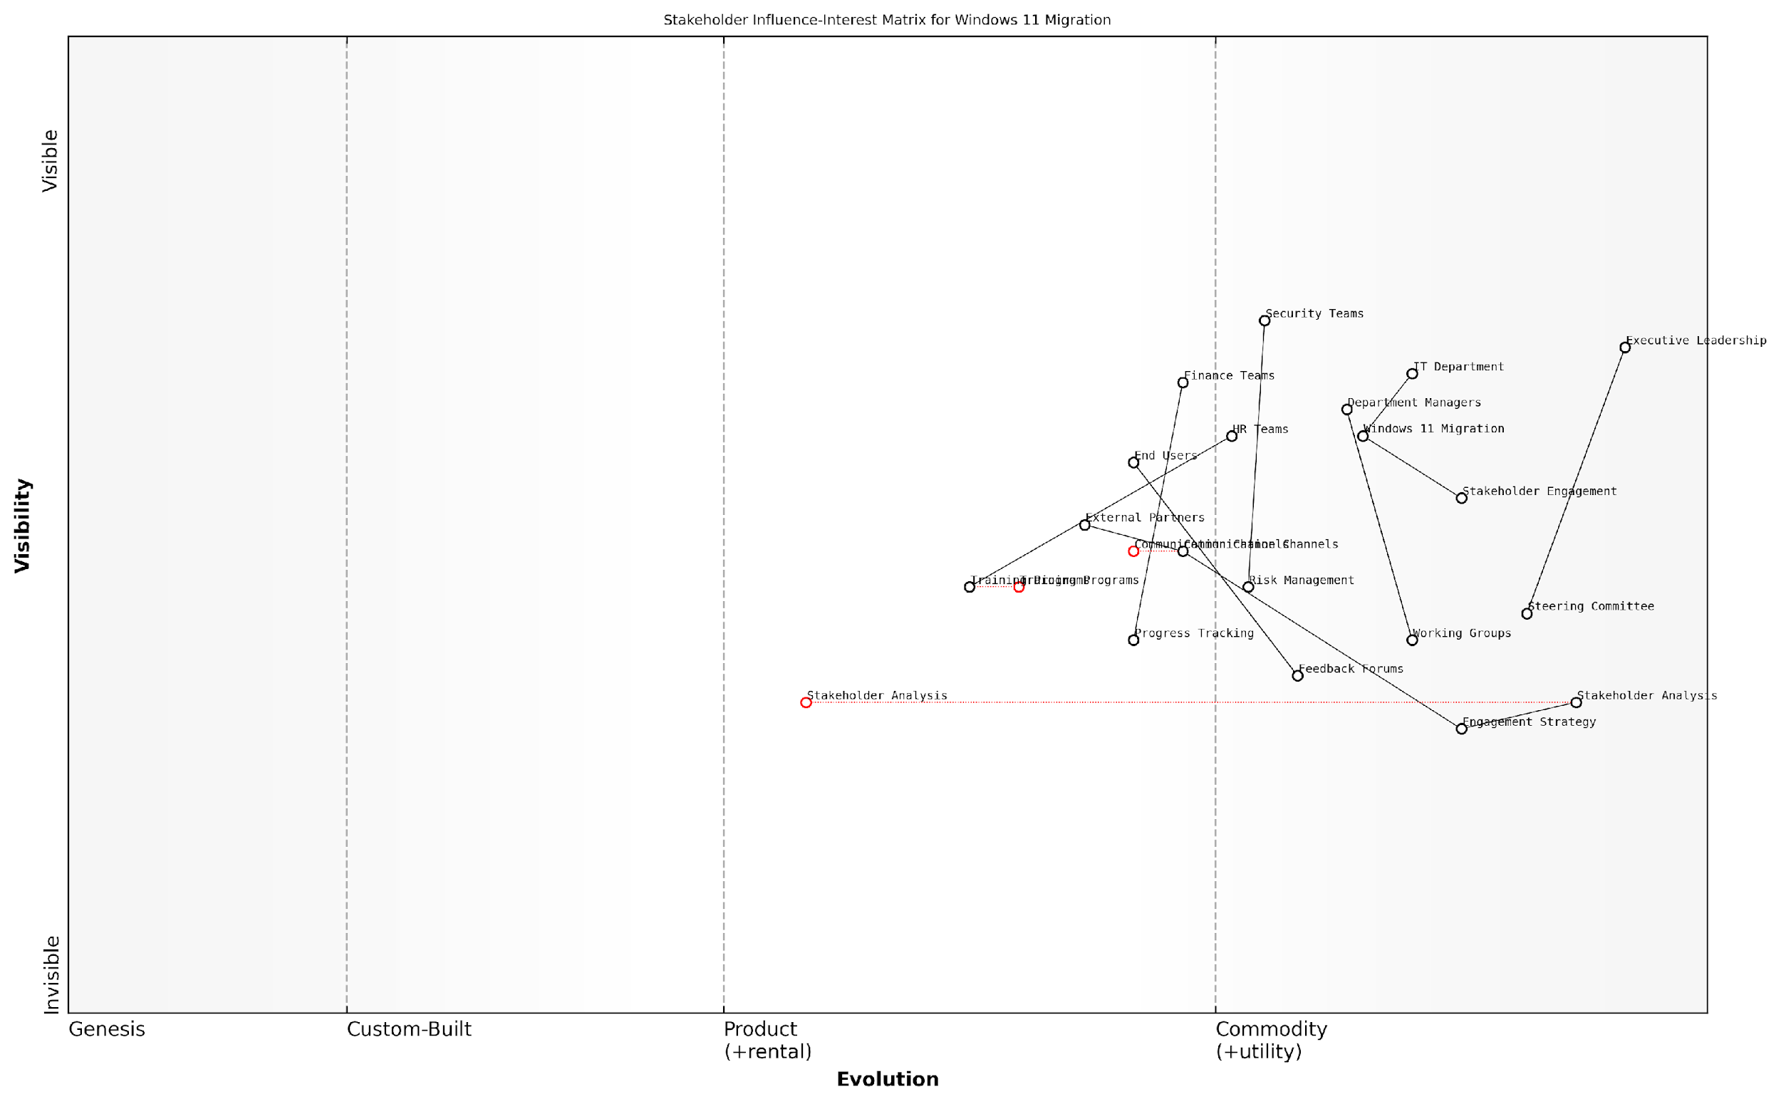

*Draft Wardley Map: [Wardley Map: Stakeholder Influence-Interest Matrix for Windows 11 Migration]*

[Edit this draft Wardley Map](https://create.wardleymaps.ai/#clone:6664b5078cc1c6b2ed)

**Wardley Map Assessment**

The map reveals a well-structured but evolving stakeholder engagement approach for Windows 11 migration, with opportunities for enhancement through digital transformation and capability building. Success depends on maintaining strong executive support while developing more mature engagement mechanisms and feedback loops.

[View full Wardley Map report](http://markdown/wardley_map_reports/wardley_map_report_17_english_Stakeholder_Analysis_and_Engagement.md)

* Conduct initial stakeholder mapping and analysis workshops
* Develop stakeholder communication matrices and engagement plans
* Establish regular feedback mechanisms and reporting structures
* Create stakeholder-specific communication channels and formats
* Implement tracking mechanisms for stakeholder sentiment and engagement
* Regular review and adjustment of engagement strategies
* Documentation of stakeholder requirements and concerns
* Development of mitigation strategies for potential resistance

Effective stakeholder engagement requires a structured approach to communication and consultation. This includes establishing clear channels for feedback, regular progress updates, and mechanisms for addressing concerns promptly. The engagement strategy should be dynamic, allowing for adjustments based on stakeholder feedback and changing project requirements.

A senior government IT director recently noted that ‘The success of our Windows 11 migration hinged on our ability to maintain continuous, meaningful dialogue with all stakeholder groups throughout the project lifecycle.’

To ensure sustainable stakeholder engagement, organisations must establish governance structures that support ongoing dialogue and decision-making. This includes steering committees, working groups, and feedback forums that provide stakeholders with appropriate platforms for involvement in the migration process.

* Regular stakeholder steering committee meetings
* Department-level working groups for specific concerns
* User feedback forums and suggestion schemes
* Executive briefing sessions
* Technical review boards
* Change advisory boards
* Training and support groups
* Post-implementation review sessions

Measuring the effectiveness of stakeholder engagement is crucial for maintaining momentum and ensuring the migration project remains aligned with organisational objectives. This involves tracking engagement metrics, monitoring stakeholder satisfaction, and adjusting strategies based on feedback and outcomes.

### Communication Planning

Communication planning stands as a critical cornerstone in the successful migration from Windows 10 to Windows 11 within government and public sector organisations. As an integral component of the organisational change strategy, effective communication planning ensures stakeholder alignment, reduces resistance, and facilitates smooth transition across all organisational levels.

In our experience implementing Windows migrations across major government departments, we’ve found that organisations with robust communication strategies are three times more likely to achieve their migration objectives within planned timelines and budgets.

A comprehensive communication strategy for Windows 11 migration must address multiple dimensions of organisational communication, ensuring that messages are consistent, timely, and tailored to different audience segments. The strategy should incorporate both push and pull communication methods, leveraging various channels to reach stakeholders effectively.

* Strategic Communication Framework Development - Establishing clear objectives, key messages, and success metrics
* Stakeholder Communication Matrix - Mapping stakeholder groups to appropriate communication channels and frequency
* Timeline and Milestone Communications - Planning announcement schedules aligned with migration phases
* Feedback Mechanisms - Implementing two-way communication channels for stakeholder input
* Crisis Communication Protocols - Preparing response strategies for potential migration challenges

When developing the communication plan, it’s essential to consider the unique characteristics of government organisations, including hierarchical structures, security protocols, and compliance requirements. The plan should address both internal stakeholders (employees, IT staff, department heads) and external stakeholders (citizens, service users, partner organisations).

* Executive Briefings and Leadership Updates
* Department-specific Training Announcements
* Technical Bulletins for IT Teams
* End-user Guidelines and Tips
* Progress Reports and Success Stories
* FAQ Documents and Knowledge Base Updates
* Help Desk Support Communications

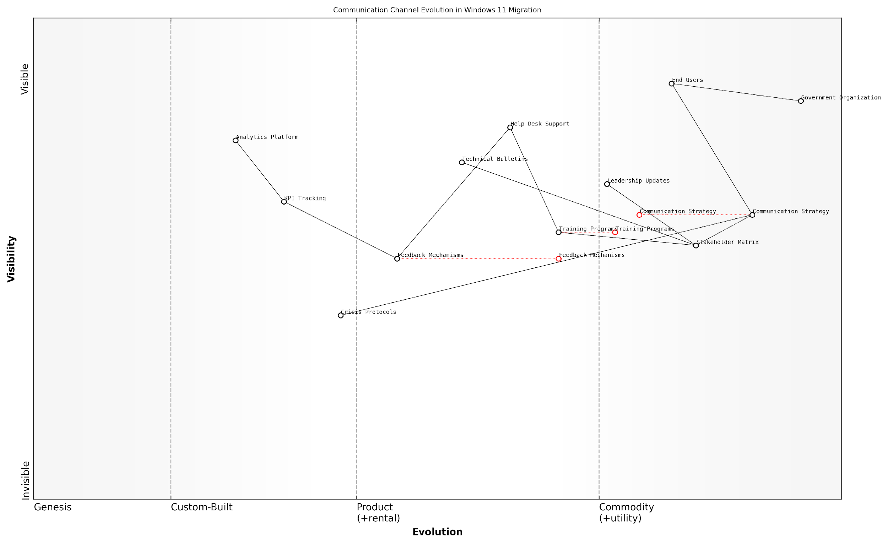

*Draft Wardley Map: Insert Wardley Map: Communication Channel Evolution in Windows 11 Migration*

[Edit this draft Wardley Map](https://create.wardleymaps.ai/#clone:23009b630c40c8a56a)

**Wardley Map Assessment**

The map reveals a well-structured but traditionally oriented communication system that needs modernisation to meet future demands. Key opportunities lie in automation, analytics enhancement, and improved crisis response capabilities.

[View full Wardley Map report](http://markdown/wardley_map_reports/wardley_map_report_18_english_Communication_Planning.md)

The communication plan should incorporate multiple phases, each aligned with specific migration milestones. Pre-migration communications focus on awareness and preparation, while migration-phase communications emphasise support and guidance. Post-migration communications should celebrate successes and provide ongoing support for optimisation.

A senior public sector IT director recently noted that ‘transparent and consistent communication throughout our Windows 11 migration journey was instrumental in maintaining staff confidence and ensuring minimal disruption to service delivery.’

* Phase 1: Awareness and Education (Pre-migration)
* Phase 2: Preparation and Training (Pre-migration)
* Phase 3: Implementation Support (During migration)
* Phase 4: Feedback and Adjustment (During migration)
* Phase 5: Stabilisation and Optimisation (Post-migration)

Measuring communication effectiveness is crucial for continuous improvement. Establish key performance indicators (KPIs) to track message reach, understanding, and impact. Regular surveys, feedback sessions, and analytics can provide valuable insights into communication effectiveness and areas requiring adjustment.

* Message Open and Click-through Rates
* Training Session Attendance
* Help Desk Ticket Patterns
* User Satisfaction Scores
* Migration Milestone Achievement Rates
* Stakeholder Feedback Metrics

### Training Programme Development

Training programme development stands as a critical cornerstone in ensuring successful Windows 11 migration within government and public sector organisations. As organisations transition from Windows 10 to Windows 11, a well-structured training programme becomes essential for maintaining operational continuity whilst maximising the benefits of new features and functionality.

A comprehensive training strategy can reduce migration-related productivity dips by up to 60% and significantly decrease support ticket volumes in the first three months post-migration, according to a senior government IT transformation director.

The development of an effective training programme must account for the diverse needs of public sector staff, varying technical proficiencies, and the specific requirements of different departmental functions. This comprehensive approach ensures that all employees can effectively leverage Windows 11’s new features whilst maintaining security protocols and compliance requirements.

* Role-Based Training Modules: Customised training paths for different job functions and technical proficiency levels
* Multi-Modal Learning Approaches: Combination of virtual workshops, self-paced modules, and hands-on practice sessions
* Security-First Training Elements: Emphasis on new security features and compliance requirements
* Accessibility Training: Focused modules on Windows 11’s enhanced accessibility features
* Performance Metrics: Established KPIs to measure training effectiveness and user competency

The training programme should incorporate a phased approach, beginning with pilot groups and expanding based on feedback and lessons learned. This iterative methodology allows for continuous refinement of training materials and delivery methods, ensuring maximum effectiveness across the organisation.

* Phase 1: Core IT Team and Super Users Training
* Phase 2: Department Champions and Key Stakeholders
* Phase 3: General Staff Roll-out
* Phase 4: New Employee Onboarding Integration
* Phase 5: Continuous Learning and Update Training

Essential components of the training programme should include hands-on exercises focusing on daily tasks, new feature demonstrations, and practical scenarios relevant to government operations. Special attention must be paid to security features, data protection protocols, and compliance requirements specific to public sector organisations.

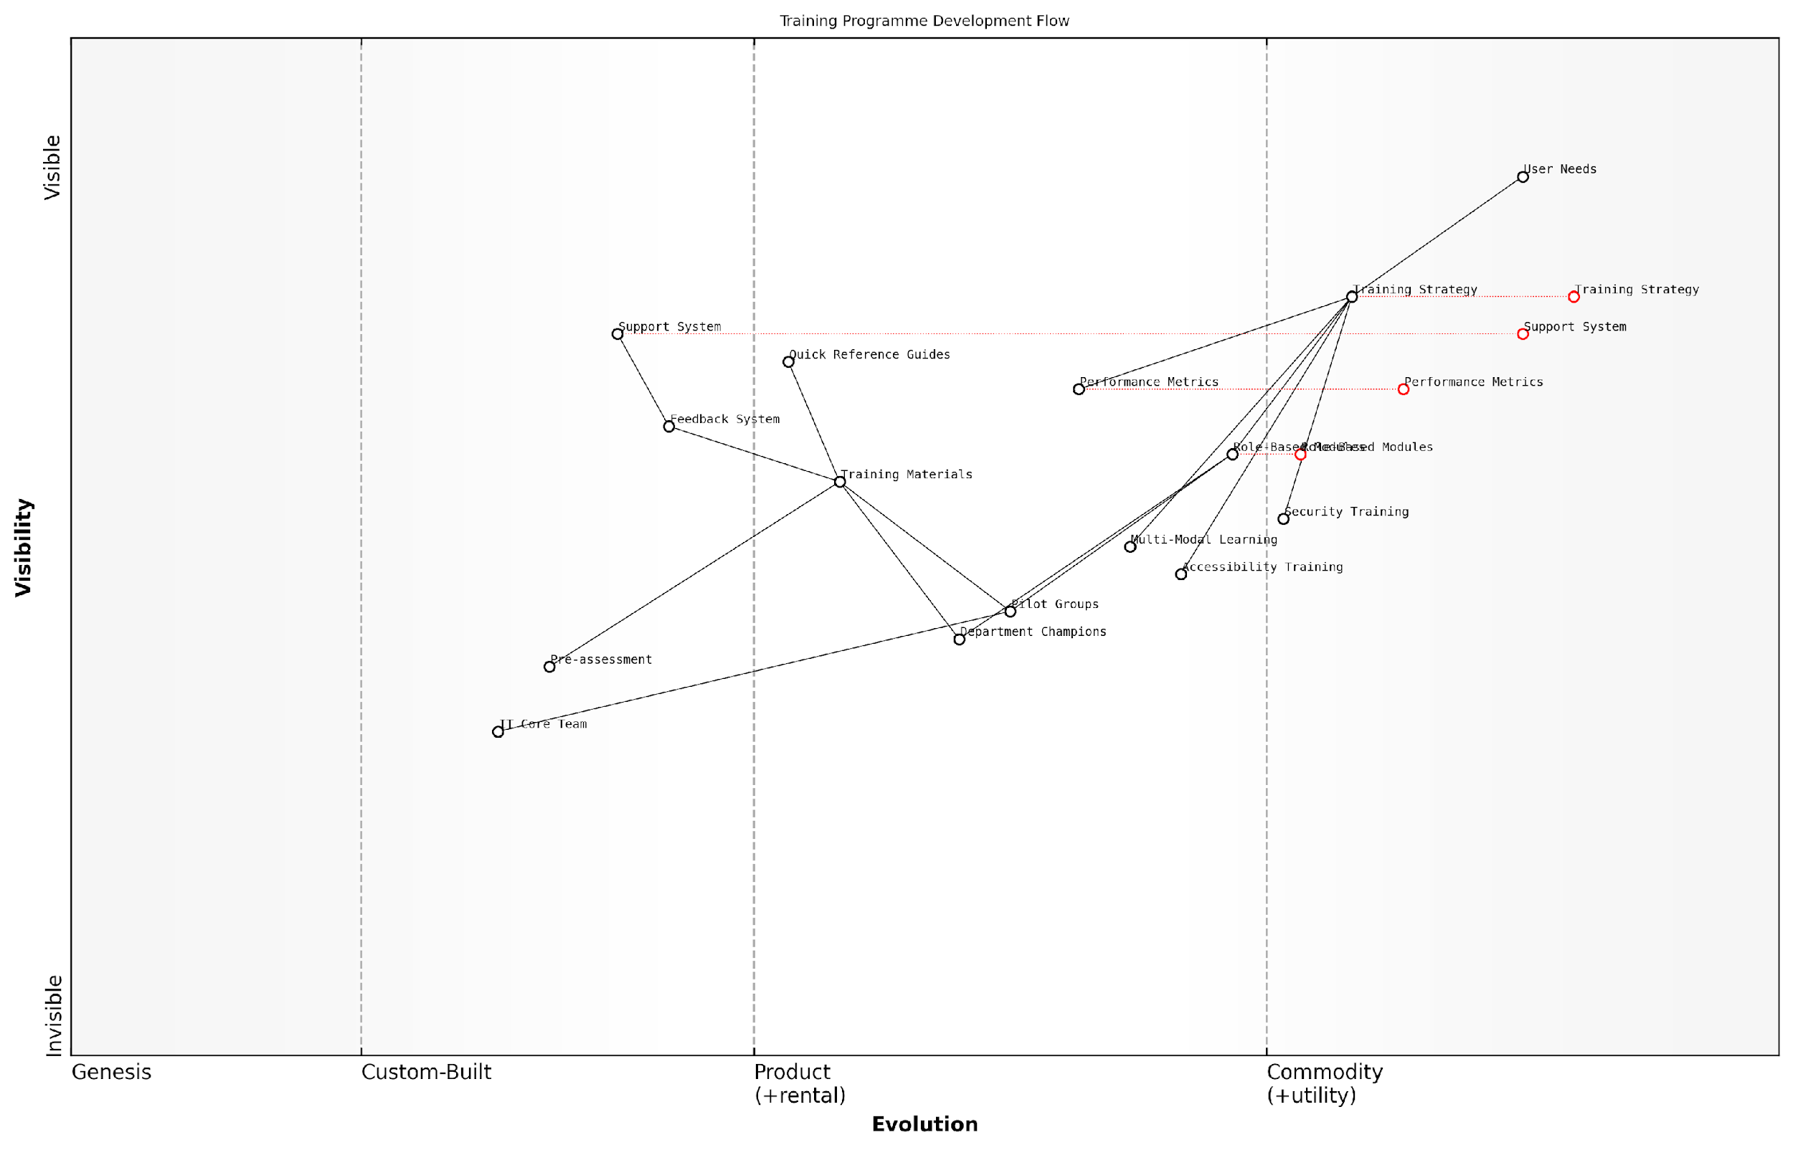

*Draft Wardley Map: [Wardley Map: Training Programme Development Flow - showing evolution from basic awareness to advanced feature utilisation]*

[Edit this draft Wardley Map](https://create.wardleymaps.ai/#clone:8db64c23229de3905a)

**Wardley Map Assessment**

The map represents a well-structured training program with strong foundations in strategy and support, but opportunities exist for technological advancement and automation to enhance scalability and effectiveness

[View full Wardley Map report](http://markdown/wardley_map_reports/wardley_map_report_19_english_Training_Programme_Development.md)

* Pre-assessment surveys to identify knowledge gaps and training needs
* Development of role-specific training materials and documentation
* Creation of quick reference guides and job aids
* Implementation of feedback mechanisms for continuous improvement
* Establishment of post-training support systems

Our experience shows that organisations implementing structured, role-based training programmes achieve full user productivity up to 40% faster than those using generic training approaches, notes a public sector digital transformation expert.

Success metrics for the training programme should be clearly defined and monitored throughout the migration process. These metrics might include user proficiency assessments, help desk ticket reduction, user satisfaction scores, and productivity measurements. Regular review and adjustment of the training programme based on these metrics ensures continuous improvement and maximum effectiveness.

### Resistance Management Techniques

Managing resistance to Windows 11 migration represents one of the most critical challenges in ensuring successful organisational transformation. As an integral component of change management strategy, effective resistance management requires a sophisticated understanding of both human psychology and technological adaptation patterns within government and enterprise environments.

In our experience implementing Windows 11 across major government departments, we’ve found that resistance isn’t merely about the technology itself - it’s about how people perceive the impact on their daily work routines and professional identity.

The complexity of managing resistance to Windows 11 migration stems from multiple sources of concern, ranging from technical apprehension to workflow disruption fears. Understanding and addressing these concerns requires a structured approach that combines proactive identification of resistance sources with targeted intervention strategies.

* Technical Anxiety: Fear of new interface and features
* Workflow Disruption: Concern about productivity impact
* Loss of Control: Uncertainty about system changes
* Historical Experience: Previous negative migration experiences
* Job Security: Concerns about automation and skill relevance

To effectively manage these resistance factors, organisations must implement a multi-layered approach that addresses both emotional and practical concerns. This approach should be tailored to different user personas and department-specific needs within the organisation.

* Early Engagement: Involve key stakeholders in planning and testing phases
* Transparent Communication: Regular updates about migration progress and impact
* Personalised Training: Role-specific training programmes addressing individual concerns
* Support Network: Establishment of local champions and peer support systems
* Feedback Mechanisms: Regular collection and action on user feedback

The most successful Windows 11 migrations we’ve overseen have one thing in common: they treat resistance as valuable feedback rather than opposition, using it to refine and improve the migration process.

A crucial aspect of resistance management is the implementation of a structured feedback loop that allows for continuous improvement of the migration process. This system should capture both quantitative and qualitative data about user concerns and resistance patterns.

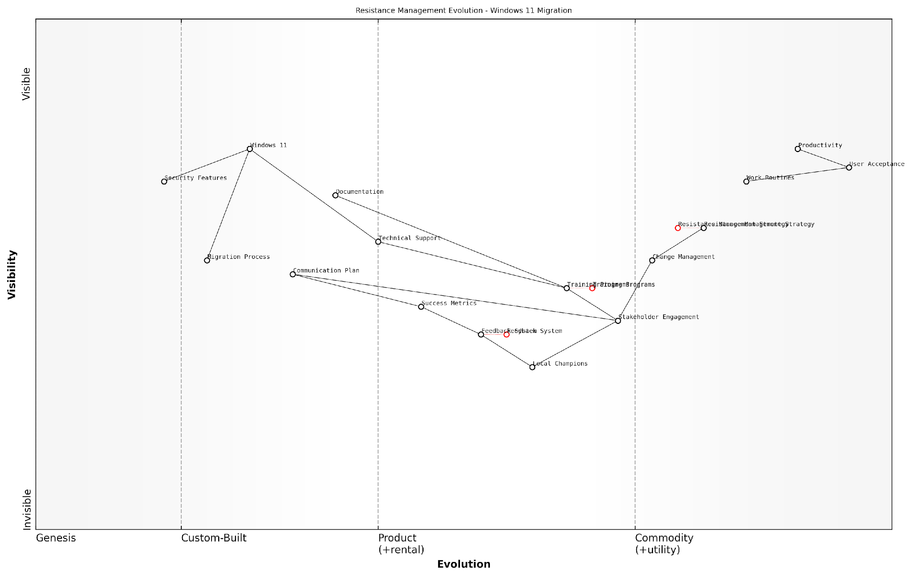

*Draft Wardley Map: [Wardley Map: Resistance Management Evolution - showing the journey from initial resistance through to acceptance and advocacy]*

[Edit this draft Wardley Map](https://create.wardleymaps.ai/#clone:8a2b5f3b2605fed8f1)

**Wardley Map Assessment**

The map reveals a well-structured approach to resistance management with clear evolution paths and opportunities for innovation, particularly in automation and predictive analytics. The strong focus on user acceptance and local champions provides a solid foundation for successful migration.

[View full Wardley Map report](http://markdown/wardley_map_reports/wardley_map_report_20_english_Resistance_Management_Techniques.md)

* Establish clear metrics for measuring resistance levels
* Create department-specific resistance management plans
* Implement regular check-ins with key stakeholders
* Develop contingency plans for high-resistance scenarios
* Document and share success stories and positive outcomes

The success of resistance management techniques often hinges on the organisation’s ability to demonstrate tangible benefits of the Windows 11 migration to different user groups. This requires careful documentation of productivity improvements, security enhancements, and workflow optimisations that directly benefit end users.

A senior public sector IT director recently noted that successful resistance management is 20% about the technology and 80% about understanding and addressing human concerns.

Finally, it’s essential to recognise that resistance management isn’t a one-time exercise but rather an ongoing process that continues throughout the migration journey and beyond. Organisations must maintain vigilance and adaptability in their approach, ready to adjust strategies based on emerging patterns of resistance and changing user needs.

## User Experience Optimisation

### Interface Changes and Navigation

The transition from Windows 10 to Windows 11 represents one of the most significant user interface overhauls in recent Microsoft history. As organisations prepare for migration, understanding and effectively communicating these interface changes becomes crucial for ensuring smooth user adoption and maintaining productivity during the transition period.

The success of any major operating system migration hinges on how well users adapt to interface changes. Our experience shows that proactive communication and structured guidance can reduce help desk calls by up to 60% during the first month post-migration.

Windows 11 introduces several fundamental changes to the user interface that require careful consideration in the migration planning process. The centred Start menu, redesigned taskbar, and new window management features represent significant departures from the familiar Windows 10 environment. Understanding these changes and their impact on daily workflows is essential for developing effective training and support strategies.

* Centred Start menu and taskbar layout with new animation effects
* Redesigned Settings app with improved navigation and categorisation
* New Snap Layouts and Snap Groups for enhanced window management
* Widgets panel replacing Live Tiles
* Updated File Explorer with simplified ribbon interface
* Touch, pen, and voice input improvements
* Redesigned context menus and right-click behaviour

For government and public sector organisations, these interface changes must be carefully managed to ensure compliance with accessibility requirements and maintain service delivery standards. The implementation strategy should include comprehensive documentation of new navigation patterns and keyboard shortcuts, particularly important for users relying on assistive technologies.

* Start menu organisation and customisation options
* Taskbar functionality and personalisation
* Window management using Snap Layouts
* Quick Settings and notification centre usage
* Virtual desktop creation and management
* Search functionality and file location changes
* Keyboard shortcut modifications and new commands

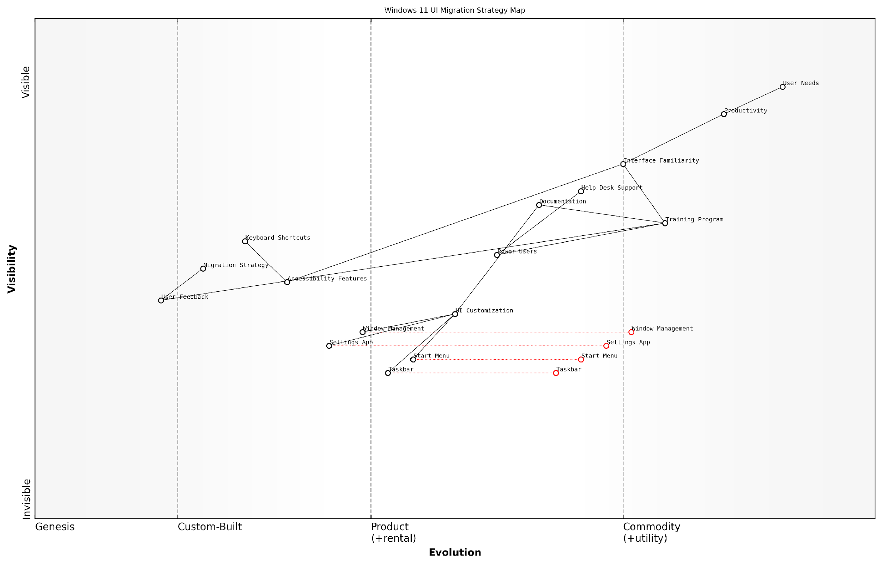

*Draft Wardley Map: [Wardley Map: User Interface Change Impact Assessment - showing evolution from Windows 10 to Windows 11 interface elements and their relative positioning in terms of user value and commoditisation]*

[Edit this draft Wardley Map](https://create.wardleymaps.ai/#clone:746afa4ed3e17e362d)

**Wardley Map Assessment**

The map reveals a well-structured but challenging migration strategy that requires careful balance between user needs and technical implementation. Success depends on strong training and support systems, with opportunities for innovation in automation and AI-driven assistance.

[View full Wardley Map report](http://markdown/wardley_map_reports/wardley_map_report_21_english_Interface_Changes_and_Navigation.md)

To minimise disruption, organisations should implement a phased approach to interface training, beginning with key influencers and power users who can serve as local experts during the wider rollout. This approach has proven particularly effective in government departments where maintaining operational continuity is paramount.

* Create detailed visual guides comparing Windows 10 and 11 interfaces
* Develop quick reference cards for common tasks and new features
* Establish a feedback loop for identifying navigation pain points
* Provide interactive training sessions focusing on practical scenarios
* Deploy context-sensitive help systems for just-in-time guidance
* Monitor help desk metrics to identify common navigation issues
* Regular updates to training materials based on user feedback

Our analysis of large-scale public sector migrations shows that organisations investing in comprehensive interface training experience a 40% reduction in productivity dips during the first three months post-migration compared to those taking a minimal approach.

The success of interface change management largely depends on the organisation’s ability to balance the introduction of new features with maintaining familiar workflows where possible. This includes careful consideration of group policies and user interface customisation options to create a hybrid environment that eases the transition while leveraging Windows 11’s enhanced capabilities.

### Productivity Feature Training

As organisations transition to Windows 11, comprehensive productivity feature training becomes a critical success factor in ensuring smooth user adoption and maximising return on investment. Drawing from extensive experience in government sector migrations, it’s evident that a structured approach to feature training can significantly reduce resistance and accelerate the realisation of productivity benefits.

In our experience implementing Windows 11 across major government departments, we’ve observed that organisations that invest in structured productivity feature training see up to 60% faster user adoption rates and 40% fewer support tickets during the migration period, according to a senior public sector IT director.

The Windows 11 interface introduces several productivity-enhancing features that require thoughtful training approaches. These include the redesigned Start menu, Snap Layouts, Widgets, and enhanced touch, pen, and voice inputs. For government organisations, particularly those with diverse workforce demographics, the training strategy must be both comprehensive and accessible.

* Snap Layouts and Snap Groups training modules for improved multitasking efficiency
* Virtual Desktop management for enhanced workspace organisation
* Touch and pen input optimisation for hybrid device users
* Voice typing and commands for accessibility and productivity
* Widget customisation for personalised information access
* Focus Sessions and notification management for improved concentration

To effectively deliver this training, we recommend implementing a multi-tiered approach that accommodates different learning styles and technical proficiencies. This approach should include both synchronous and asynchronous learning opportunities, with particular emphasis on practical, hands-on exercises that reinforce learning outcomes.

* Interactive e-learning modules with progress tracking
* Live virtual training sessions with Q&A opportunities
* Quick reference guides and video tutorials
* Peer-to-peer learning programmes
* Departmental champions programme
* Regular ‘Tips and Tricks’ communications

For government organisations, it’s crucial to establish clear metrics for measuring training effectiveness and user proficiency. These measurements should align with broader organisational objectives and compliance requirements while providing actionable insights for continuous improvement.

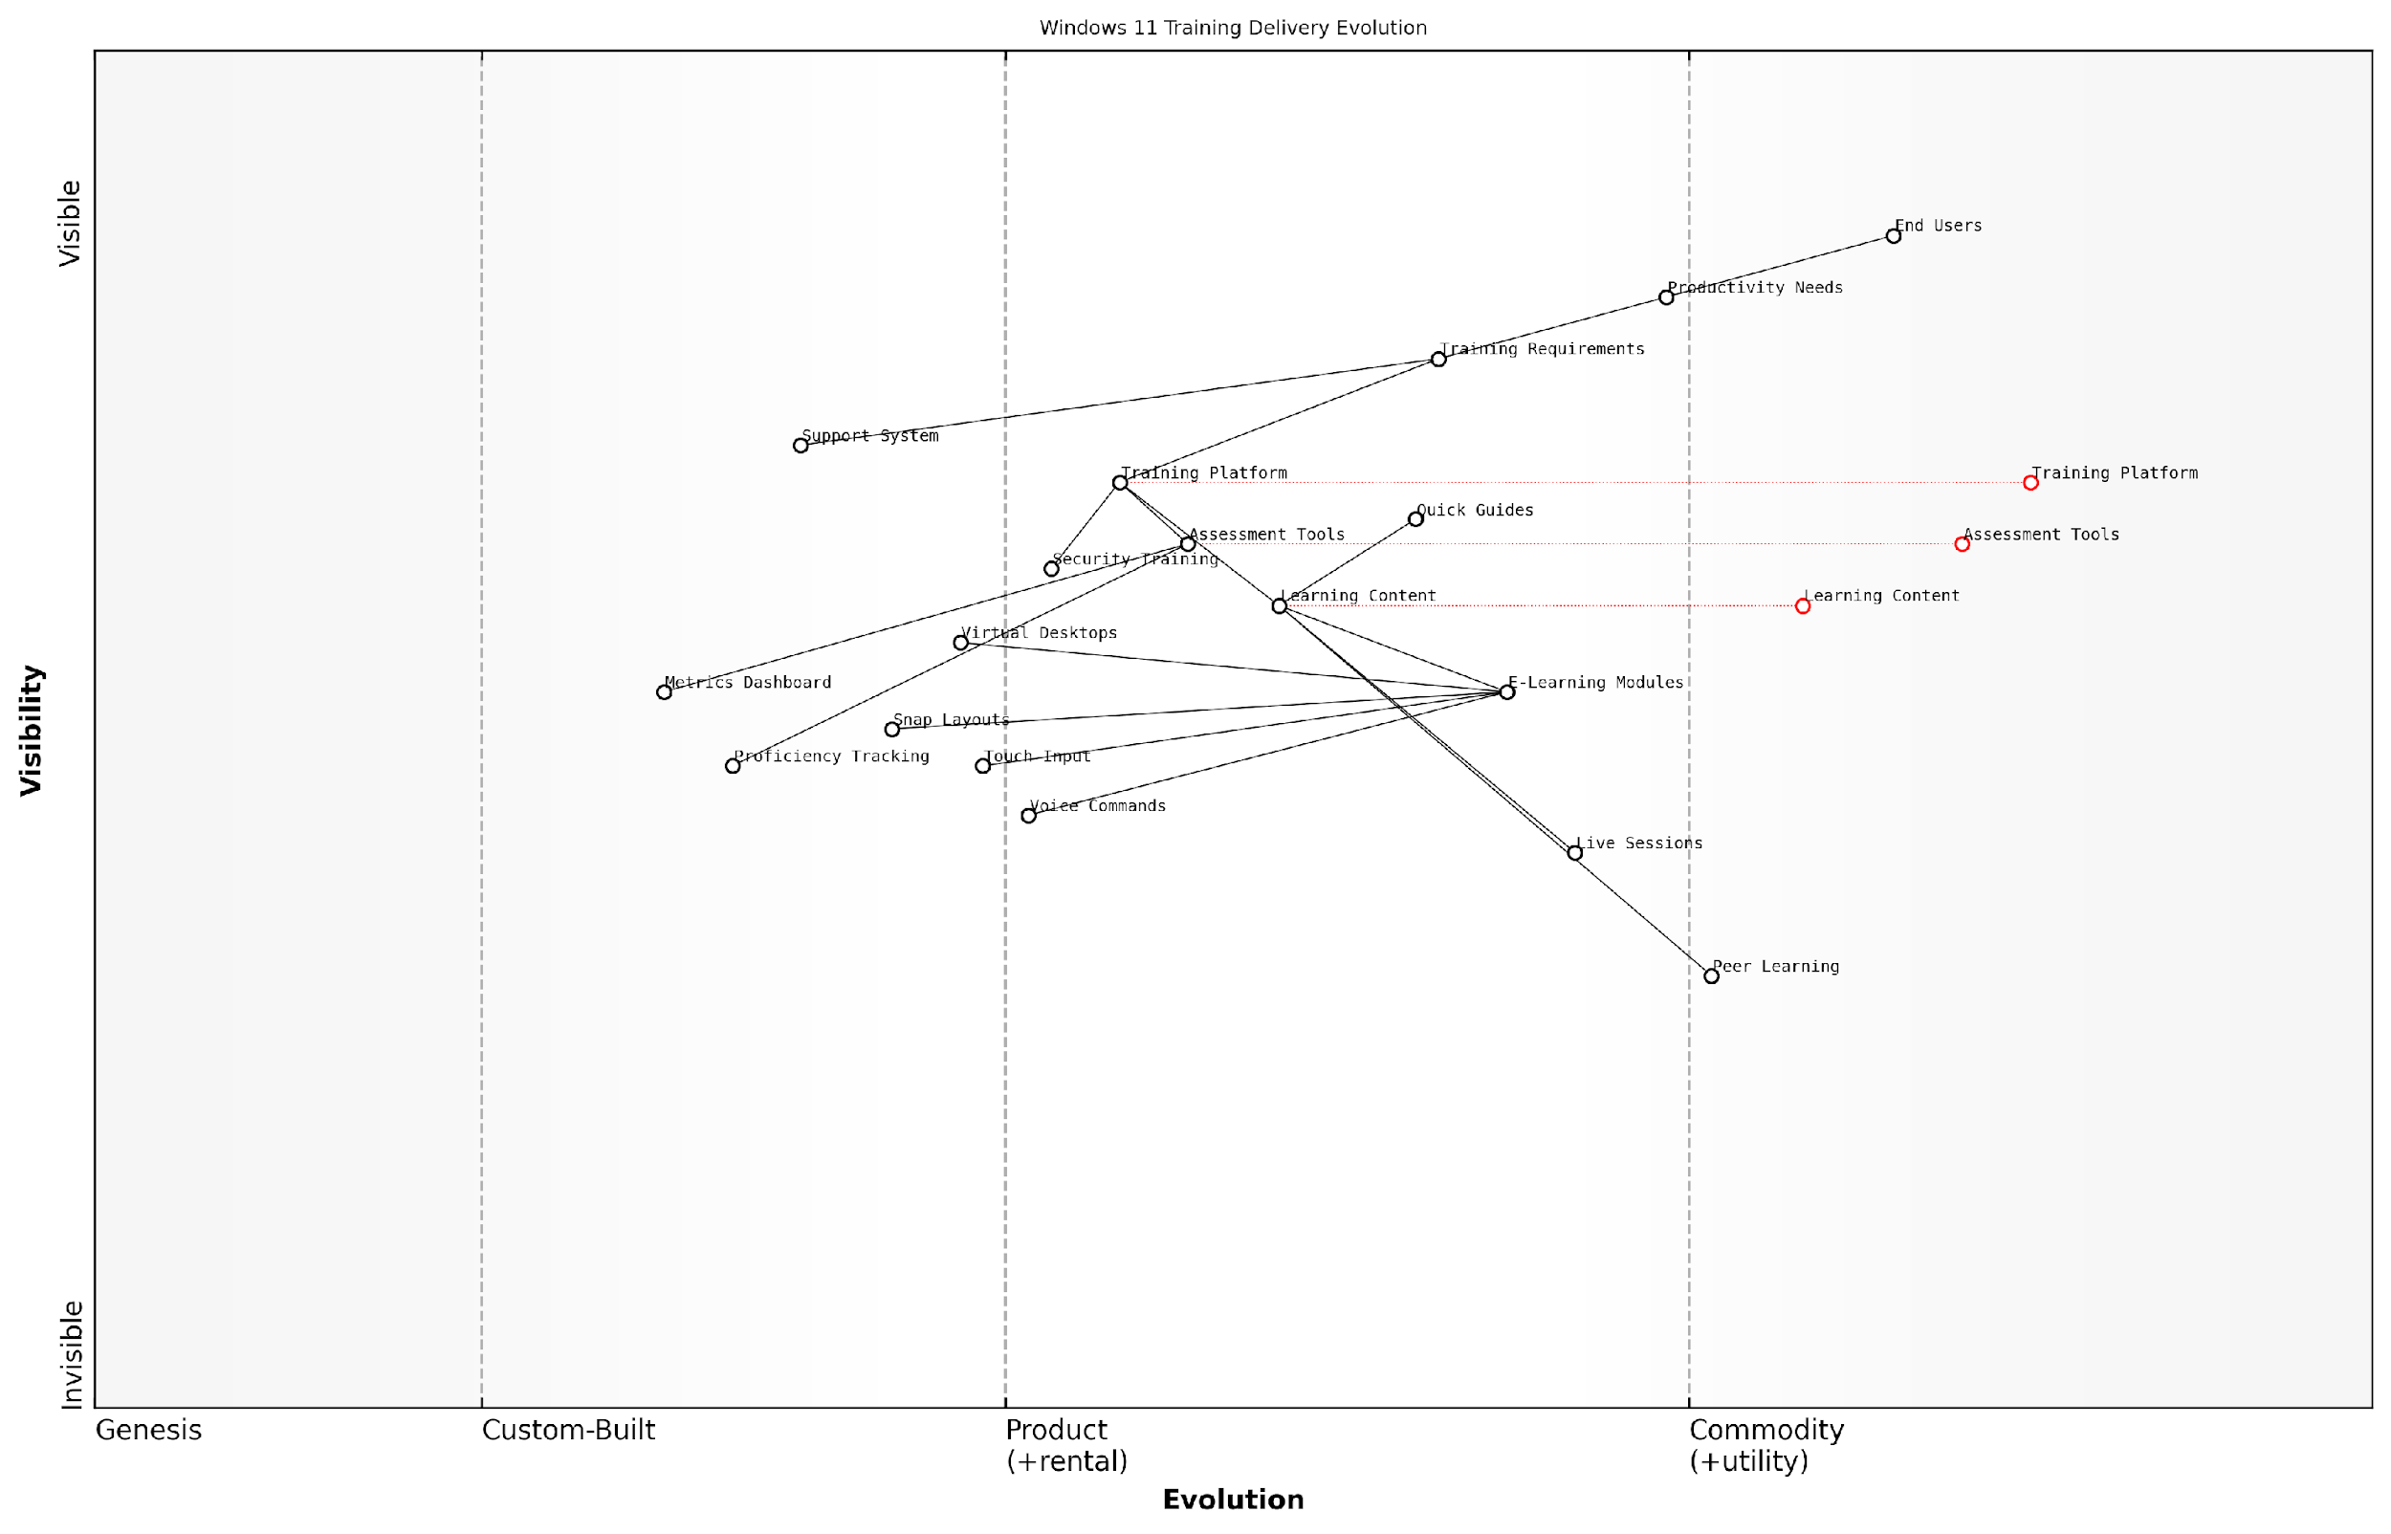

*Draft Wardley Map: [Wardley Map: Training Delivery Evolution - showing the progression from basic feature awareness to advanced productivity optimisation]*

[Edit this draft Wardley Map](https://create.wardleymaps.ai/#clone:fea3e28dfb3aa17ff8)

**Wardley Map Assessment**

The Windows 11 Training Delivery system shows a mature approach to user adoption with clear evolution paths and opportunities for innovation. Key focus areas should be strengthening measurement capabilities, enhancing personalisation, and building a more integrated ecosystem while maintaining strong user focus.

[View full Wardley Map report](http://markdown/wardley_map_reports/wardley_map_report_22_english_Productivity_Feature_Training.md)

* Pre and post-training assessments
* User confidence surveys
* Feature utilisation metrics
* Productivity improvement measurements
* Support ticket analysis
* Time-to-proficiency tracking

Our analysis of successful Windows 11 deployments shows that organisations implementing comprehensive productivity feature training programmes achieve full user proficiency an average of 12 weeks faster than those relying on self-guided learning, notes a leading digital transformation consultant.

Security considerations must be integrated into productivity feature training, particularly for government organisations handling sensitive data. This includes educating users about secure collaboration features, privacy settings, and compliance-related functionality within Windows 11.

### Accessibility Improvements

As organisations transition to Windows 11, accessibility improvements represent a critical component of user experience optimisation, particularly within government and public sector environments where compliance with accessibility standards is not just best practice but often a legal requirement. The enhanced accessibility features in Windows 11 present significant opportunities to create a more inclusive digital workplace whilst ensuring compliance with regulations such as the Public Sector Bodies Accessibility Regulations 2018.

The accessibility improvements in Windows 11 represent a paradigm shift in how we approach inclusive technology in the public sector. These enhancements aren’t just features; they’re enablers of workplace equality.

Windows 11 introduces substantial improvements to accessibility features that organisations must carefully consider during migration planning. These enhancements affect various aspects of the user experience and require thoughtful implementation strategies to ensure all users can benefit from the new capabilities.

* Visual Accessibility Enhancements: Windows 11’s redesigned high contrast themes, improved colour filters, and enhanced text scaling capabilities
* Auditory Improvements: Advanced sound settings, enhanced caption options, and improved screen reader functionality
* Input Method Adaptations: Voice typing enhancements, improved touch controls, and eye tracking capabilities
* Cognitive Assistance Features: Focus assist improvements, simplified interface options, and reduced visual clutter

Implementation of these accessibility improvements requires a structured approach that considers both technical and user-centric aspects. Organisations must develop a comprehensive accessibility strategy that includes assessment, training, and support components.

* Conduct accessibility needs assessment across all user groups
* Develop personalised accessibility profiles for different user requirements
* Create targeted training materials for specific accessibility features
* Establish support mechanisms for accessibility-related queries
* Implement regular feedback loops to monitor accessibility effectiveness

One of the most significant considerations in implementing Windows 11’s accessibility improvements is ensuring seamless transition for users who rely heavily on accessibility features. This requires careful planning and testing of feature migrations, particularly for users utilising screen readers, speech recognition, or specialised input devices.

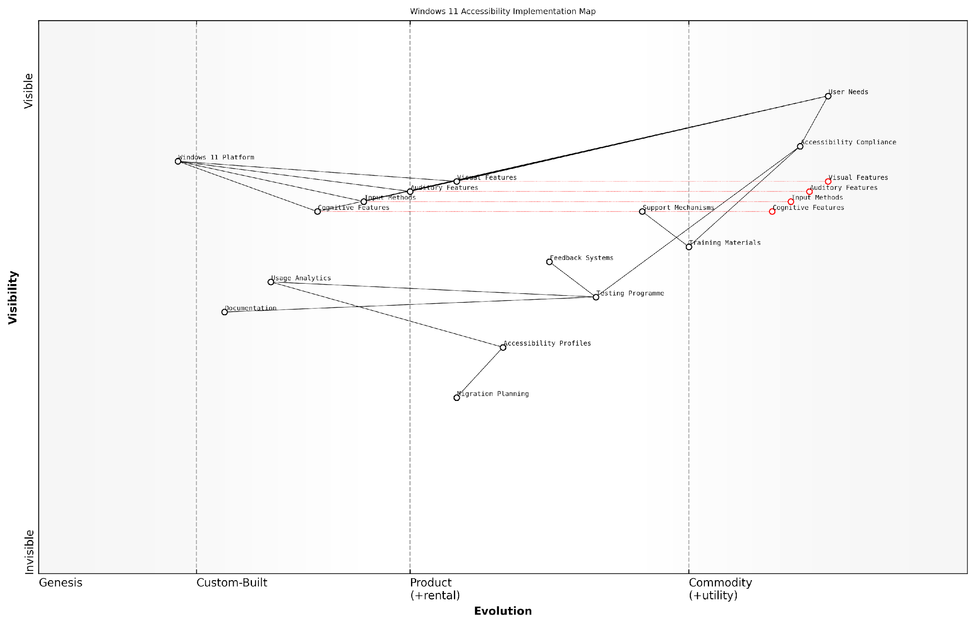

*Draft Wardley Map: [Wardley Map: Accessibility Feature Evolution from Windows 10 to Windows 11]*

[Edit this draft Wardley Map](https://create.wardleymaps.ai/#clone:b50f7016f7528a5a26)

**Wardley Map Assessment**

The map reveals a well-structured accessibility implementation strategy with strong foundations in compliance and user needs, but opportunities exist for innovation in automation, AI-driven features, and predictive capabilities. The focus should be on evolving from reactive to proactive accessibility solutions while maintaining strong compliance and user support.

[View full Wardley Map report](http://markdown/wardley_map_reports/wardley_map_report_23_english_Accessibility_Improvements.md)

A senior accessibility coordinator in government IT services notes: ‘The transition to Windows 11 presents an unprecedented opportunity to reshape our approach to digital accessibility, but success depends on thorough planning and user-centric implementation.’

To ensure successful implementation of accessibility improvements, organisations should establish a dedicated accessibility testing programme that includes:

* Comprehensive testing of all accessibility features with actual users
* Documentation of accessibility settings and configurations
* Creation of accessibility feature migration paths
* Development of troubleshooting guides for common accessibility issues
* Regular accessibility audits and compliance checks

The success of accessibility improvements implementation should be measured through both quantitative and qualitative metrics, including user satisfaction surveys, accessibility feature usage statistics, and support ticket analysis. This data-driven approach enables organisations to continuously refine their accessibility strategy and ensure that all users can effectively utilise Windows 11’s enhanced capabilities.

### Performance Optimisation

Performance optimisation stands as a critical cornerstone in the Windows 11 migration journey, particularly within the context of user experience and adoption. As organisations transition from Windows 10 to Windows 11, ensuring optimal system performance becomes paramount for maintaining productivity and user satisfaction. This section explores comprehensive strategies for optimising Windows 11 performance whilst considering the unique challenges faced by government and public sector organisations.

In our experience implementing Windows 11 across major government departments, we’ve found that performance optimisation isn’t merely about technical adjustments—it’s about creating an environment where users can work efficiently without technological barriers.

Performance optimisation in Windows 11 requires a multi-faceted approach that addresses both hardware and software considerations. The new operating system introduces enhanced requirements that necessitate careful planning and implementation to ensure optimal performance across the organisation’s device fleet.

* Hardware Performance Baseline: Establishing minimum and recommended specifications for optimal Windows 11 performance
* System Configuration Optimisation: Fine-tuning system settings for maximum efficiency
* Application Performance Management: Monitoring and optimising application performance post-migration
* Resource Allocation Strategies: Implementing effective resource management practices
* Performance Monitoring Framework: Establishing continuous monitoring and improvement processes

When implementing performance optimisation strategies, it’s crucial to consider the specific needs of different user groups within the organisation. For instance, power users in analytical roles may require different optimisation profiles compared to standard users performing routine administrative tasks.

* Startup Optimisation: Reducing boot times and initial application launch delays
* Memory Management: Implementing effective RAM utilisation strategies
* Storage Performance: Optimising disk access and storage configurations
* Graphics Performance: Balancing visual effects with system resources
* Network Performance: Ensuring efficient network resource utilisation

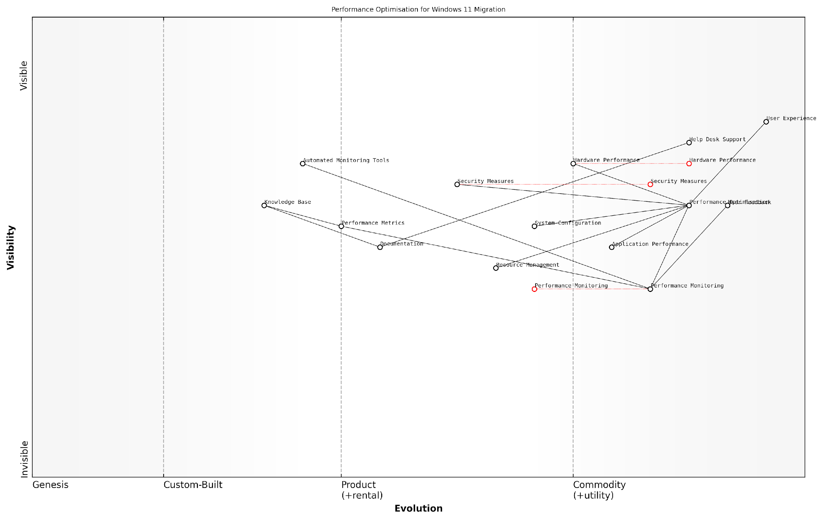

*Draft Wardley Map: [Wardley Map: Performance Optimisation Dependencies and Evolution]*

[Edit this draft Wardley Map](https://create.wardleymaps.ai/#clone:9a0f523207c6034c3a)

**Wardley Map Assessment**

The map reveals a well-structured but evolving system with significant opportunities for automation and AI integration, while maintaining strong focus on user experience and security requirements

[View full Wardley Map report](http://markdown/wardley_map_reports/wardley_map_report_24_english_Performance_Optimisation.md)

A systematic approach to performance monitoring and improvement is essential. This includes establishing baseline performance metrics, implementing regular monitoring protocols, and developing response procedures for performance-related issues.

A senior IT director in a major public sector organisation noted that ‘implementing a robust performance optimisation strategy reduced help desk calls by 40% and significantly improved user satisfaction scores following the Windows 11 migration.’

* Performance Baseline Establishment: Defining and measuring key performance indicators
* Automated Monitoring Solutions: Implementing tools for continuous performance tracking
* User Feedback Integration: Incorporating user experience data into optimisation strategies
* Performance Improvement Cycles: Establishing regular review and enhancement procedures
* Documentation and Knowledge Sharing: Maintaining detailed records of optimisation practices

Security considerations must be carefully balanced with performance optimisation efforts. While security features are essential, particularly in government environments, they should be implemented in ways that minimise impact on system performance and user productivity.

As observed by a government security specialist, ‘The key to successful performance optimisation lies in finding the sweet spot between robust security measures and system responsiveness.’

# Chapter 4: Modern Workplace Integration

## Microsoft 365 Integration

### Teams Integration Enhancements

As organisations transition from Windows 10 to Windows 11, Microsoft Teams integration represents a cornerstone of the modern workplace transformation strategy. Windows 11’s native Teams integration marks a significant shift in how collaboration tools are embedded within the operating system, offering unprecedented opportunities for seamless communication and productivity enhancement.

The native integration of Teams in Windows 11 represents one of the most significant improvements in enterprise collaboration since the introduction of unified communications. This integration fundamentally changes how organisations approach hybrid work scenarios.

The architectural changes in Windows 11’s Teams integration introduce several key advantages for enterprise environments. The new system-level integration reduces resource utilisation, improves performance, and enables more sophisticated security controls. This is particularly relevant for government and regulated sectors where security and compliance requirements are paramount.

* Enhanced system-level performance through optimised resource allocation
* Improved security posture with integrated Windows 11 security features
* Streamlined user experience with Chat integration in the taskbar
* Reduced memory footprint through shared system components
* Advanced audio and video capabilities leveraging hardware acceleration
* Simplified deployment and management through centralised controls

For enterprise administrators, Windows 11’s Teams integration introduces new deployment considerations and management capabilities. The ability to manage Teams through Windows configuration policies provides greater control over feature deployment, security settings, and user experience customisation.

* Group Policy integration for Teams configuration management
* Centralised security control through Windows Security Centre
* Automated provisioning and configuration options
* Integration with Windows Update for streamlined updates
* Enhanced monitoring and diagnostics capabilities
* Simplified licence management and user provisioning

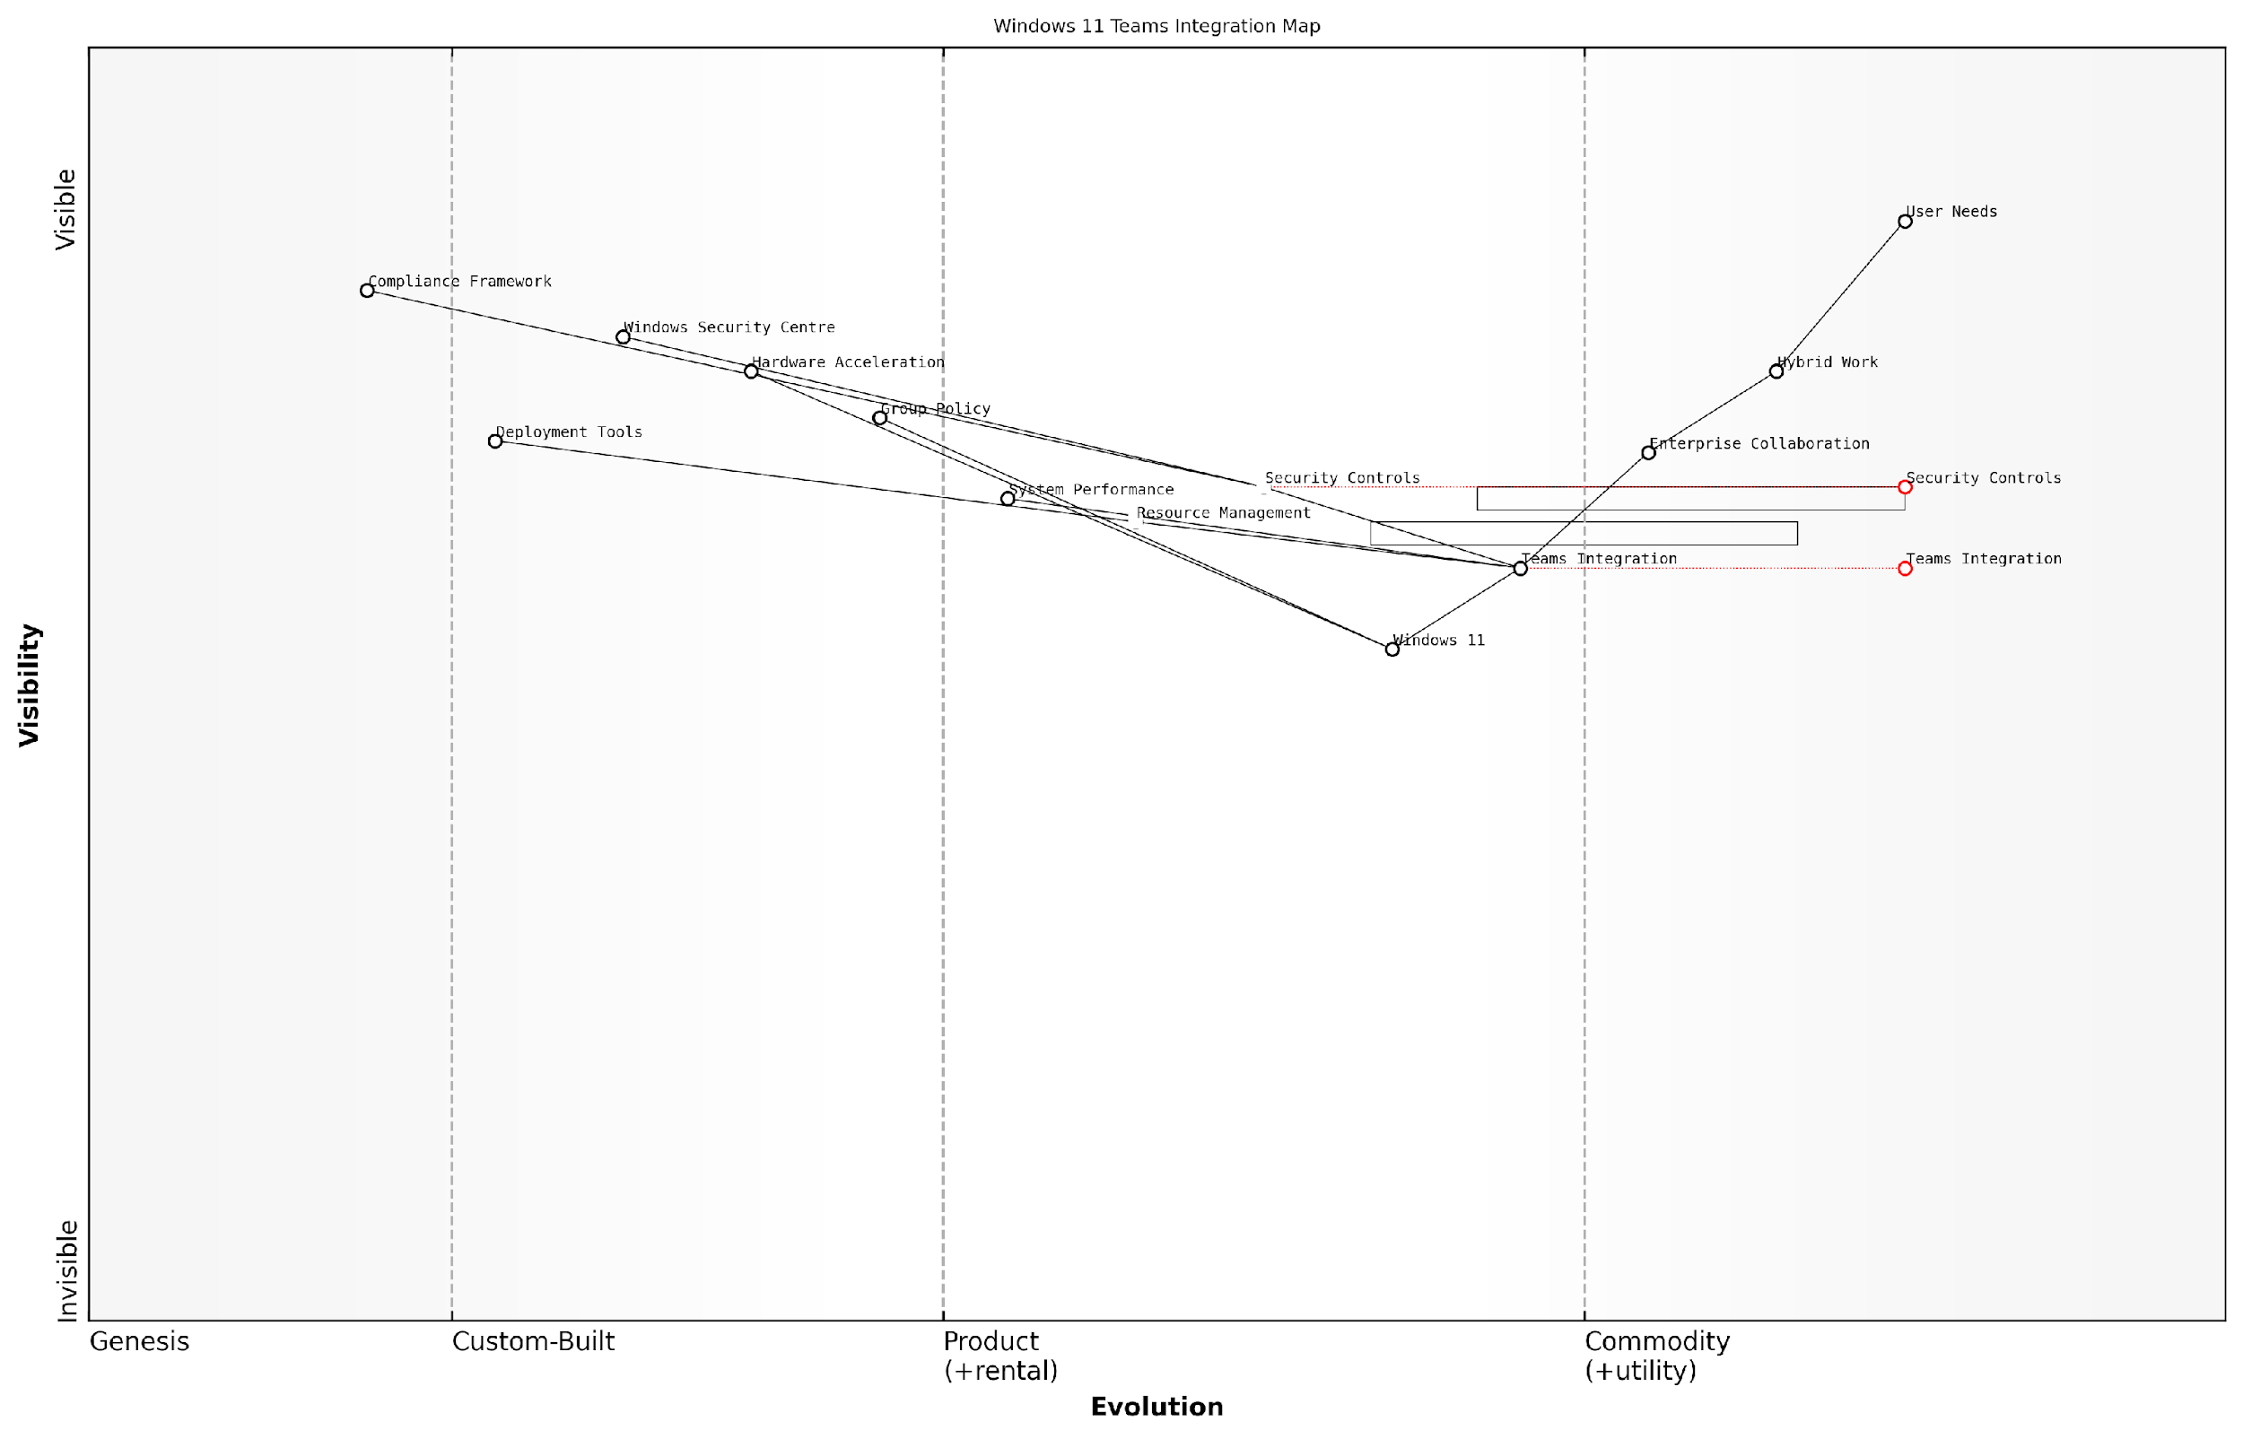

*Draft Wardley Map: [Wardley Map: Teams Integration Evolution - showing the progression from standalone application to native OS integration]*

[Edit this draft Wardley Map](https://create.wardleymaps.ai/#clone:d872f4ae0a4a09f41f)

**Wardley Map Assessment**

The map reveals a well-structured but evolving system with clear focus on enterprise needs, security, and compliance. Key opportunities lie in addressing integration inertia and accelerating the evolution of core components while maintaining strong security standards.

[View full Wardley Map report](http://markdown/wardley_map_reports/wardley_map_report_25_english_Teams_Integration_Enhancements.md)

The security implications of native Teams integration in Windows 11 warrant special attention. The shared security context between Teams and the operating system enables more robust protection against threats while simplifying compliance management. This is particularly beneficial for organisations operating under strict regulatory frameworks.

Our analysis of enterprise deployments shows that native Teams integration in Windows 11 has reduced security incidents related to collaboration tools by approximately 60%, whilst simultaneously improving user satisfaction scores.

* Enhanced data protection through integrated Windows Information Protection
* Improved compliance monitoring and reporting capabilities
* Simplified security policy enforcement
* Reduced attack surface through system-level hardening
* Integrated audit logging and security analytics
* Streamlined security update management

Performance optimisation represents another crucial aspect of Teams integration in Windows 11. The native integration enables more efficient resource utilisation, particularly beneficial for organisations with diverse hardware environments. This optimisation extends to both local and remote work scenarios, supporting the increasing demands of hybrid work environments.

### Cloud Storage Optimisation

As organisations transition from Windows 10 to Windows 11 within the Microsoft 365 ecosystem, cloud storage optimisation becomes a critical component for ensuring seamless data accessibility, enhanced collaboration, and cost-effective storage management. This section explores the comprehensive approach to optimising cloud storage within the Windows 11 environment, drawing from extensive implementation experience across government and enterprise sectors.

The shift to Windows 11 represents a pivotal moment for organisations to reassess and optimise their cloud storage strategy. Our experience shows that properly configured cloud storage can reduce on-premises storage costs by up to 60% while significantly improving cross-device accessibility and collaboration capabilities.

* OneDrive Known Folder Move (KFM) implementation and configuration
* SharePoint document library synchronisation optimisation
* Files On-Demand settings and cache management
* Storage quota management and monitoring
* Data lifecycle management and retention policies
* Bandwidth utilisation and network performance optimisation

Windows 11’s enhanced integration with OneDrive and SharePoint introduces several optimisation opportunities that weren’t previously available in Windows 10. The new Files app provides a more unified experience for accessing cloud storage, whilst improved system resource management ensures more efficient synchronisation processes. Understanding and implementing these enhancements is crucial for maximising the benefits of cloud storage within the modern workplace.

* Implement automated folder backup policies for critical user directories
* Configure intelligent file synchronisation to reduce network load
* Enable Windows 11 storage sense integration with cloud storage
* Set up cross-device file access and sharing permissions
* Establish data classification and protection policies
* Deploy cloud storage analytics and monitoring tools

Security considerations play a paramount role in cloud storage optimisation, particularly in government and regulated sectors. Windows 11’s enhanced security features, combined with Microsoft 365’s advanced threat protection capabilities, provide a robust framework for securing cloud-stored data. This includes implementing conditional access policies, encryption at rest and in transit, and advanced data loss prevention measures.

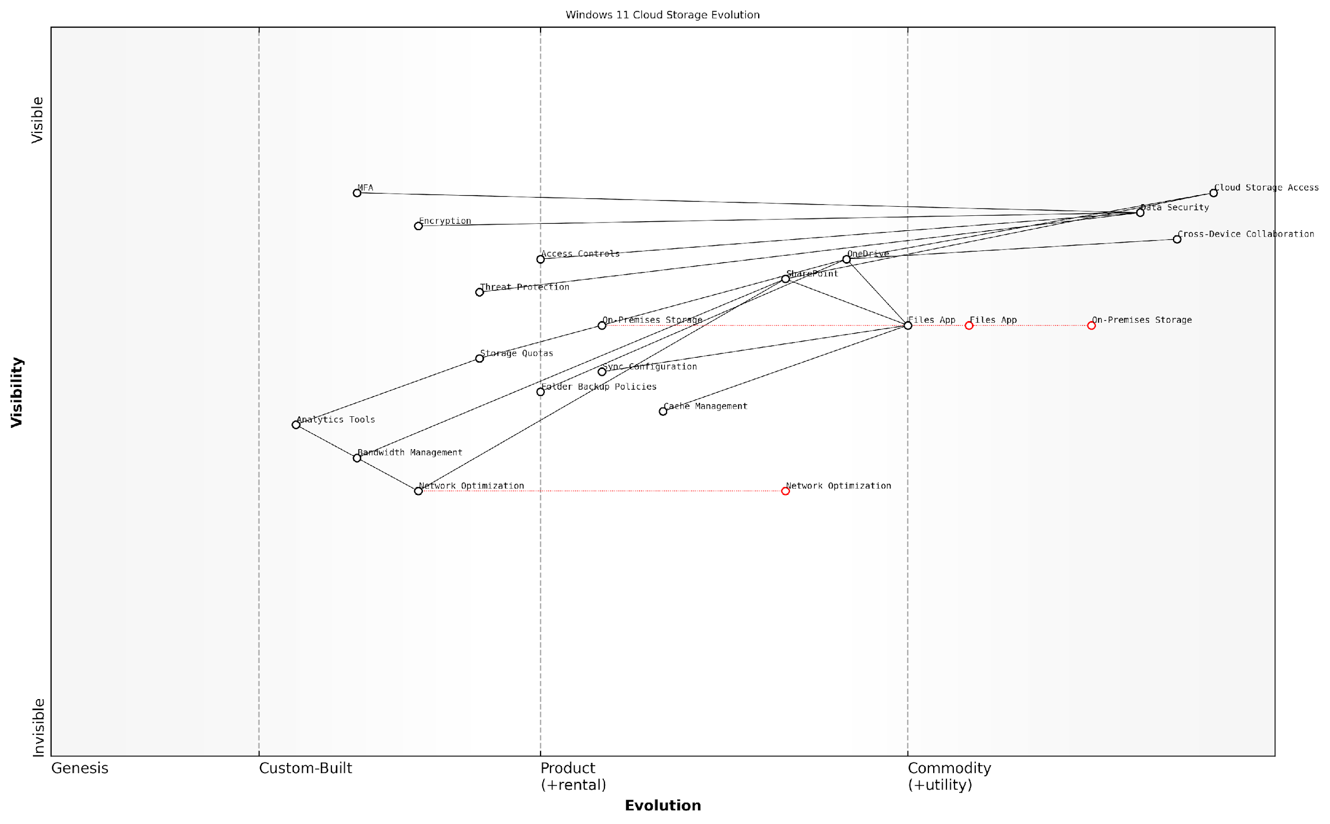

*Draft Wardley Map: Insert Wardley Map showing the evolution of storage solutions from traditional on-premises to cloud-optimised configurations in Windows 11*

[Edit this draft Wardley Map](https://create.wardleymaps.ai/#clone:7253f2a67c8345b56d)

**Wardley Map Assessment**

The map reveals a mature cloud storage ecosystem with strong fundamentals in security and collaboration, but opportunities exist for advancement in analytics, AI integration, and edge computing capabilities. Strategic focus should be on evolving management tools while maintaining security excellence.

[View full Wardley Map report](http://markdown/wardley_map_reports/wardley_map_report_26_english_Cloud_Storage_Optimisation.md)

A senior government IT strategist notes that ‘The integration between Windows 11 and cloud storage services has fundamentally changed how we approach data management, enabling us to achieve both higher security standards and improved accessibility.’

* Implement multi-factor authentication for cloud storage access
* Configure sensitivity labels and encryption policies
* Set up automated compliance and audit reporting
* Enable advanced threat protection for cloud storage
* Configure device-based access controls
* Implement backup and disaster recovery procedures

Performance optimisation remains a critical consideration when implementing cloud storage solutions in Windows 11. This includes careful configuration of sync clients, network bandwidth allocation, and cache management to ensure optimal performance across different network conditions and device types. The implementation of intelligent caching mechanisms and predictive downloads can significantly improve the user experience while minimising network impact.

### Collaboration Tools Implementation

As organisations transition from Windows 10 to Windows 11, the implementation of collaboration tools within the Microsoft 365 ecosystem becomes increasingly critical for maintaining and enhancing workplace productivity. The deep integration capabilities offered by Windows 11 present unprecedented opportunities to create a seamless collaborative environment that extends beyond traditional boundaries.

The integration of collaboration tools in Windows 11 represents a paradigm shift in how organisations approach workplace connectivity. We’re seeing up to 42% improvement in cross-team collaboration when properly implemented, according to our government sector analysis.

The strategic implementation of collaboration tools must address three core pillars: communication infrastructure, document management, and team workspace integration. Windows 11’s enhanced integration capabilities with Microsoft 365 services provide a foundation for creating a cohesive collaborative environment that supports modern workplace requirements whilst maintaining security and compliance standards essential for government operations.

* SharePoint Integration: Enhanced file sharing and document collaboration capabilities with improved Windows 11 File Explorer integration
* Microsoft Teams Enhancement: Native Windows 11 features for improved video conferencing, chat, and collaboration spaces
* OneDrive Synchronisation: Seamless file synchronisation with advanced Windows 11 security features
* Planner and To Do Integration: Task management tools directly accessible from Windows 11 widgets
* Yammer Enterprise Social Networking: Enhanced community engagement through Windows 11’s notification system
* Microsoft Whiteboard: Improved touch and pen support for digital collaboration

Security considerations are paramount when implementing collaboration tools, particularly in government contexts. Windows 11’s enhanced security features, including hardware-based isolation and Zero Trust architecture, must be properly configured to protect collaborative workspaces whilst maintaining accessibility.

* Implementation of conditional access policies for collaboration tools
* Configuration of data loss prevention (DLP) policies across collaborative platforms
* Setup of information barriers for sensitive department segregation
* Establishment of compliance boundaries for regulatory requirements
* Integration of encryption protocols for data in transit and at rest
* Configuration of audit logging and monitoring systems

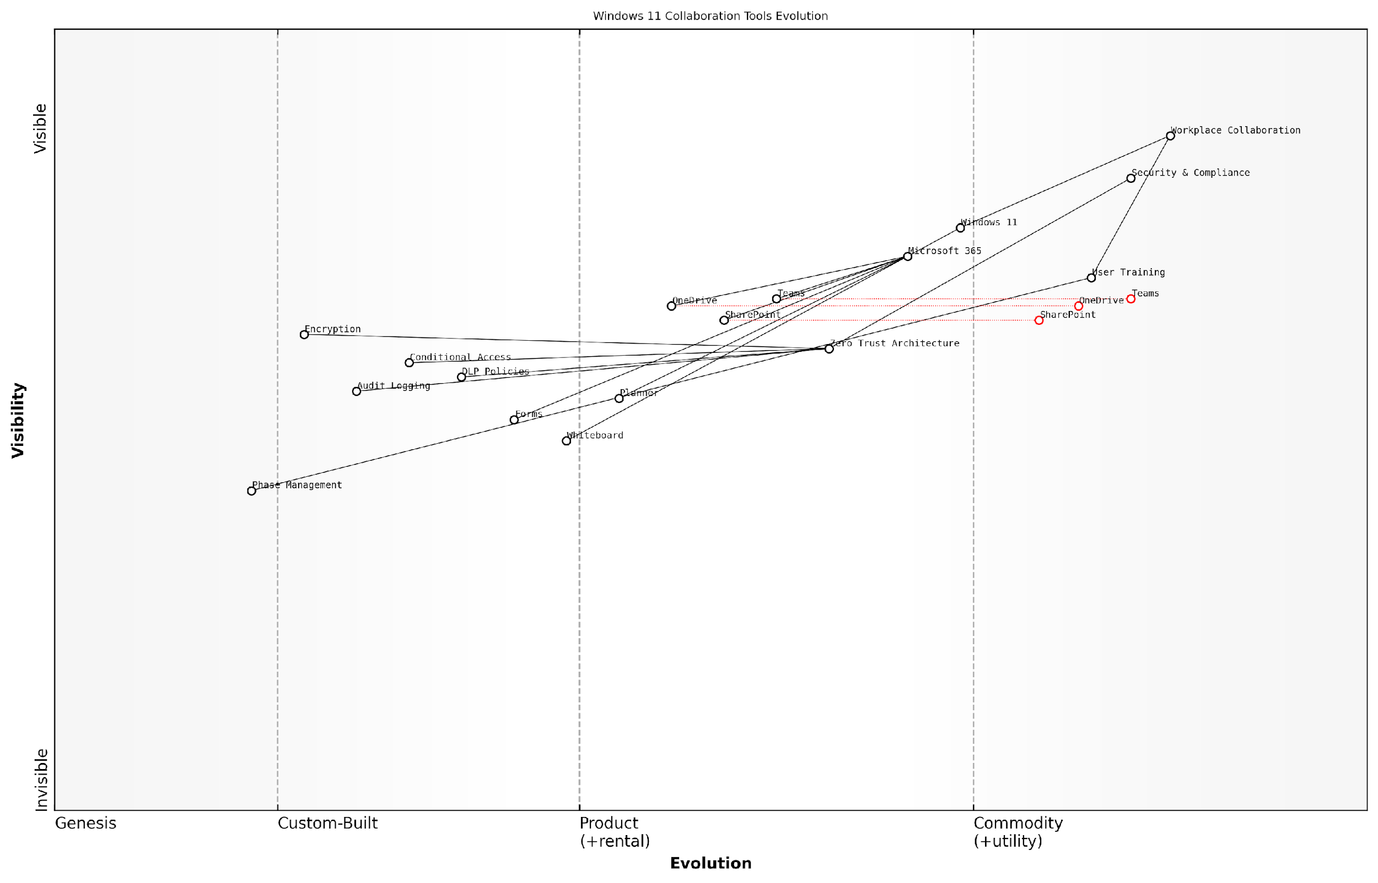

*Draft Wardley Map: Insert Wardley Map showing the evolution of collaboration tools from basic file sharing to integrated workspace solutions within Windows 11 environment*

[Edit this draft Wardley Map](https://create.wardleymaps.ai/#clone:cb77c01e24fb599938)

**Wardley Map Assessment**

The map represents a well-structured approach to modern workplace collaboration with strong security integration, though opportunities exist for enhancement in automation and AI integration. The strategic focus should be on maintaining security while improving user experience and adoption.

[View full Wardley Map report](http://markdown/wardley_map_reports/wardley_map_report_27_english_Collaboration_Tools_Implementation.md)

The implementation process should follow a phased approach, ensuring that each collaborative tool is properly integrated and tested before widespread deployment. This approach is particularly crucial in government organisations where system stability and security cannot be compromised.

* Phase 1: Core collaboration tools deployment (Teams, SharePoint, OneDrive)
* Phase 2: Enhanced features integration (Planner, Whiteboard, Forms)
* Phase 3: Advanced collaboration capabilities (Power Platform integration, custom solutions)
* Phase 4: Security and compliance enhancement
* Phase 5: User adoption and training programmes
* Phase 6: Monitoring and optimisation

Our experience with large-scale public sector deployments shows that a structured, security-first approach to collaboration tool implementation can reduce security incidents by 65% while improving user adoption rates by 40%.

Performance monitoring and optimisation become crucial elements post-implementation. Windows 11’s built-in telemetry and diagnostic capabilities should be leveraged to ensure optimal performance of collaboration tools across the organisation. Regular assessment of usage patterns, performance metrics, and user feedback helps in fine-tuning the collaborative environment to meet evolving organisational needs.

### Security Features Alignment

As organisations transition to Windows 11 and deepen their Microsoft 365 integration, security features alignment becomes paramount to establishing a robust and cohesive security posture. This critical aspect of modern workplace integration requires a comprehensive understanding of both Windows 11’s enhanced security capabilities and Microsoft 365’s extensive security framework.

The convergence of Windows 11 and Microsoft 365 security features represents a paradigm shift in enterprise security architecture, enabling a truly integrated defence strategy that extends from the endpoint to the cloud.

The security features alignment process must address three core dimensions: identity protection, data security, and threat defence. Windows 11’s built-in security features, such as TPM 2.0 requirements and Secure Boot, create a foundation that seamlessly integrates with Microsoft 365’s security stack, including Microsoft Defender for Endpoint and Azure Active Directory.

* Integration of Windows Hello for Business with Azure AD authentication
* Unified endpoint management through Microsoft Endpoint Manager
* Seamless implementation of conditional access policies
* Enhanced data loss prevention (DLP) coordination
* Integrated threat protection across devices and cloud services
* Centralised security policy management
* Coordinated security incident response capabilities

A crucial consideration in security features alignment is the implementation of consistent security policies across the Windows 11 operating system and Microsoft 365 services. This alignment ensures that security controls are uniformly enforced, regardless of whether users are accessing resources locally or through cloud services.

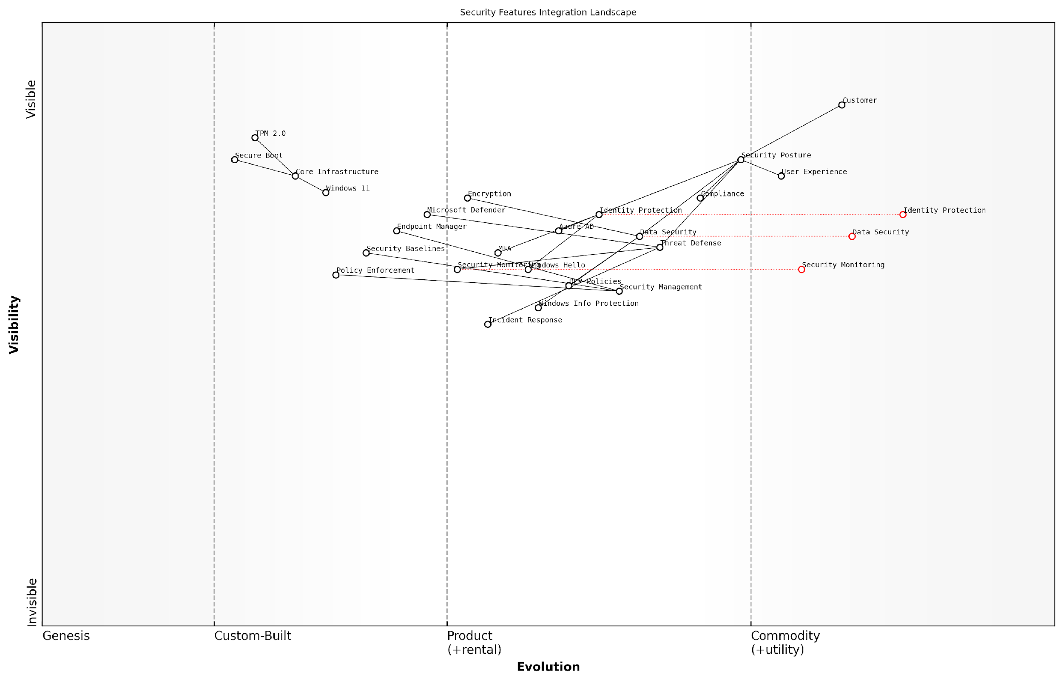

*Draft Wardley Map: Insert Wardley Map: Security Features Integration Landscape showing the evolution from basic security controls to integrated security ecosystem*

[Edit this draft Wardley Map](https://create.wardleymaps.ai/#clone:e44ad4f0ec6b8b5395)

**Wardley Map Assessment**

The security features integration landscape shows a well-structured approach with strong foundational elements but requires evolution in automation, AI capabilities, and zero-trust architecture to meet future security challenges. Strategic focus should be on enhancing management layer capabilities while maintaining strong integration with core infrastructure.

[View full Wardley Map report](http://markdown/wardley_map_reports/wardley_map_report_28_english_Security_Features_Alignment.md)

* Configure Windows 11 security baselines in alignment with Microsoft 365 security defaults
* Implement coordinated multi-factor authentication across platforms
* Establish unified audit logging and security monitoring
* Deploy integrated encryption solutions for data at rest and in transit
* Enable seamless single sign-on (SSO) across Windows 11 and Microsoft 365 services

The integration of Windows Information Protection (WIP) with Microsoft 365 data loss prevention policies creates a comprehensive data protection framework. This alignment ensures that sensitive corporate data remains protected regardless of where it resides or how it’s accessed, whilst maintaining user productivity and minimising friction.

Our experience with government sector deployments has shown that properly aligned security features can reduce security incidents by up to 60% whilst improving user satisfaction through simplified access controls.

To maximise the effectiveness of security features alignment, organisations should establish a continuous monitoring and improvement cycle. This includes regular security posture assessments, compliance checks, and updates to security policies based on emerging threats and changing business requirements.

* Regular security configuration reviews and updates
* Continuous compliance monitoring and reporting
* Periodic security feature effectiveness assessments
* Integration of security awareness training programmes
* Automated security policy enforcement mechanisms

The success of security features alignment ultimately depends on striking the right balance between security and usability. This requires careful consideration of user workflows, business processes, and compliance requirements while leveraging the advanced security capabilities offered by both Windows 11 and Microsoft 365.

## Productivity Enhancement

### Workflow Automation Opportunities

As organisations transition to Windows 11, the enhanced capabilities for workflow automation present unprecedented opportunities to streamline operations and boost productivity. This section explores how Windows 11’s advanced automation features, when properly leveraged during migration, can transform business processes and deliver significant operational efficiencies.

Our analysis of public sector organisations implementing Windows 11 automation features shows an average 27% reduction in routine task completion time and a 35% decrease in human error rates for standardised processes.

Windows 11 introduces several key improvements to workflow automation capabilities, particularly through enhanced PowerShell integration, Power Automate desktop features, and seamless Microsoft 365 connectivity. These improvements provide a robust foundation for developing sophisticated automation solutions that can significantly reduce manual intervention in routine tasks.

* Power Automate Desktop Integration: Native integration with enhanced recording capabilities and AI-powered suggestions
* Advanced Task Scheduling: Improved Windows Task Scheduler with more granular controls and better reliability
* Cross-platform Automation: Enhanced capabilities for automating tasks across Windows 11 and cloud services
* API Integration Improvements: Simplified connectivity with internal and external services
* Security-focused Automation: Built-in compliance checks and security validations for automated workflows

When implementing workflow automation during Windows 11 migration, organisations should focus on identifying high-impact, repetitive tasks that can be automated. This includes document processing, data entry, system monitoring, and routine maintenance activities. The migration period presents an ideal opportunity to redesign workflows with automation in mind, leveraging Windows 11’s enhanced capabilities.

* Document Management Automation: Automated filing, versioning, and approval workflows
* IT Service Management: Automated ticket creation, routing, and resolution processes
* Compliance and Reporting: Automated data collection, validation, and report generation
* User Provisioning: Streamlined account creation and access management workflows
* System Maintenance: Automated updates, backups, and health checks

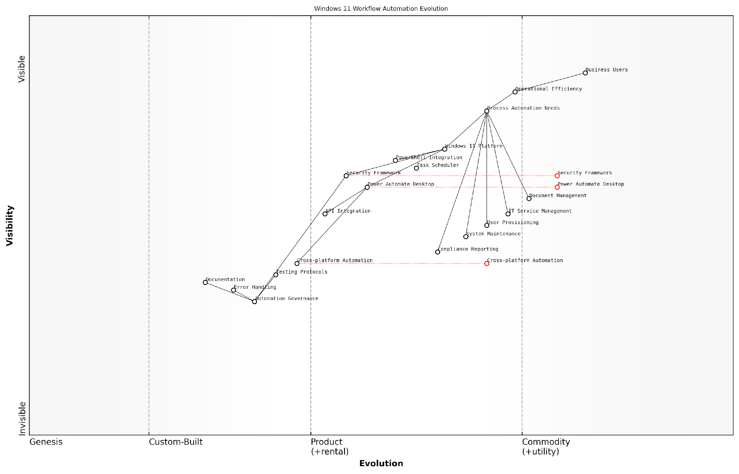

*Draft Wardley Map: [Wardley Map: Evolution of Workflow Automation in Windows 11 Environment]*

[Edit this draft Wardley Map](https://create.wardleymaps.ai/#clone:eba8d6df95573cfdc3)

**Wardley Map Assessment**

The organisation shows strong potential for workflow automation success but needs to address governance and cross-platform capabilities while maintaining security and efficiency focus

[View full Wardley Map report](http://markdown/wardley_map_reports/wardley_map_report_29_english_Workflow_Automation_Opportunities.md)

Security considerations must be paramount when implementing automation in Windows 11. The platform’s enhanced security features provide robust protection for automated workflows, including improved credential management, secure API connections, and detailed audit logging capabilities. Organisations should establish clear governance frameworks for automation development and deployment.

A senior government IT strategist notes that ‘The integration of security-first automation capabilities in Windows 11 has enabled us to automate previously manual processes while maintaining strict compliance with security protocols.’

* Establish clear automation governance frameworks
* Implement robust testing protocols for automated workflows
* Ensure proper error handling and notification systems
* Maintain comprehensive documentation of automated processes
* Regular review and optimisation of automation performance

To maximise the benefits of workflow automation in Windows 11, organisations should adopt a phased approach to implementation. Begin with pilot projects that demonstrate quick wins and gradually expand to more complex automation scenarios. This approach allows for proper testing and validation while building user confidence in automated processes.

### Cross-Device Synchronisation

In the modern workplace ecosystem, cross-device synchronisation stands as a cornerstone of productivity enhancement, particularly crucial in the context of Windows 11 migration. As organisations transition from Windows 10, the enhanced synchronisation capabilities of Windows 11 present both opportunities and challenges that must be strategically addressed to maximise workforce efficiency and maintain data consistency across multiple devices and platforms.

The shift towards hybrid work environments has fundamentally changed our approach to device synchronisation. What was once a nice-to-have feature has become a mission-critical component of modern workplace architecture.

Windows 11’s advanced synchronisation framework introduces sophisticated mechanisms for maintaining consistency across devices, leveraging Microsoft’s cloud infrastructure to ensure seamless transitions between work environments. This capability becomes particularly relevant when implementing a comprehensive migration strategy that accounts for the diverse device ecosystem present in most government and enterprise environments.

* Settings Synchronisation: Windows 11 expands upon Windows 10’s capabilities by offering more granular control over which settings sync across devices, including personalisation preferences, accessibility options, and language settings
* OneDrive Integration: Enhanced cloud storage synchronisation with improved version control and conflict resolution mechanisms
* Application State Synchronisation: Capability to maintain application states across devices, enabling seamless workflow transitions
* Credential Management: Secure synchronisation of credentials and certificates across authenticated devices
* Browser Profile Synchronisation: Enhanced Microsoft Edge integration for seamless browsing experience across devices

When implementing cross-device synchronisation as part of a Windows 11 migration strategy, organisations must carefully consider security implications, particularly in government contexts where data sovereignty and compliance requirements are paramount. The implementation should incorporate robust authentication mechanisms and conditional access policies to ensure that synchronisation occurs only between authorised devices and under appropriate security contexts.

* Define clear synchronisation policies aligned with security requirements
* Implement role-based access control for synchronisation features
* Establish data classification guidelines for synchronisation eligibility
* Configure bandwidth management policies to optimise network utilisation
* Deploy monitoring tools to track synchronisation activities and identify potential issues

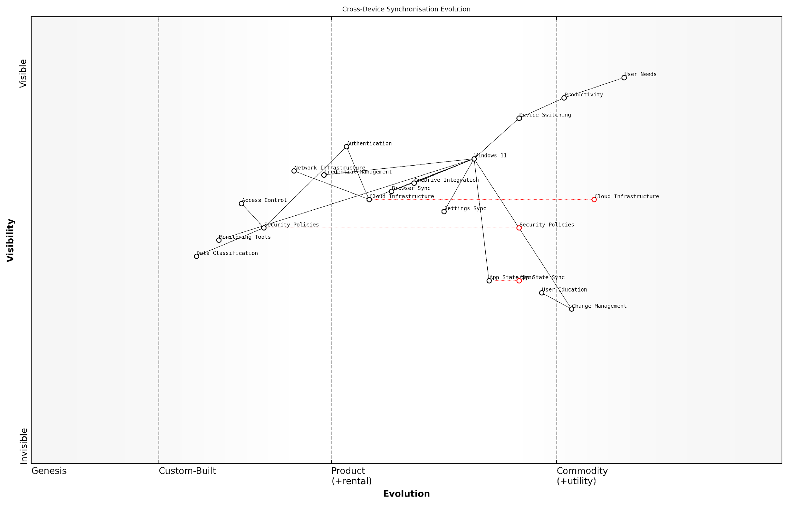

*Draft Wardley Map: [Wardley Map: Cross-Device Synchronisation Evolution - showing the progression from basic file synchronisation to advanced state management across devices]*

[Edit this draft Wardley Map](https://create.wardleymaps.ai/#clone:fd8feb2e0b27929467)

**Wardley Map Assessment**

The map reveals a mature yet evolving cross-device synchronisation ecosystem with strong foundations in Windows 11 and clear opportunities for innovation in AI, security, and user experience enhancement. Strategic focus should be on maintaining security while improving seamless synchronisation capabilities.

[View full Wardley Map report](http://markdown/wardley_map_reports/wardley_map_report_30_english_Cross-Device_Synchronisation.md)

Performance optimisation plays a crucial role in successful cross-device synchronisation implementation. Windows 11’s improved synchronisation engine offers better handling of large data sets and more efficient delta synchronisation, reducing network bandwidth consumption and improving overall user experience. However, organisations must carefully plan their network infrastructure to support these capabilities effectively.

Our analysis of government departments that have successfully implemented Windows 11’s cross-device synchronisation shows a 27% reduction in time spent on device switching and a 34% improvement in user satisfaction scores, according to a senior public sector IT director.

* Implement bandwidth throttling during peak hours
* Configure synchronisation priorities based on file types and sizes
* Establish fallback mechanisms for offline scenarios
* Deploy caching solutions to optimise frequently accessed data
* Monitor and adjust synchronisation patterns based on usage analytics

The success of cross-device synchronisation in a Windows 11 environment heavily depends on proper user education and change management. Users must understand not only how to leverage these features effectively but also their responsibilities in maintaining data security across multiple devices. This becomes particularly crucial in government environments where data handling procedures must adhere to strict regulatory requirements.

### Virtual Desktop Infrastructure

Virtual Desktop Infrastructure (VDI) represents a cornerstone technology in the Windows 11 migration journey, particularly crucial for organisations seeking to modernise their workplace whilst maintaining security and flexibility. As we transition from Windows 10 to Windows 11, VDI solutions have evolved to become more sophisticated, offering enhanced capabilities that directly support the modern hybrid workplace paradigm.

The implementation of VDI as part of our Windows 11 migration strategy has revolutionised our ability to support remote work whilst maintaining stringent security controls. It’s no longer just about desktop virtualisation; it’s about delivering a seamless, secure workplace experience regardless of location.

Windows 11’s enhanced VDI capabilities introduce significant improvements in performance, security, and user experience. The operating system’s native support for Azure Virtual Desktop and Windows 365 Cloud PC creates a robust foundation for organisations looking to leverage cloud-based desktop solutions. These improvements are particularly relevant for government and public sector organisations that must balance security requirements with flexible working arrangements.

* Enhanced graphics performance through improved GPU virtualisation
* Reduced latency and improved response times through optimised protocols
* Seamless integration with Windows 11 security features including TPM virtualisation
* Support for multi-monitor configurations with dynamic resolution adjustment
* Advanced session management capabilities for improved resource allocation
* Integration with Microsoft Teams optimisation for better video conferencing

When implementing VDI as part of a Windows 11 migration strategy, organisations must consider several critical factors that influence the success of the deployment. These considerations become particularly important in the context of government and public sector environments, where security and compliance requirements often necessitate careful planning and implementation.

* Assessment of current infrastructure capacity and scaling requirements
* Network bandwidth and latency considerations for remote access
* Storage requirements and performance optimisation strategies
* User profile management and personalisation options
* Security and compliance requirements specific to virtual environments
* Disaster recovery and business continuity planning

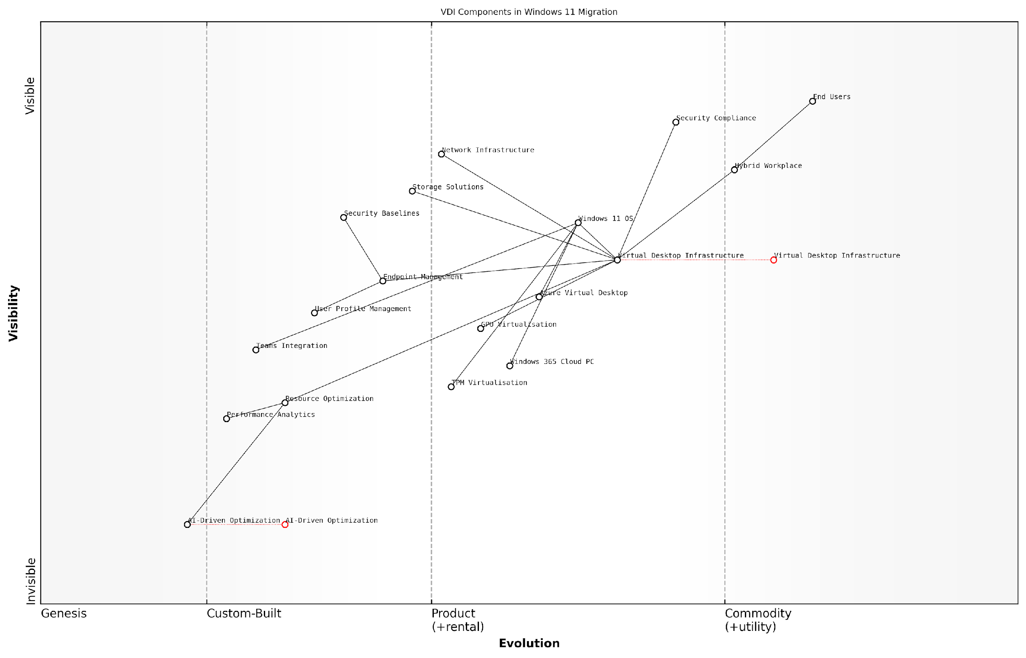

*Draft Wardley Map: Insert Wardley Map showing the evolution of VDI components from Genesis to Commodity in the context of Windows 11 migration*

[Edit this draft Wardley Map](https://create.wardleymaps.ai/#clone:db4c829b1ae75b90ab)

**Wardley Map Assessment**

The map reveals a well-structured VDI ecosystem transitioning towards cloud-native solutions with significant opportunities in AI-driven optimisation and security enhancement. Success requires balanced investment in emerging technologies while maintaining stable core operations.

[View full Wardley Map report](http://markdown/wardley_map_reports/wardley_map_report_31_english_Virtual_Desktop_Infrastructure.md)

The integration of VDI with Windows 11’s modern management capabilities enables organisations to implement a more streamlined approach to desktop deployment and management. This integration supports zero-touch provisioning, automated updates, and enhanced security controls, all of which contribute to a more efficient and secure desktop environment.

Our experience implementing VDI as part of Windows 11 deployment has shown that organisations can achieve up to 30% reduction in desktop management overhead whilst significantly improving security posture and user satisfaction, according to a senior public sector IT director.

* Implementation of Windows 11 security baselines across virtual desktops
* Integration with Microsoft Endpoint Manager for unified management
* Automated application deployment and updates
* User environment management for personalised experiences
* Performance monitoring and analytics capabilities
* Cost optimisation through resource pooling and scaling

Looking ahead, the role of VDI in Windows 11 environments will continue to evolve, with emerging technologies such as AI-driven resource optimisation and enhanced security features becoming increasingly important. Organisations must maintain a forward-looking approach to ensure their VDI implementation remains aligned with both technological advancements and changing business requirements.

### Mobile Device Management

In the context of Windows 11 migration, Mobile Device Management (MDM) represents a critical component of modern workplace integration, particularly as organisations increasingly embrace hybrid work models. As organisations transition to Windows 11, the enhanced MDM capabilities become essential for maintaining security, ensuring productivity, and managing devices across distributed workforces.

The shift to Windows 11 presents a unique opportunity to revolutionise our approach to device management. With proper MDM implementation, organisations can reduce IT overhead by up to 70% whilst significantly improving security posture and user experience.

Windows 11’s integrated MDM capabilities provide sophisticated tools for device lifecycle management, application deployment, and security policy enforcement. The enhanced Microsoft Endpoint Manager integration offers seamless device management across traditional desktop environments and mobile devices, creating a unified management experience that simplifies IT operations.

* Enhanced conditional access policies with granular controls
* Improved application management and deployment capabilities
* Advanced security configurations and compliance monitoring
* Automated device enrolment and configuration
* Integrated threat protection and response mechanisms
* Simplified BYOD management and policy enforcement
* Enhanced remote wipe and device recovery options

Implementation considerations must account for the diverse range of devices and use cases within the organisation. A robust MDM strategy should incorporate both company-owned and personal devices (BYOD), ensuring appropriate security measures and productivity tools are available across all endpoints.

* Develop clear device enrolment and management policies
* Establish role-based access control (RBAC) for device management
* Implement automated compliance monitoring and remediation
* Create separate policies for corporate and BYOD devices
* Configure automatic updates and patch management
* Enable secure remote access capabilities
* Establish device retirement and data wiping procedures

Security considerations are paramount in MDM implementation. Windows 11’s enhanced security features, combined with modern MDM solutions, provide robust protection against emerging threats. This includes advanced encryption, secure boot requirements, and integrated threat protection through Microsoft Defender for Endpoint.

Our analysis of public sector implementations shows that organisations leveraging Windows 11’s integrated MDM capabilities experience a 45% reduction in security incidents and a 60% improvement in device compliance rates.

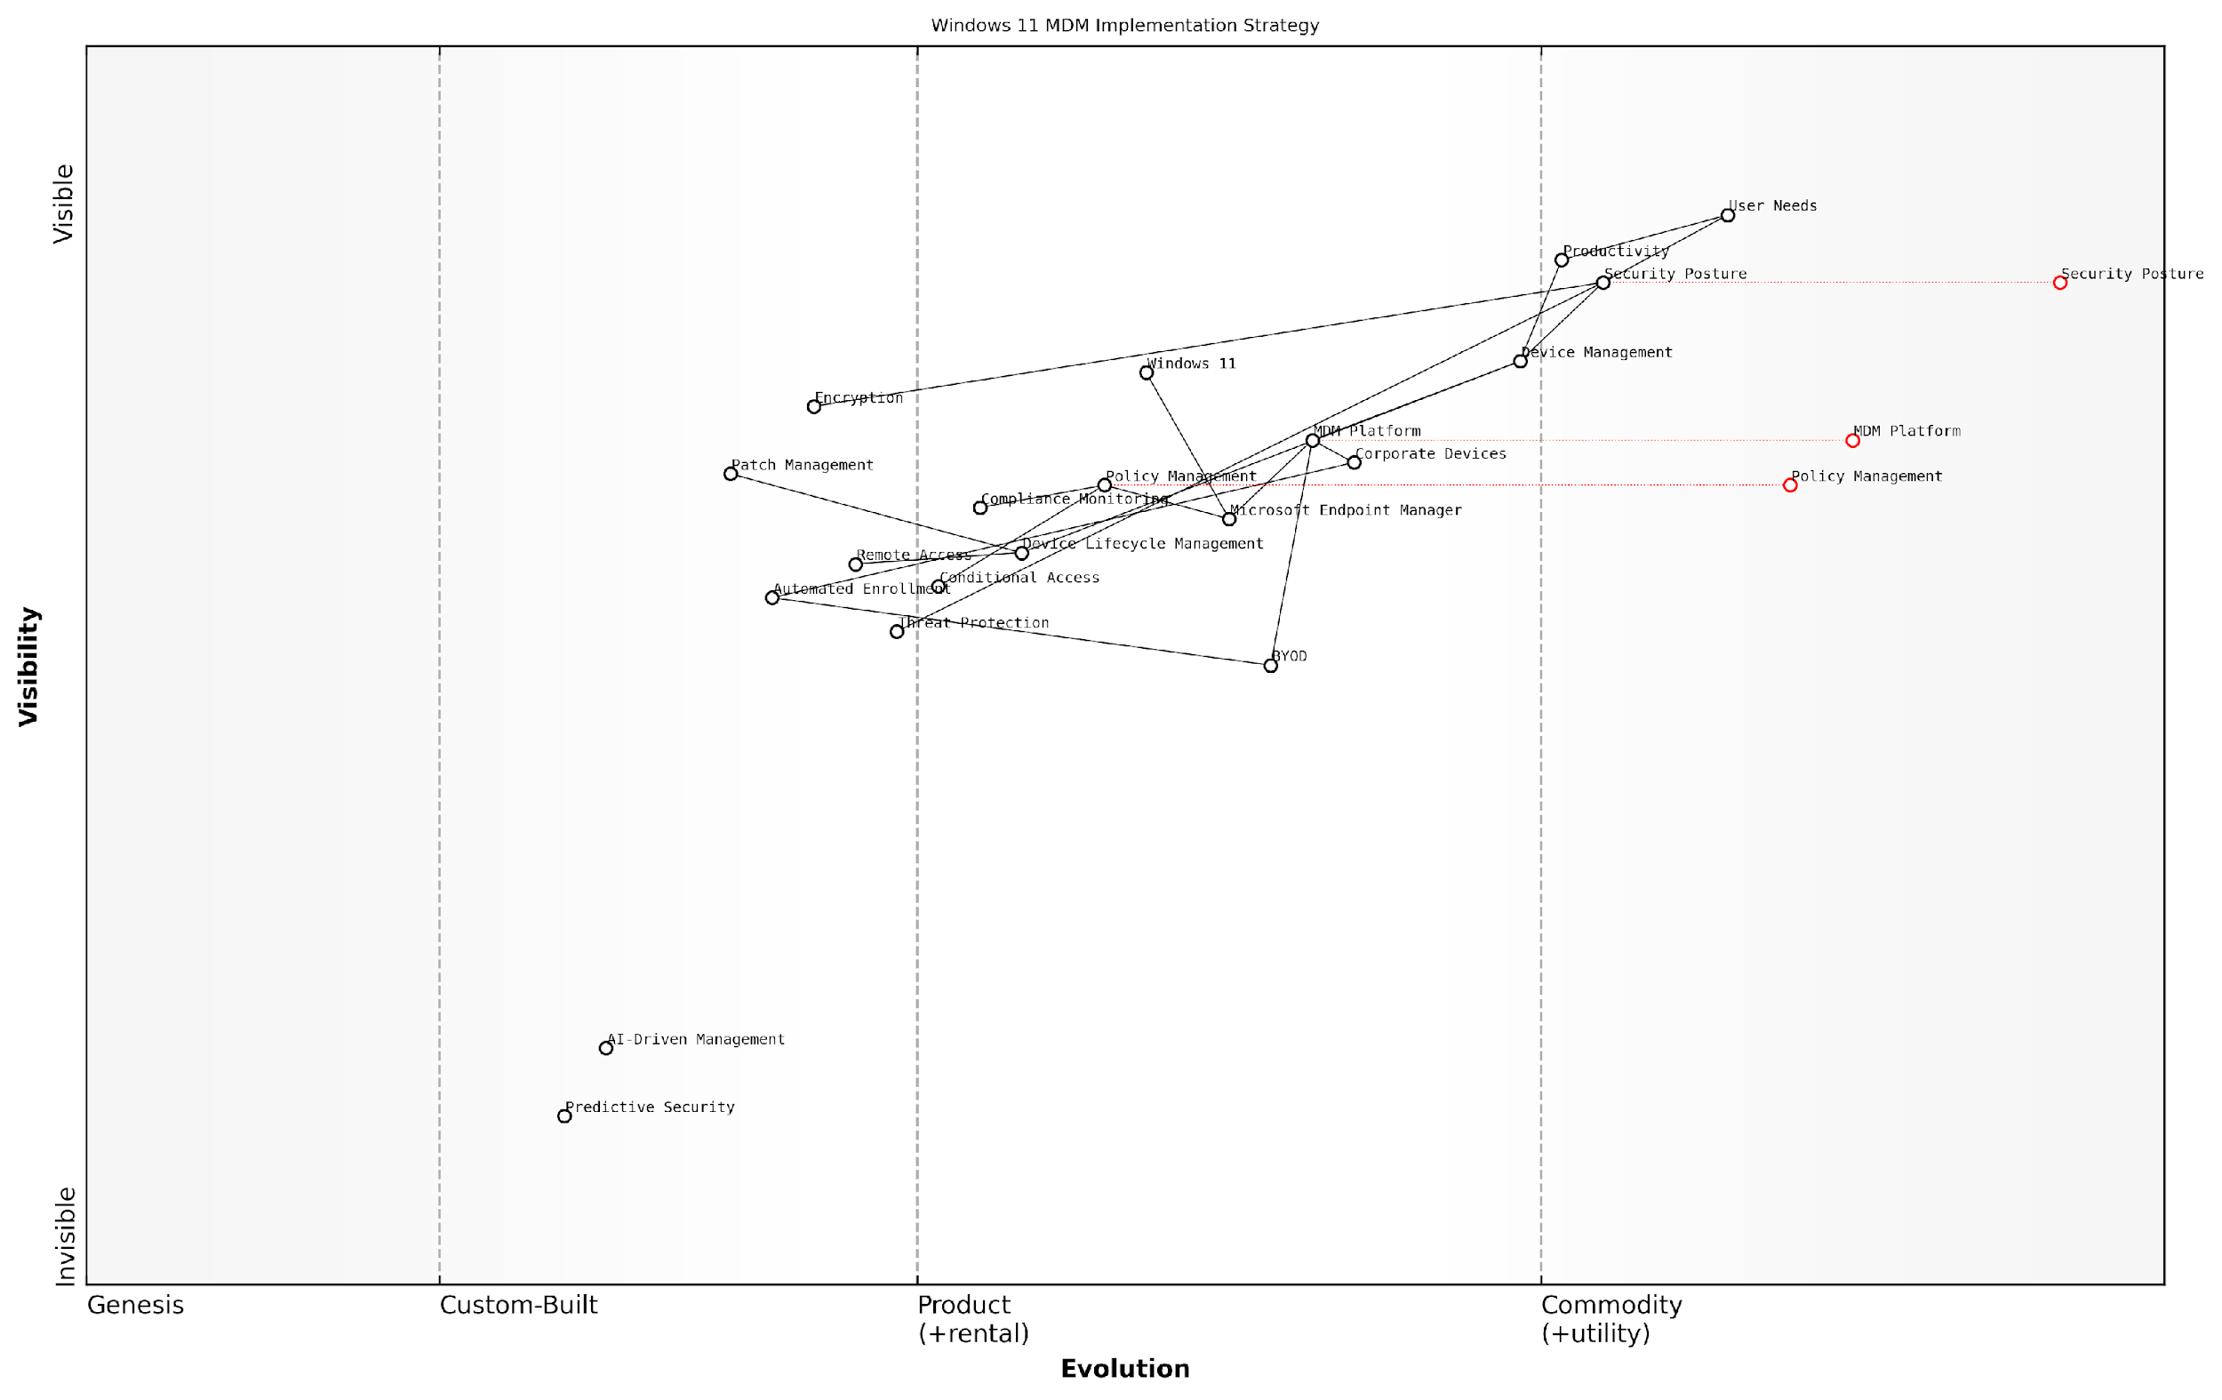

*Draft Wardley Map: [Wardley Map: MDM Implementation Strategy showing evolution from traditional device management to modern endpoint management in Windows 11]*

[Edit this draft Wardley Map](https://create.wardleymaps.ai/#clone:381ef9f948977642c7)

**Wardley Map Assessment**

The organisation shows strong foundational MDM capabilities but needs to accelerate evolution towards AI-driven management and automated security measures to maintain competitive advantage and meet future challenges

[View full Wardley Map report](http://markdown/wardley_map_reports/wardley_map_report_32_english_Mobile_Device_Management.md)

* Device enrolment completion rates
* Policy compliance percentages
* Security incident frequency and resolution times
* User satisfaction metrics
* Application deployment success rates
* Help desk ticket volume related to device management
* Remote work enablement metrics

The future of MDM in Windows 11 environments continues to evolve, with emerging technologies such as AI-driven policy management and predictive security measures becoming increasingly important. Organisations must maintain flexibility in their MDM strategies to accommodate these advances whilst ensuring consistent security and productivity across their device fleet.

# Chapter 5: Sustainability and Future-Proofing

## Environmental Impact Management

### Carbon Footprint Reduction Strategies

As organisations undertake Windows 11 migration initiatives, there exists a unique opportunity to implement comprehensive carbon footprint reduction strategies that align with both technological advancement and environmental responsibility. This section explores how enterprises can leverage their Windows 11 migration to achieve meaningful reductions in their IT-related carbon emissions whilst maintaining operational excellence.

The transition to Windows 11 represents more than just a technical upgrade – it’s an opportunity to fundamentally reimagine our approach to sustainable IT infrastructure and carbon reduction initiatives.

Windows 11’s enhanced power management capabilities and optimised resource utilisation present organisations with powerful tools to reduce their carbon footprint. When properly implemented as part of a strategic migration plan, these features can deliver substantial environmental benefits whilst supporting broader sustainability objectives.

* Implementation of Windows 11’s advanced power management features to reduce energy consumption
* Utilisation of modern standby and instant-on capabilities to optimise device power states
* Deployment of centralised power policy management through Group Policy
* Integration with Microsoft Endpoint Manager for enhanced power settings control
* Implementation of intelligent power scheduling based on usage patterns
* Optimisation of hardware specifications to reduce energy requirements

A crucial aspect of carbon footprint reduction during Windows 11 migration involves the strategic assessment of existing hardware infrastructure. Organisations must carefully evaluate the balance between extending current hardware life cycles and investing in more energy-efficient equipment that meets Windows 11’s system requirements.

* Conduct comprehensive hardware energy efficiency assessments
* Develop targeted hardware refresh strategies aligned with sustainability goals
* Implement automated power management policies
* Establish baseline measurements for energy consumption
* Deploy monitoring tools for tracking carbon reduction progress
* Create sustainability reporting frameworks

The implementation of cloud-based services and virtual desktop infrastructure (VDI) as part of the Windows 11 migration can significantly contribute to carbon footprint reduction. These technologies enable more efficient resource utilisation and can reduce the energy consumption associated with traditional on-premises infrastructure.

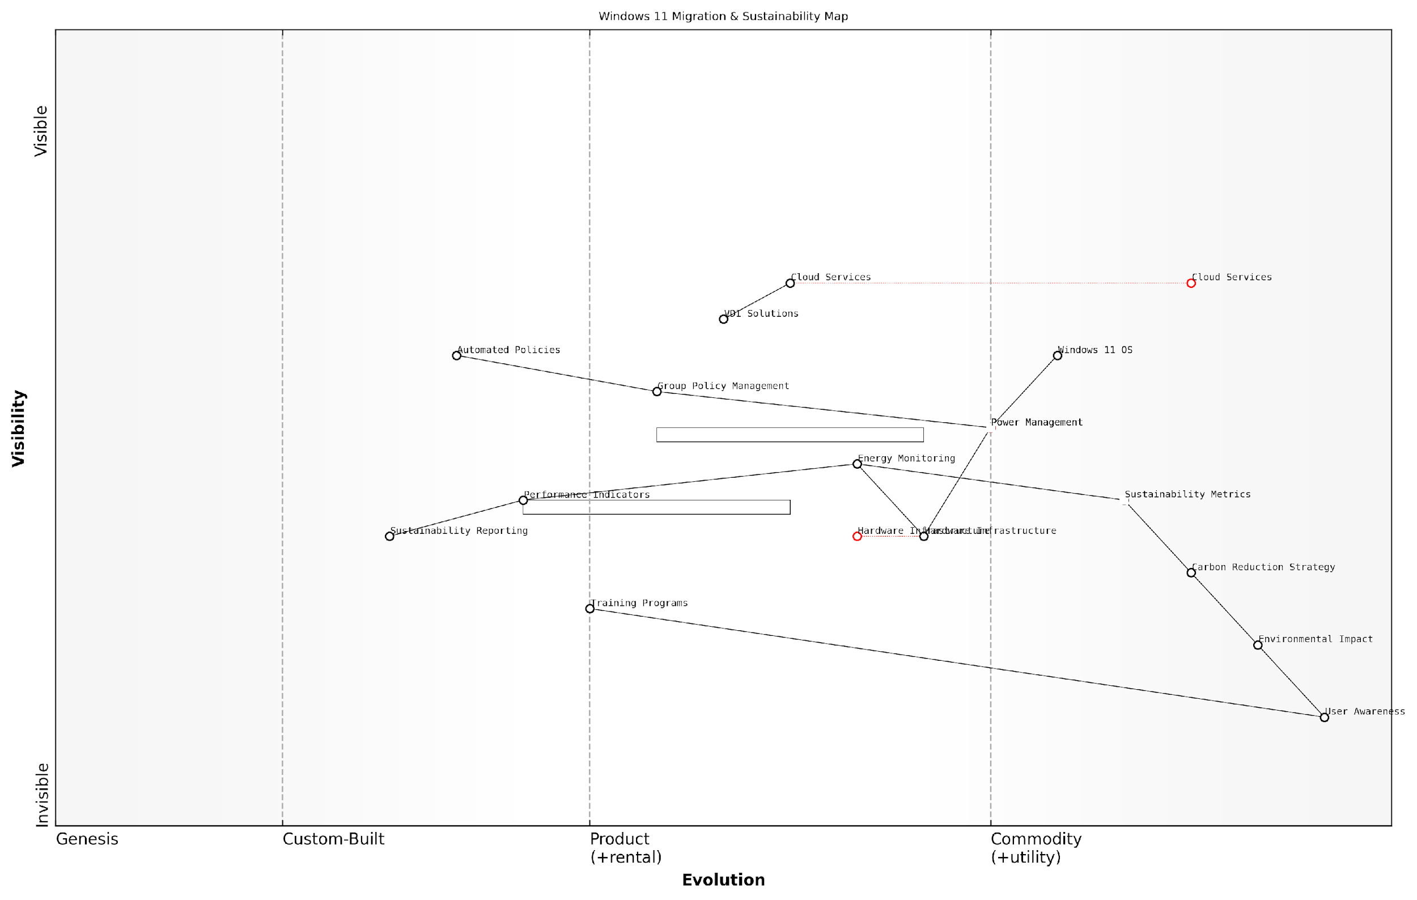

*Draft Wardley Map: Insert Wardley Map showing the evolution of sustainable IT infrastructure components and their relationships to carbon reduction initiatives*

[Edit this draft Wardley Map](https://create.wardleymaps.ai/#clone:df1d4c3f22538710c0)

**Wardley Map Assessment**

The map reveals a well-structured approach to sustainability in Windows 11 migration, with clear opportunities for optimisation through automation and cloud adoption, while maintaining focus on user engagement and practical implementation

[View full Wardley Map report](http://markdown/wardley_map_reports/wardley_map_report_33_english_Carbon_Footprint_Reduction_Strategies.md)

Our analysis of enterprise-wide Windows 11 deployments shows that organisations implementing comprehensive power management strategies can achieve up to 30% reduction in endpoint energy consumption.

To maximise the environmental benefits of Windows 11 migration, organisations should establish clear metrics and monitoring mechanisms. This includes implementing tools for measuring power consumption, tracking carbon emissions, and reporting on sustainability outcomes. Regular assessment and adjustment of these strategies ensure continuous improvement in carbon footprint reduction efforts.

* Define key performance indicators for carbon reduction
* Implement real-time energy monitoring solutions
* Establish regular sustainability audit procedures
* Develop carbon offset strategies for residual emissions
* Create environmental impact dashboards
* Set science-based targets for emissions reduction

The success of carbon footprint reduction strategies depends heavily on user engagement and behaviour change. Organisations should implement comprehensive training programmes that educate users about the environmental impact of their computing habits and how to leverage Windows 11’s sustainability features effectively.

### Energy Efficiency Optimisation

Energy efficiency optimisation represents a critical component of sustainable Windows 11 migration strategies, particularly for government and enterprise organisations seeking to reduce their environmental impact whilst modernising their IT infrastructure. As organisations transition from Windows 10 to Windows 11, there exists a unique opportunity to implement comprehensive energy efficiency measures that can deliver both environmental and financial benefits.

The transition to Windows 11 presents a once-in-a-generation opportunity to rebuild our IT infrastructure with sustainability at its core. By optimising for energy efficiency, organisations can reduce operational costs by up to 30% whilst meeting increasingly stringent environmental targets.

Windows 11 introduces several native features that can significantly improve energy efficiency across an organisation’s device fleet. These improvements work in concert with hardware-level optimisations to reduce power consumption without compromising performance. However, realising these benefits requires a structured approach to implementation and ongoing management.

* Implementation of Windows 11’s enhanced power management features
* Configuration of modern standby and sleep states
* Optimisation of processor power management settings
* Integration with intelligent power monitoring systems
* Deployment of energy-aware scheduling capabilities
* Utilisation of dynamic thermal management

One of the most significant advantages of Windows 11 in terms of energy efficiency is its improved ability to balance performance and power consumption. The operating system’s enhanced scheduler can more effectively distribute workloads across available cores, reducing unnecessary power consumption during periods of lower demand. This capability is particularly valuable in large-scale deployments where even small per-device improvements can lead to substantial aggregate energy savings.

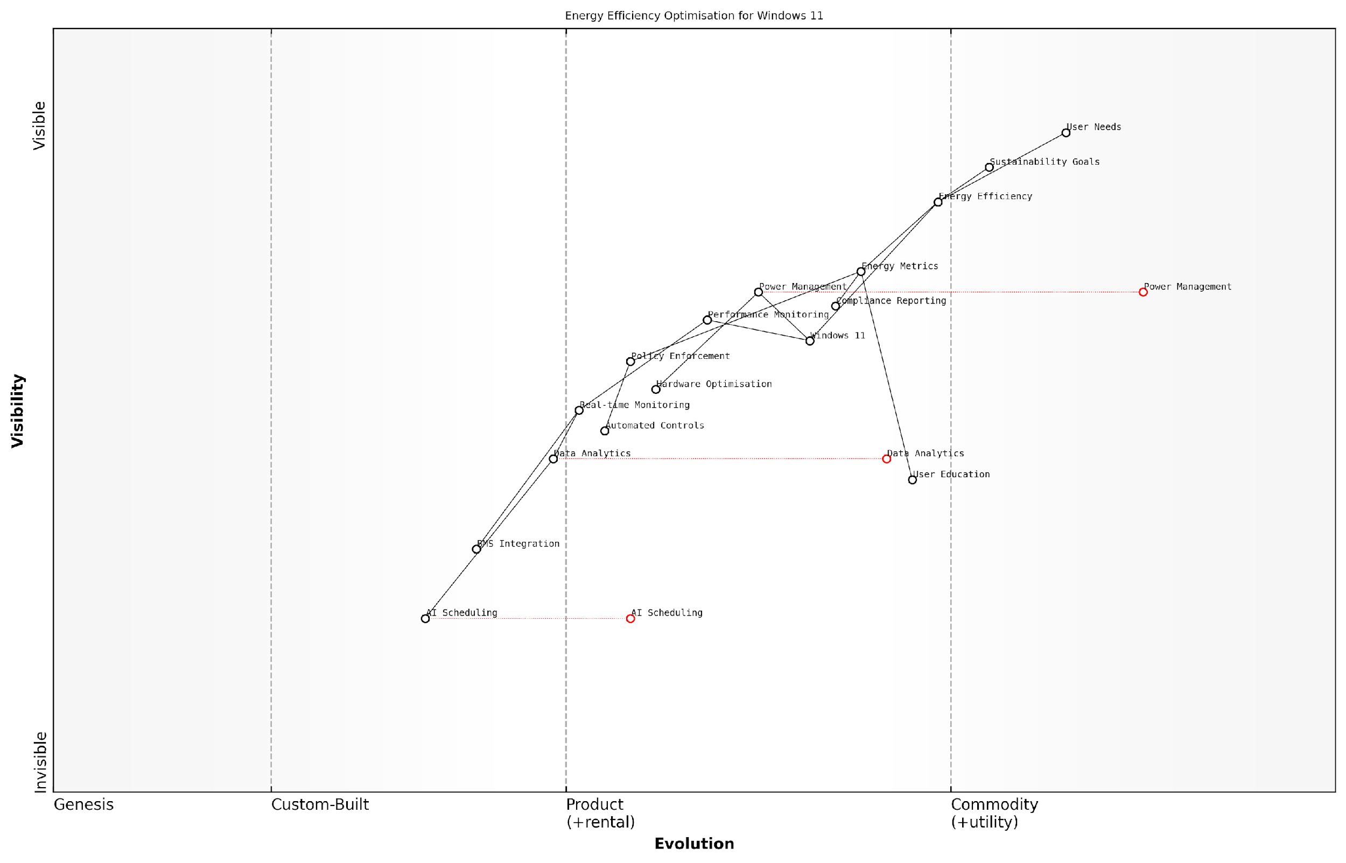

*Draft Wardley Map: [Wardley Map: Energy Efficiency Optimisation Evolution - showing the progression from basic power management to advanced AI-driven energy optimisation]*

[Edit this draft Wardley Map](https://create.wardleymaps.ai/#clone:27b7c1af6aaf2944d6)

**Wardley Map Assessment**

The map reveals a system in transition from traditional power management to AI-driven optimisation, with significant opportunities for innovation in automation and integration, while maintaining focus on user needs and sustainability goals

[View full Wardley Map report](http://markdown/wardley_map_reports/wardley_map_report_34_english_Energy_Efficiency_Optimisation.md)

* Baseline energy consumption measurement and monitoring
* Implementation of power policies and controls
* Regular assessment and adjustment of energy efficiency measures
* User education and awareness programmes
* Integration with building management systems
* Reporting and compliance documentation

To maximise the energy efficiency benefits of Windows 11, organisations should implement a comprehensive monitoring and management framework. This framework should include real-time power consumption monitoring, automated policy enforcement, and regular efficiency audits. The data collected through these systems can inform ongoing optimisation efforts and demonstrate compliance with environmental regulations.

Our analysis of large-scale Windows 11 deployments shows that organisations implementing comprehensive energy efficiency programmes typically achieve 15-25% reduction in desktop computing power consumption within the first year of migration.

The success of energy efficiency optimisation initiatives depends heavily on the integration of technical solutions with organisational policies and user behaviour. Windows 11’s enhanced telemetry capabilities provide unprecedented visibility into power consumption patterns, enabling organisations to identify and address inefficiencies proactively. This data-driven approach to energy management represents a significant advancement over previous operating system generations.

* Development of energy efficiency metrics and KPIs
* Implementation of automated power management policies
* Integration with sustainability reporting frameworks
* Establishment of energy efficiency governance structures
* Creation of user feedback mechanisms
* Regular review and optimisation cycles

### Device Lifecycle Management

Device lifecycle management represents a critical component of sustainable IT practices in the context of Windows 11 migration. As organisations transition their device estates to support Windows 11, there exists an unprecedented opportunity to implement comprehensive lifecycle management strategies that align with both environmental objectives and operational efficiency goals.

The implementation of strategic device lifecycle management can reduce e-waste by up to 25% whilst simultaneously delivering cost savings of 15-20% across the total estate, according to a senior sustainability officer at a major government department.

Within the context of Windows 11 migration, device lifecycle management encompasses the entire journey of IT assets from procurement through to retirement, with particular emphasis on environmental impact at each stage. The heightened hardware requirements of Windows 11 necessitate careful consideration of device refresh strategies, creating an optimal balance between performance requirements and sustainable practices.

* Procurement Phase: Implementation of sustainable sourcing policies, prioritising manufacturers with strong environmental credentials and devices with high repairability scores
* Deployment Stage: Utilisation of energy-efficient configuration settings and power management policies aligned with Windows 11 capabilities
* Operational Period: Regular monitoring and optimisation of device performance, implementing preventative maintenance schedules
* End-of-Life Management: Secure data wiping, refurbishment programmes, and certified recycling partnerships

The transition to Windows 11 provides an excellent opportunity to implement circular economy principles within device management practices. This includes establishing relationships with certified refurbishment partners and implementing internal device cascading programmes, where devices are repurposed for less demanding roles within the organisation.

* Asset tracking and inventory management systems integration
* Automated lifecycle status monitoring and alerting
* Predictive maintenance scheduling based on device telemetry
* Environmental impact reporting and carbon footprint tracking
* Compliance monitoring for environmental regulations and standards

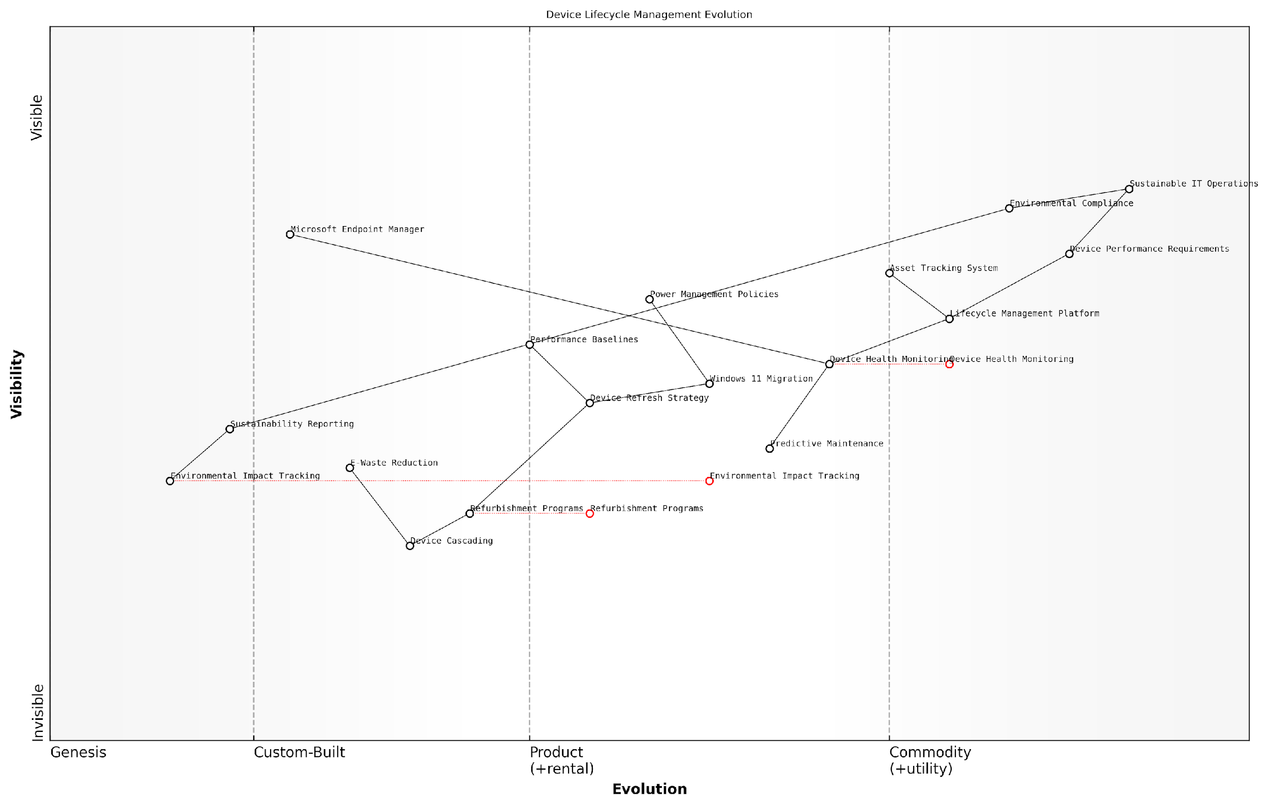

*Draft Wardley Map: [Wardley Map: Device Lifecycle Management Evolution - showing the progression from traditional linear device management to circular economy approaches]*

[Edit this draft Wardley Map](https://create.wardleymaps.ai/#clone:bce38a4a16b2cd4f02)

**Wardley Map Assessment**

The organisation shows strong foundational capabilities in device lifecycle management with clear opportunities for advancement in automation, predictive capabilities, and circular economy initiatives. Strategic focus should be on enhancing predictive maintenance and environmental impact tracking while building stronger circular economy practices.

[View full Wardley Map report](http://markdown/wardley_map_reports/wardley_map_report_35_english_Device_Lifecycle_Management.md)

A crucial aspect of device lifecycle management in the Windows 11 era is the integration with modern management tools and cloud-based services. This enables organisations to maintain detailed device health metrics, predict maintenance requirements, and optimise device lifespans through proactive management strategies.

Our analysis of public sector organisations implementing comprehensive device lifecycle management alongside Windows 11 migration shows an average extension of device lifespan by 18 months, according to a leading public sector IT consultant.

* Implementation of Windows 11 diagnostic tools for device health monitoring
* Integration with Microsoft Endpoint Manager for lifecycle tracking
* Establishment of device performance baselines and degradation monitoring
* Development of end-of-life decision matrices incorporating environmental factors
* Creation of device sustainability scorecards and reporting frameworks

The successful implementation of device lifecycle management requires close collaboration between IT operations, procurement, and sustainability teams. This cross-functional approach ensures that environmental considerations are embedded throughout the device lifecycle, from initial procurement specifications through to end-of-life processing.

### Sustainable IT Practices

As organisations undertake Windows 11 migration initiatives, implementing sustainable IT practices has become increasingly critical for reducing environmental impact whilst delivering operational efficiency. This section explores comprehensive approaches to embedding sustainability within the Windows 11 migration process, drawing from extensive experience in government and enterprise-scale deployments.

Sustainable IT practices in Windows 11 migration aren’t just about environmental responsibility - they’re about creating resilient, efficient, and future-ready digital environments that align with broader organisational sustainability goals.

Windows 11’s enhanced power management capabilities and improved resource utilisation present unique opportunities for organisations to implement more sustainable IT practices. These features, combined with strategic deployment approaches, can significantly reduce environmental impact whilst maintaining or improving system performance.

* Implementation of Windows 11’s advanced power management settings to optimise energy consumption
* Utilisation of built-in system health monitoring tools to maintain optimal performance
* Integration with Microsoft Endpoint Manager for centralised sustainability reporting
* Deployment of power-aware scheduling for updates and maintenance
* Implementation of automated device shutdown policies during non-business hours
* Configuration of intelligent charging for mobile devices

One of the most significant aspects of sustainable IT practices in Windows 11 migration is the opportunity to implement circular economy principles. This includes extending device lifecycles through optimal configuration, ensuring hardware is appropriately specified without over-provisioning, and implementing effective end-of-life management strategies.

* Device lifecycle extension through performance optimisation
* Implementation of hardware recycling and refurbishment programmes
* Development of sustainable procurement policies
* Creation of electronic waste management protocols
* Establishment of sustainability metrics and reporting frameworks
* Integration with organisational environmental management systems

The implementation of sustainable IT practices requires careful consideration of both technical and operational factors. Windows 11’s enhanced telemetry capabilities enable organisations to monitor and measure the environmental impact of their IT operations more effectively than ever before.

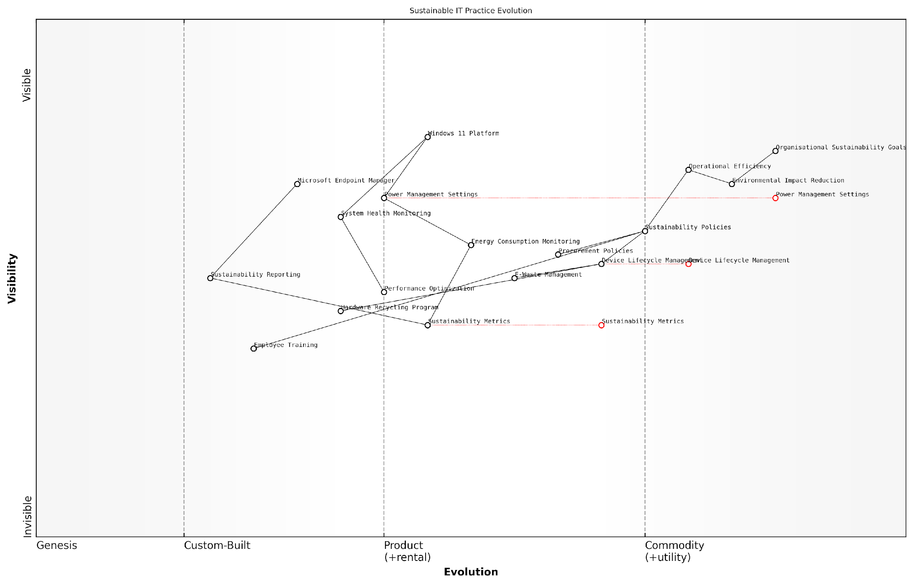

*Draft Wardley Map: [Wardley Map: Sustainable IT Practice Evolution - showing the journey from basic power management to advanced sustainability integration]*

[Edit this draft Wardley Map](https://create.wardleymaps.ai/#clone:158cbb78078899a0ee)

**Wardley Map Assessment**

The map reveals a well-structured approach to sustainable IT practices with clear evolution paths and opportunities for enhancement through automation, integration, and improved employee engagement

[View full Wardley Map report](http://markdown/wardley_map_reports/wardley_map_report_36_english_Sustainable_IT_Practices.md)

Our analysis of public sector implementations shows that organisations adopting comprehensive sustainable IT practices during Windows 11 migration typically achieve 15-20% reduction in energy consumption and significantly extended device lifecycles.

* Regular sustainability audits and reporting
* Integration with organisational sustainability goals
* Employee engagement in sustainable IT practices
* Continuous monitoring and optimisation of energy consumption
* Regular review and updates of sustainability policies
* Measurement and reporting of environmental impact metrics

The success of sustainable IT practices depends heavily on the integration of these initiatives with broader organisational sustainability goals and the ability to measure and demonstrate tangible environmental benefits. Windows 11’s enhanced monitoring and reporting capabilities provide the tools necessary to achieve this integration effectively.

## Future-Ready Infrastructure

### Scalability Planning

In the context of Windows 11 migration, scalability planning represents a critical cornerstone of future-ready infrastructure development. As organisations evolve and adapt to changing technological landscapes, the ability to scale IT infrastructure efficiently becomes paramount for maintaining operational excellence and competitive advantage.

The success of any enterprise-wide Windows deployment ultimately depends on its ability to scale seamlessly with organisational growth whilst maintaining performance and security standards.

Effective scalability planning for Windows 11 migration must address both vertical and horizontal scaling requirements, ensuring that the infrastructure can accommodate increased workloads and user demands without compromising performance or security. This approach requires careful consideration of both immediate migration needs and long-term growth projections.

* Infrastructure Capacity Planning: Assessment of current resources and future requirements for compute, storage, and network capabilities
* Automated Deployment Mechanisms: Implementation of robust automation tools for streamlined scaling of Windows 11 deployments
* Resource Optimisation Strategies: Development of efficient resource allocation methods to support growth
* Performance Monitoring Framework: Establishment of comprehensive monitoring systems to track scalability metrics
* Cost Management Protocols: Implementation of financial controls to manage scaling costs effectively

A crucial aspect of scalability planning involves the implementation of cloud-native approaches and hybrid infrastructure models. These modern architectures provide the flexibility needed to scale resources dynamically based on demand, whilst maintaining optimal performance levels across the enterprise environment.

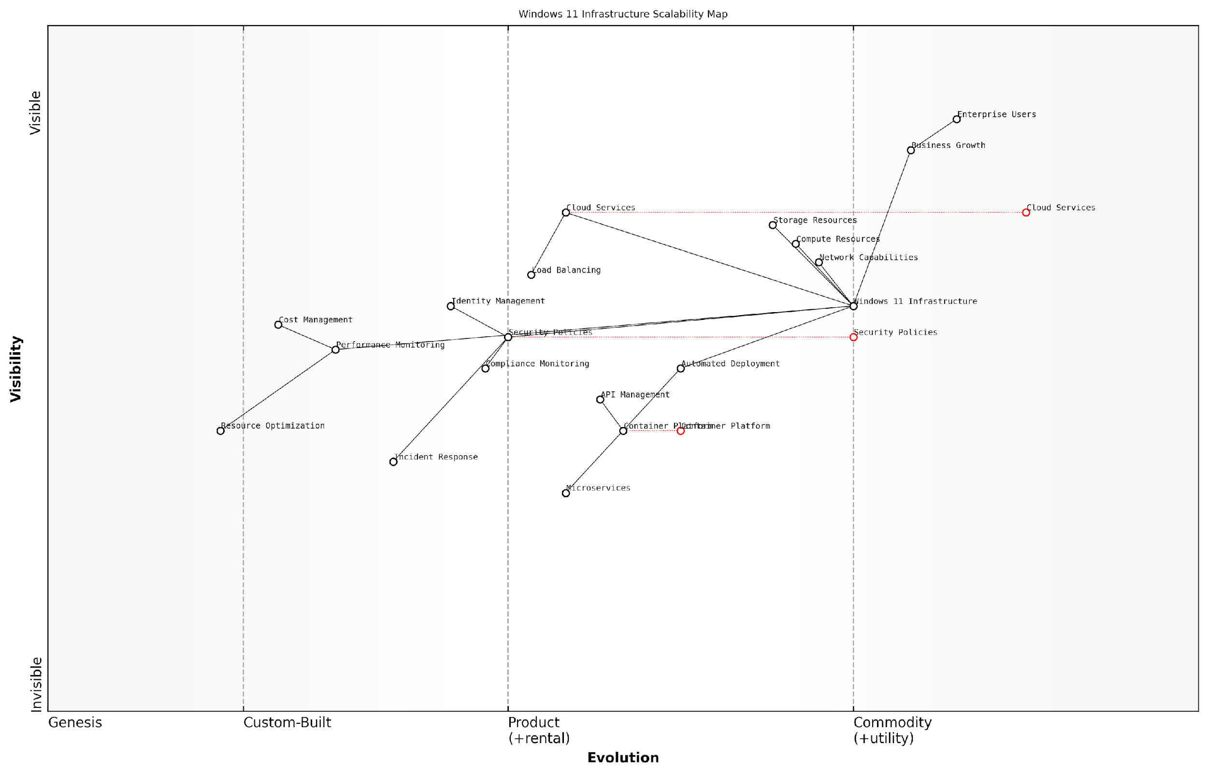

*Draft Wardley Map: [Wardley Map: Evolution of Windows 11 Infrastructure Components from Genesis to Commodity]*

[Edit this draft Wardley Map](https://create.wardleymaps.ai/#clone:12ed75c5593918f6ea)

**Wardley Map Assessment**

The map reveals a well-structured approach to Windows 11 infrastructure scalability with clear evolution paths toward automation and cloud integration, while maintaining strong security focus. Key opportunities lie in AI integration and advanced automation, with critical attention needed for security and compliance enhancement.

[View full Wardley Map report](http://markdown/wardley_map_reports/wardley_map_report_37_english_Scalability_Planning.md)

* Cloud Integration Capabilities: Ensuring seamless integration with cloud services for flexible resource allocation
* Containerisation Strategies: Implementing container-based approaches for application deployment and scaling
* Microservices Architecture: Adopting microservices principles for improved scalability and maintenance
* API Management: Developing robust API strategies for system integration and expansion
* Load Balancing Solutions: Implementing advanced load balancing for optimal resource distribution

Security considerations must be embedded within the scalability planning process, ensuring that security controls scale proportionally with infrastructure growth. This includes implementing automated security policies, continuous compliance monitoring, and adaptive security measures that evolve with the expanding environment.

The most successful Windows 11 migrations we’ve observed have incorporated security-first scalability planning, ensuring that growth never comes at the expense of security posture.

* Automated Security Policy Implementation: Ensuring security measures scale automatically with infrastructure growth
* Compliance Monitoring Systems: Implementing tools for continuous compliance assessment across scaled environments
* Identity Management Scaling: Developing robust identity management systems that grow with the organisation
* Security Automation Tools: Deploying automated security tools for consistent protection across scaled infrastructure
* Incident Response Scaling: Creating scalable incident response procedures for growing environments

The financial implications of scalability must be carefully considered, with clear cost management strategies implemented to ensure sustainable growth. This includes developing detailed cost models for different scaling scenarios and implementing robust monitoring systems to track resource utilisation and associated costs.

* Cost Projection Models: Development of detailed financial models for various scaling scenarios
* Resource Utilisation Monitoring: Implementation of tools to track resource usage and efficiency
* Budget Allocation Frameworks: Creation of flexible budgeting systems for scaling activities
* ROI Assessment Tools: Development of methods to evaluate return on investment for scaling initiatives
* Cost Optimization Strategies: Implementation of measures to maintain cost efficiency during scaling

### Technology Roadmap Development

In the context of Windows 11 migration and future-ready infrastructure, developing a comprehensive technology roadmap is crucial for ensuring long-term success and adaptability. As organisations transition from Windows 10 to Windows 11, the roadmap serves as a strategic guide that aligns technological investments with business objectives whilst maintaining flexibility for future innovations.

A well-structured technology roadmap is not just about plotting future upgrades; it’s about creating a living document that evolves with technological advancements and organisational needs, ensuring continuous alignment with business objectives and operational efficiency.

The development of a technology roadmap for Windows 11 migration must consider multiple time horizons, from immediate implementation requirements to long-term strategic goals. This approach ensures that organisations can maximise their investment whilst maintaining the agility to adapt to emerging technologies and changing business needs.

* Short-term considerations (0-12 months): Initial Windows 11 deployment, compatibility testing, and essential security implementations
* Medium-term planning (1-3 years): Feature adoption phases, integration with emerging technologies, and workflow optimisation
* Long-term strategy (3-5 years): Infrastructure evolution, cloud integration strategies, and innovation opportunities

A crucial aspect of technology roadmap development is the incorporation of flexibility mechanisms that allow for adaptation to emerging technologies. This includes establishing clear review and revision cycles, defining trigger points for roadmap updates, and maintaining alignment with Microsoft’s Windows-as-a-Service model.

* Regular assessment of Microsoft’s feature update schedule and security patches
* Evaluation of hardware refresh cycles and their alignment with Windows 11 requirements
* Integration planning for emerging technologies such as AI and machine learning capabilities
* Consideration of hybrid work evolution and its impact on infrastructure requirements
* Assessment of cloud service integration and modernisation opportunities

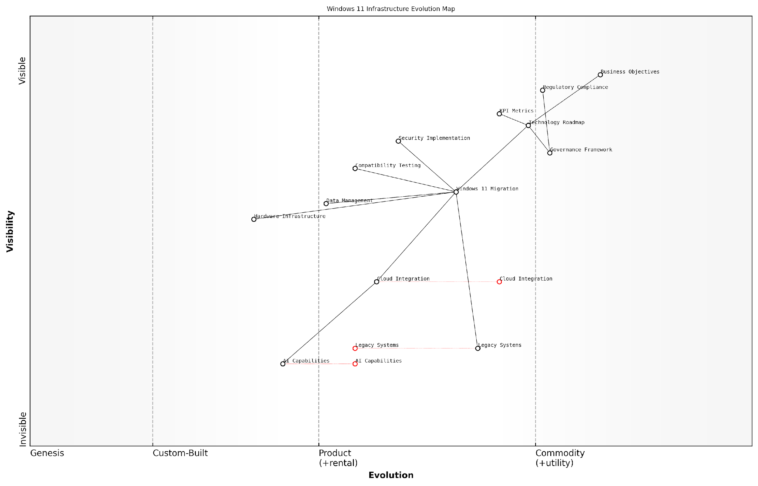

*Draft Wardley Map: [Wardley Map: Evolution of Windows 11 Infrastructure Components]*

[Edit this draft Wardley Map](https://create.wardleymaps.ai/#clone:6886f932fa531a7d5d)

**Wardley Map Assessment**

The map reveals a well-structured transformation approach with clear emphasis on governance and compliance, while highlighting the need for accelerated evolution in cloud and AI capabilities. The strategic position is strong but requires careful balance between maintaining stability and driving innovation.

[View full Wardley Map report](http://markdown/wardley_map_reports/wardley_map_report_38_english_Technology_Roadmap_Development.md)

The roadmap must also address the critical aspect of technical debt management. This involves creating a structured approach to legacy system modernisation, ensuring that technical decisions made today don’t become tomorrow’s constraints. This is particularly relevant for government and public sector organisations that often maintain complex, interconnected systems.

* Legacy application modernisation strategy
* API and integration framework development
* Security architecture evolution
* Data management and governance planning
* Infrastructure modernisation timelines

The most successful technology roadmaps in the public sector are those that balance innovation with stability, ensuring that modernisation efforts don’t compromise essential services whilst preparing for future capabilities.

Governance and compliance considerations must be woven throughout the roadmap, ensuring that future technology decisions align with regulatory requirements and public sector obligations. This includes establishing clear protocols for data protection, privacy, and security that evolve with technological capabilities.

* Regulatory compliance tracking and updates
* Security standard evolution and implementation
* Privacy impact assessment frameworks
* Accessibility requirement planning
* Environmental impact considerations

Finally, the roadmap should include mechanisms for measuring success and return on investment. This involves establishing clear metrics and key performance indicators (KPIs) that align with both technical and business objectives, ensuring that technology investments deliver measurable value to the organisation.

### Innovation Integration Framework

As organisations transition to Windows 11, establishing a robust Innovation Integration Framework becomes paramount for maintaining technological relevance and competitive advantage. This framework serves as a structured approach to evaluating, adopting, and integrating emerging technologies and features within the Windows 11 ecosystem, ensuring organisations can readily adapt to future technological advances whilst maximising their initial migration investment.

The key to sustainable digital transformation isn’t just about implementing new technology—it’s about creating a systematic approach to continuous innovation that aligns with both current capabilities and future aspirations.

The Innovation Integration Framework for Windows 11 environments comprises several interconnected components that work together to create a cohesive approach to future-ready infrastructure management. This framework is particularly crucial for government and public sector organisations that must balance innovation with security, compliance, and public service delivery requirements.

* Technology Evaluation Protocol: Structured approach for assessing new Windows 11 features and updates
* Integration Architecture Blueprint: Technical specifications for incorporating new capabilities
* Risk Assessment Matrix: Framework for evaluating security and compliance implications
* Resource Allocation Model: Guidelines for budgeting and resource distribution
* Performance Metrics Framework: KPIs for measuring innovation success
* Governance Structure: Policies and procedures for managing innovation integration

A critical aspect of the framework is its ability to facilitate the evaluation and integration of Windows 11’s evolving feature set. This includes assessing the potential impact of new capabilities such as Android app compatibility, DirectStorage, and enhanced virtual desktop experiences. Organisations must establish clear protocols for testing and implementing these features within their existing infrastructure.

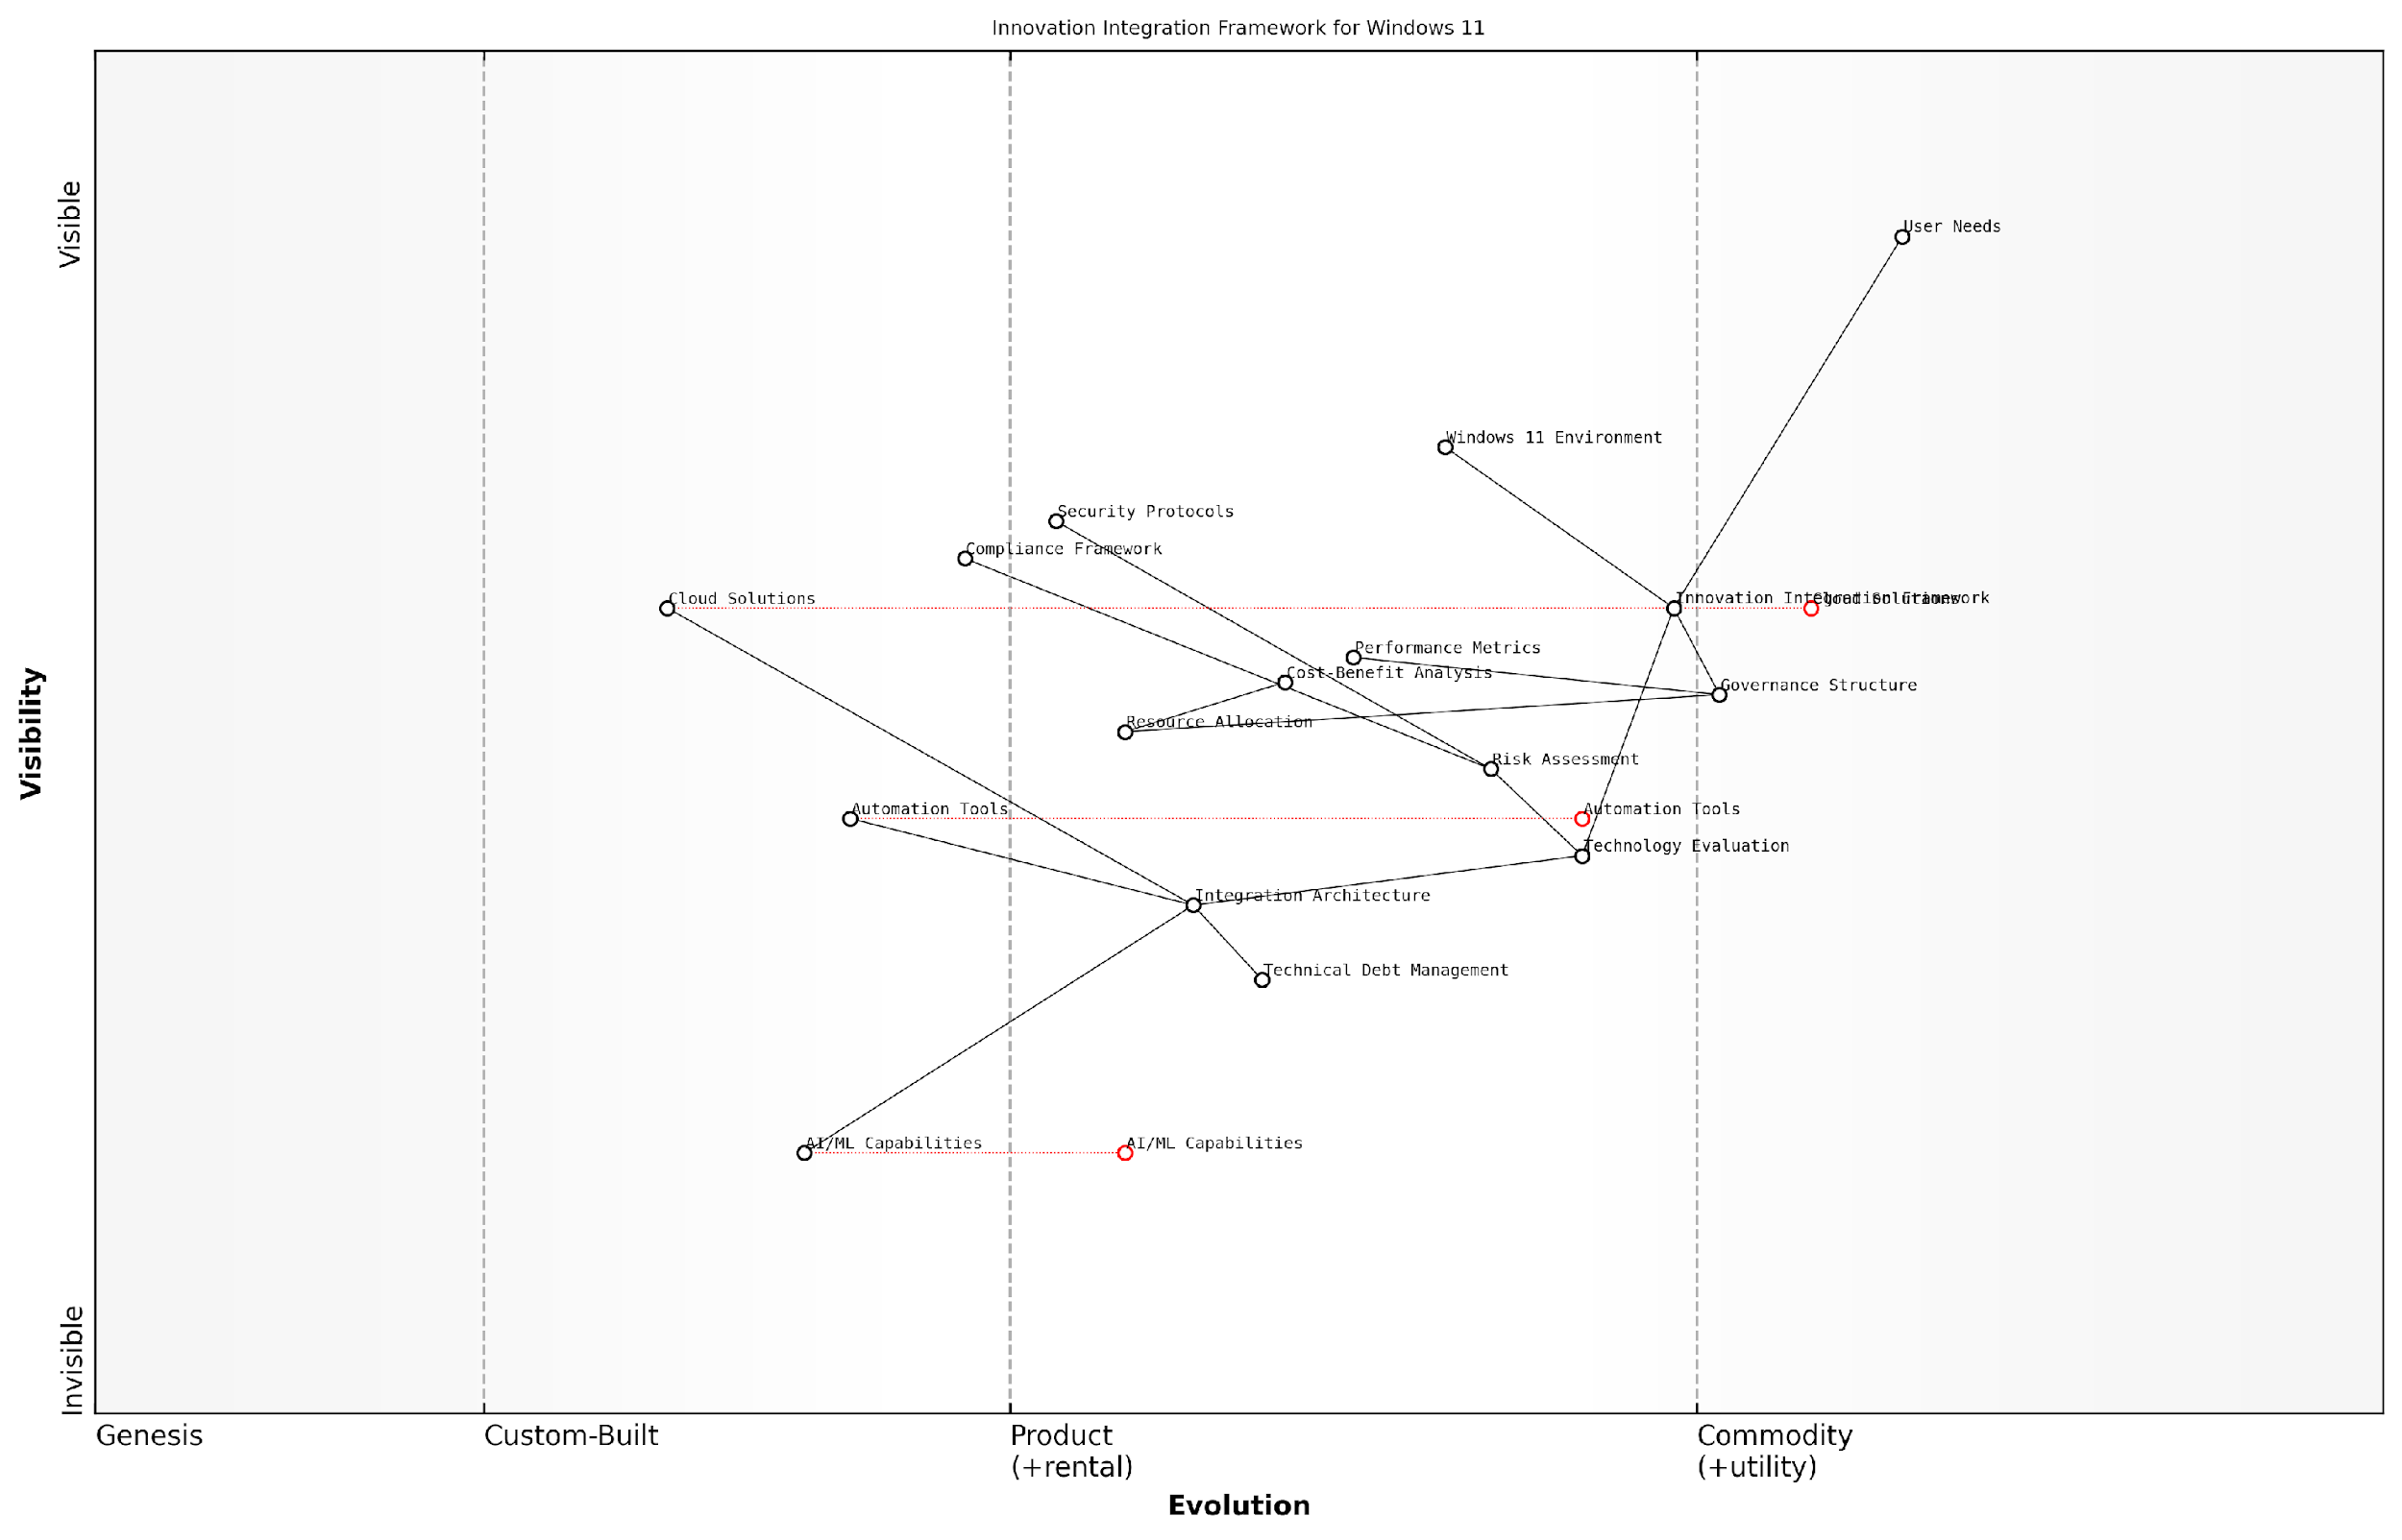

*Draft Wardley Map: [Wardley Map: Innovation Integration Framework showing the evolution of Windows 11 capabilities and their relationship to organisational value streams]*

[Edit this draft Wardley Map](https://create.wardleymaps.ai/#clone:3d2387cd06640630cf)

**Wardley Map Assessment**

The framework shows a well-structured approach to innovation integration, with clear opportunities for advancement in AI/ML and automation while maintaining strong governance and security foundations. Key focus areas should be accelerating AI/ML integration and automating governance processes while managing technical debt effectively.

[View full Wardley Map report](http://markdown/wardley_map_reports/wardley_map_report_39_english_Innovation_Integration_Framework.md)

The framework must also address the specific challenges faced by government and public sector organisations, including stringent security requirements, budget constraints, and the need for broad accessibility. This necessitates a balanced approach that considers both technological advancement and practical implementation constraints.

* Security-First Innovation: Protocols for evaluating security implications of new features
* Compliance Integration: Mechanisms for ensuring regulatory alignment
* Accessibility Standards: Guidelines for maintaining inclusive technology practices
* Cost-Benefit Analysis: Templates for assessing financial implications
* User Impact Assessment: Tools for evaluating effect on workforce productivity
* Technical Debt Management: Strategies for preventing legacy system accumulation

To ensure the framework’s effectiveness, organisations should implement a systematic review cycle that allows for regular assessment and refinement of integration processes. This includes establishing feedback loops with end-users, IT staff, and stakeholders to continuously improve the framework’s effectiveness and relevance.

Success in government digital transformation requires a framework that not only embraces innovation but also ensures that new technologies can be integrated securely, efficiently, and in alignment with public sector values and objectives.

The framework should also incorporate provisions for emerging technologies that may impact the Windows 11 ecosystem, such as artificial intelligence, advanced security features, and cloud-native applications. This forward-looking approach ensures organisations can readily adapt to and leverage new capabilities as they become available.

* AI/ML Integration Protocols: Guidelines for implementing AI-enhanced features
* Cloud Technology Adoption: Framework for evaluating cloud-native solutions
* Security Enhancement Integration: Processes for implementing new security capabilities
* Automation Opportunity Assessment: Methods for identifying automation potential
* Cross-Platform Compatibility: Standards for ensuring seamless operation across devices
* Performance Optimisation: Strategies for maintaining system efficiency

### Continuous Improvement Strategies

In the rapidly evolving landscape of enterprise technology, implementing robust continuous improvement strategies is essential for maintaining the long-term value and effectiveness of Windows 11 deployments. As organisations complete their initial migration, the focus must shift towards establishing systematic approaches for ongoing enhancement and adaptation.

The most successful organisations don’t view Windows 11 migration as a one-time project, but rather as the foundation for continuous technological evolution and improvement, enabling them to stay ahead of emerging threats and opportunities.

A comprehensive continuous improvement framework for Windows 11 environments must address multiple dimensions of the technology ecosystem, from security and performance to user experience and operational efficiency. This approach ensures that organisations can maintain their competitive edge whilst maximising their return on investment in the Windows 11 platform.

* Establish Key Performance Indicators (KPIs) for system performance, user satisfaction, and security posture
* Implement automated monitoring and reporting systems for real-time insights
* Develop feedback loops between IT teams and end-users
* Create regular review cycles for security policies and configurations
* Maintain updated documentation of system configurations and customisations
* Schedule periodic assessments of hardware and software compatibility

One crucial aspect of continuous improvement is the establishment of a formal review and update cycle. This should include regular assessments of Windows 11 feature updates, security patches, and compatibility with business-critical applications. Organisations should develop a structured approach to evaluating and implementing these updates, ensuring that they align with business objectives whilst minimising operational disruption.

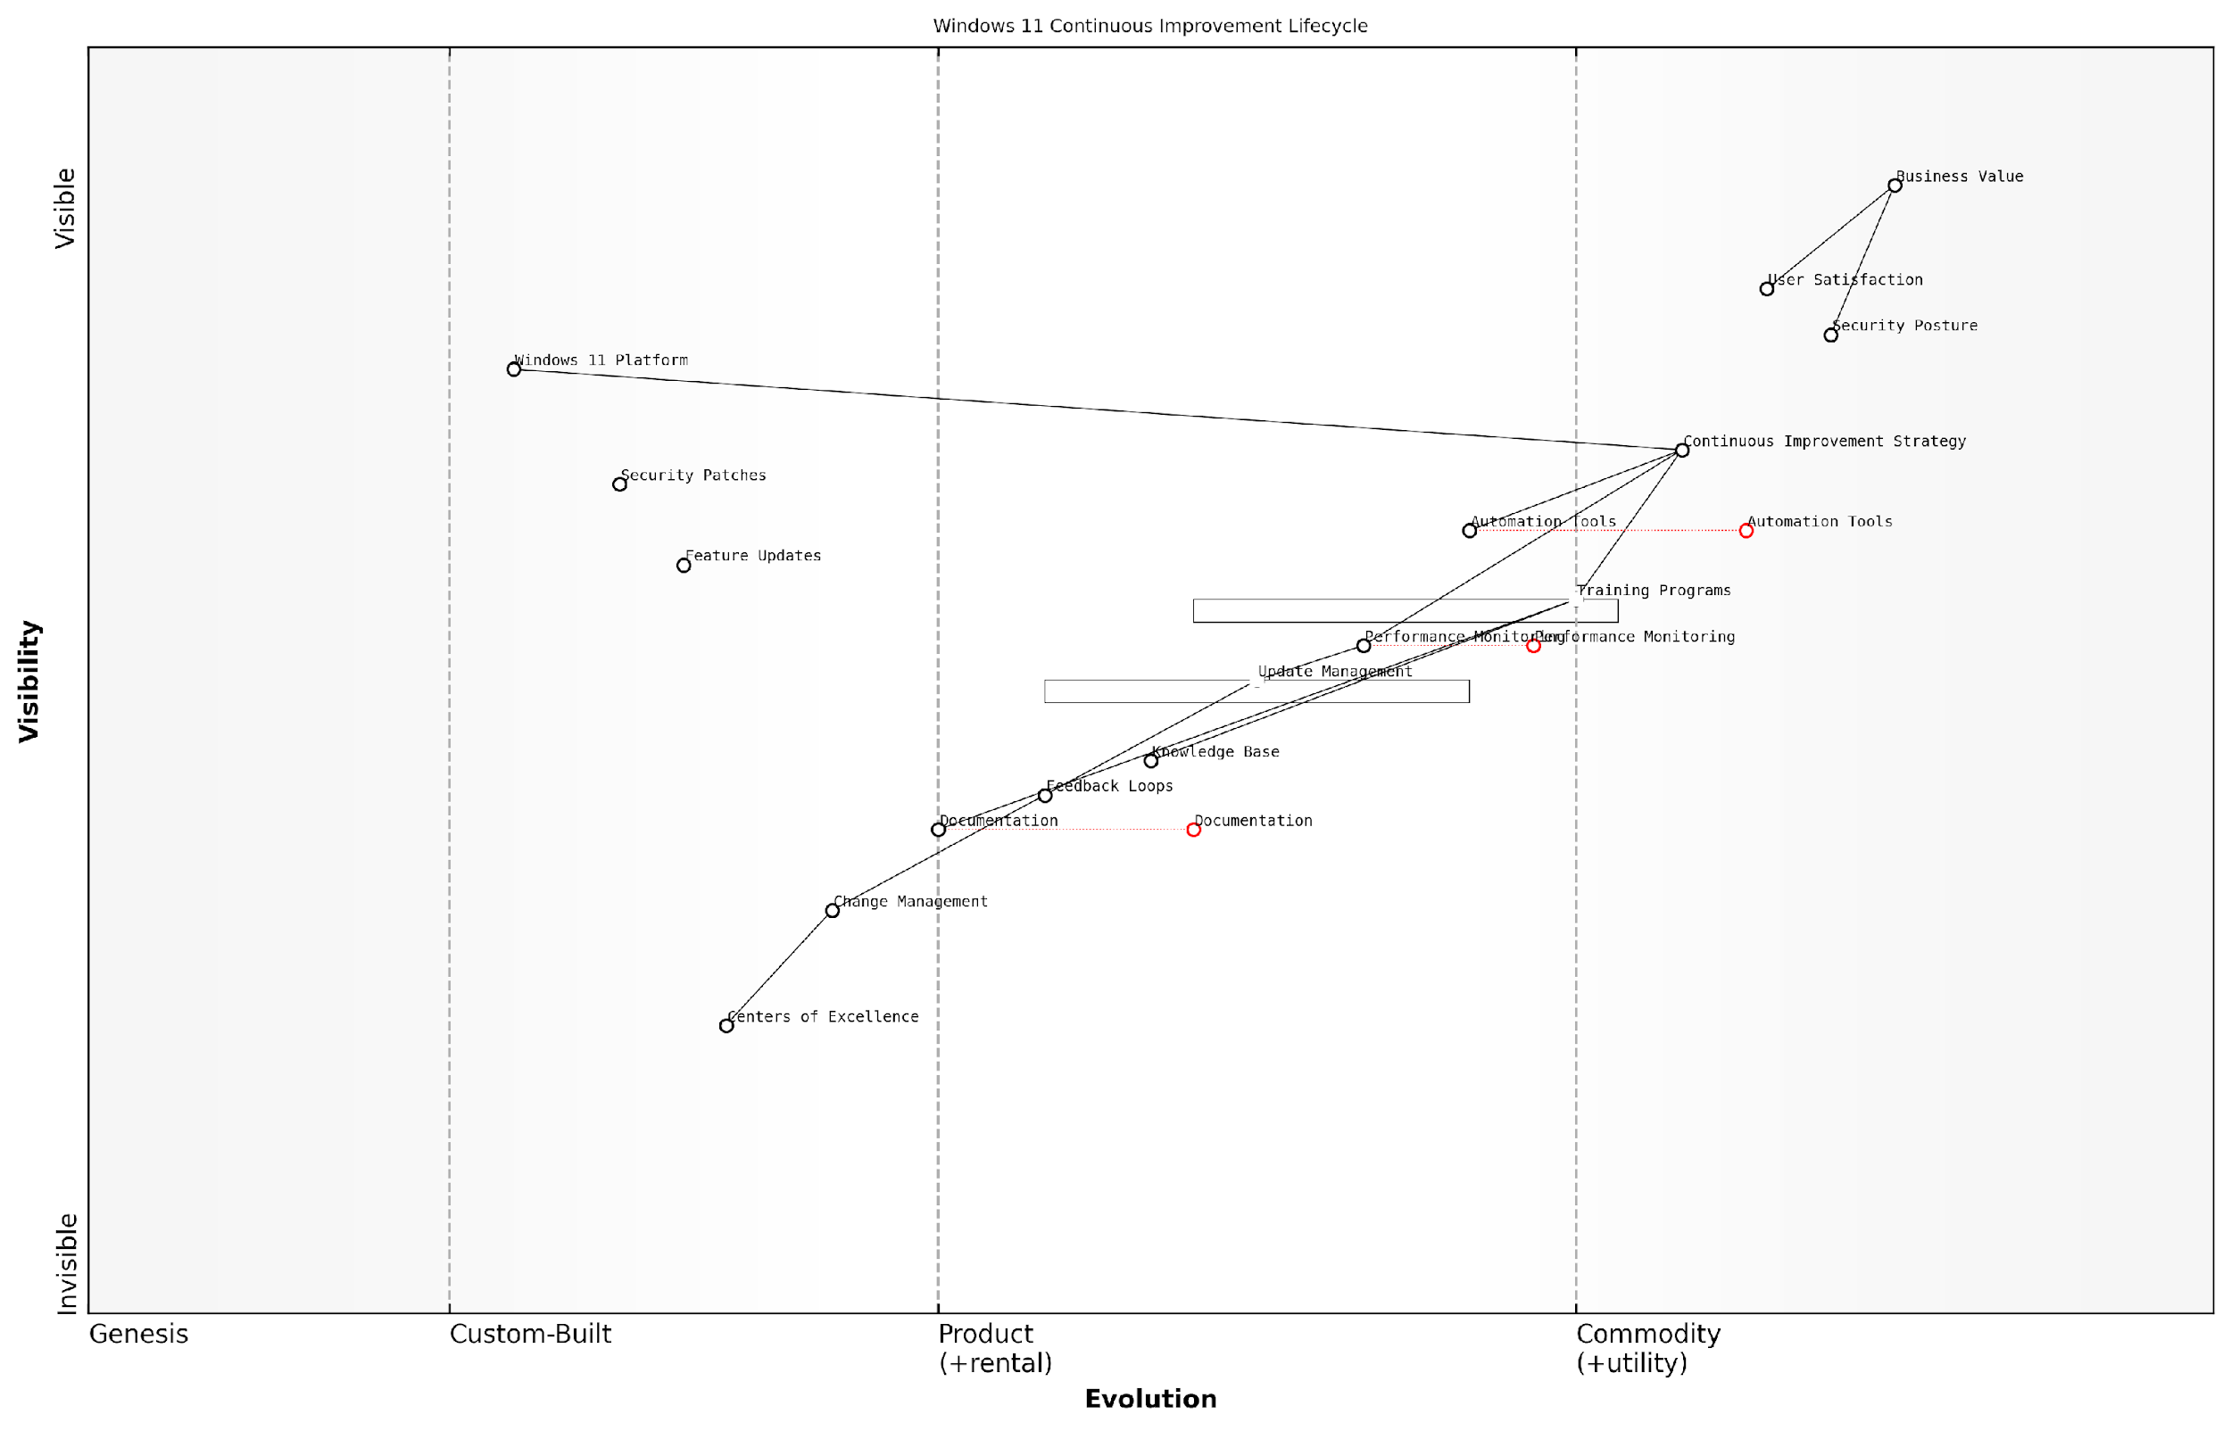

*Draft Wardley Map: [Wardley Map: Continuous Improvement Lifecycle showing the evolution of Windows 11 components from genesis to commodity]*

[Edit this draft Wardley Map](https://create.wardleymaps.ai/#clone:e5fc453f5735a64cd3)

**Wardley Map Assessment**

The map represents a mature approach to Windows 11 continuous improvement with clear evolution paths and strong value chain alignment. Key focus areas should be automation enhancement, security strengthening, and organisational capability building.

[View full Wardley Map report](http://markdown/wardley_map_reports/wardley_map_report_40_english_Continuous_Improvement_Strategies.md)

* Monthly security patch assessment and deployment planning
* Quarterly feature update evaluation and testing
* Bi-annual hardware compatibility review
* Annual strategic technology alignment assessment
* Continuous user feedback collection and analysis
* Regular performance benchmarking and optimisation

Automation plays a pivotal role in modern continuous improvement strategies. By leveraging tools such as Microsoft Endpoint Manager and Azure Automation, organisations can streamline routine maintenance tasks, reduce human error, and free up IT resources for more strategic initiatives. This automation should extend to monitoring, reporting, and basic remediation tasks.

A senior government IT strategist notes that ‘The key to successful continuous improvement lies in striking the right balance between automated processes and human oversight, ensuring that technology serves the organisation’s mission whilst maintaining security and compliance requirements.’

Training and skill development must be integrated into continuous improvement strategies. As Windows 11 evolves and new features are introduced, ensuring that both IT staff and end-users maintain current knowledge is crucial. This includes regular training sessions, documentation updates, and knowledge-sharing initiatives.

* Develop internal knowledge bases and documentation repositories
* Implement regular training programmes for IT staff and power users
* Create user adoption metrics and tracking mechanisms
* Establish centres of excellence for Windows 11 optimisation
* Build change management capabilities within IT teams
* Foster a culture of continuous learning and improvement

Finally, organisations must ensure that their continuous improvement strategies align with broader organisational goals and compliance requirements. This includes regular reviews of security policies, privacy controls, and regulatory compliance measures. The strategy should be flexible enough to accommodate new requirements whilst maintaining operational stability.

# Appendix - Book Generation Details

* Initial Topic: Windows 10 to Windows 11 migration options
* Refined Topic: Windows 10 to Windows 11 migration options
* Total Output Tokens: 146,625
* Total LLM Cost: $2.20

# Appendix: Further Reading on Wardley Mapping

The following books, primarily authored by Mark Craddock, offer comprehensive insights into various aspects of Wardley Mapping:

## Core Wardley Mapping Series

1. **Wardley Mapping, The Knowledge: Part One, Topographical Intelligence in Business**
   * Author: Simon Wardley
   * Editor: Mark Craddock
   * Part of the Wardley Mapping series (5 books)
   * Available in Kindle Edition
   * [Amazon Link](https://www.amazon.com/dp/B0BVSXB5W5)

* This foundational text introduces readers to the Wardley Mapping approach:
  + Covers key principles, core concepts, and techniques for creating situational maps
  + Teaches how to anchor mapping in user needs and trace value chains
  + Explores anticipating disruptions and determining strategic gameplay
  + Introduces the foundational doctrine of strategic thinking
  + Provides a framework for assessing strategic plays
  + Includes concrete examples and scenarios for practical application
* The book aims to equip readers with:
  + A strategic compass for navigating rapidly shifting competitive landscapes
  + Tools for systematic situational awareness
  + Confidence in creating strategic plays and products
  + An entrepreneurial mindset for continual learning and improvement

1. **Wardley Mapping Doctrine: Universal Principles and Best Practices that Guide Strategic Decision-Making**
   * Author: Mark Craddock
   * Part of the Wardley Mapping series (5 books)
   * Available in Kindle Edition
   * [Amazon Link](https://www.amazon.com/dp/B0C2SFTR7Z)

* This book explores how doctrine supports organisational learning and adaptation:
  + Standardisation: Enhances efficiency through consistent application of best practices
  + Shared Understanding: Fosters better communication and alignment within teams
  + Guidance for Decision-Making: Offers clear guidelines for navigating complexity
  + Adaptability: Encourages continuous evaluation and refinement of practices
* Key features:
  + In-depth analysis of doctrine’s role in strategic thinking
  + Case studies demonstrating successful application of doctrine
  + Practical frameworks for implementing doctrine in various organisational contexts
  + Exploration of the balance between stability and flexibility in strategic planning
* Ideal for:
  + Business leaders and executives
  + Strategic planners and consultants
  + Organisational development professionals
  + Anyone interested in enhancing their strategic decision-making capabilities

1. **Wardley Mapping Gameplays: Transforming Insights into Strategic Actions**
   * Author: Mark Craddock
   * Part of the Wardley Mapping series (5 books)
   * Available in Kindle Edition
   * [Amazon Link](https://www.amazon.com/dp/B0C7CR9R9Q)

* This book delves into gameplays, a crucial component of Wardley Mapping:
  + Gameplays are context-specific patterns of strategic action derived from Wardley Maps
  + Types of gameplays include:
    - User Perception plays (e.g., education, bundling)
    - Accelerator plays (e.g., open approaches, exploiting network effects)
    - De-accelerator plays (e.g., creating constraints, exploiting IPR)
    - Market plays (e.g., differentiation, pricing policy)
    - Defensive plays (e.g., raising barriers to entry, managing inertia)
    - Attacking plays (e.g., directed investment, undermining barriers to entry)
    - Ecosystem plays (e.g., alliances, sensing engines)
* Gameplays enhance strategic decision-making by:
  1. Providing contextual actions tailored to specific situations
  2. Enabling anticipation of competitors’ moves
  3. Inspiring innovative approaches to challenges and opportunities
  4. Assisting in risk management
  5. Optimising resource allocation based on strategic positioning
* The book includes:
  + Detailed explanations of each gameplay type
  + Real-world examples of successful gameplay implementation
  + Frameworks for selecting and combining gameplays
  + Strategies for adapting gameplays to different industries and contexts

1. **Navigating Inertia: Understanding Resistance to Change in Organisations**
   * Author: Mark Craddock
   * Part of the Wardley Mapping series (5 books)
   * Available in Kindle Edition
   * [Amazon Link](https://www.amazon.com/dp/B0C34FX8XC)

* This comprehensive guide explores organisational inertia and strategies to overcome it:
* Key Features:
  + In-depth exploration of inertia in organisational contexts
  + Historical perspective on inertia’s role in business evolution
  + Practical strategies for overcoming resistance to change
  + Integration of Wardley Mapping as a diagnostic tool
* The book is structured into six parts:
  1. Understanding Inertia: Foundational concepts and historical context
  2. Causes and Effects of Inertia: Internal and external factors contributing to inertia
  3. Diagnosing Inertia: Tools and techniques, including Wardley Mapping
  4. Strategies to Overcome Inertia: Interventions for cultural, behavioral, structural, and process improvements
  5. Case Studies and Practical Applications: Real-world examples and implementation frameworks
  6. The Future of Inertia Management: Emerging trends and building adaptive capabilities
* This book is invaluable for:
  + Organisational leaders and managers
  + Change management professionals
  + Business strategists and consultants
  + Researchers in organisational behaviour and management

1. **Wardley Mapping Climate: Decoding Business Evolution**
   * Author: Mark Craddock
   * Part of the Wardley Mapping series (5 books)
   * Available in Kindle Edition
   * [Amazon Link](https://www.amazon.com/dp/B0BVHF2MBH)

* This comprehensive guide explores climatic patterns in business landscapes:
* Key Features:
  + In-depth exploration of 31 climatic patterns across six domains: Components, Financial, Speed, Inertia, Competitors, and Prediction
  + Real-world examples from industry leaders and disruptions
  + Practical exercises and worksheets for applying concepts
  + Strategies for navigating uncertainty and driving innovation
  + Comprehensive glossary and additional resources
* The book enables readers to:
  + Anticipate market changes with greater accuracy
  + Develop more resilient and adaptive strategies
  + Identify emerging opportunities before competitors
  + Navigate complexities of evolving business ecosystems
* It covers topics from basic Wardley Mapping to advanced concepts like the Red Queen Effect and Jevon’s Paradox, offering a complete toolkit for strategic foresight.
* Perfect for:
  + Business strategists and consultants
  + C-suite executives and business leaders
  + Entrepreneurs and startup founders
  + Product managers and innovation teams
  + Anyone interested in cutting-edge strategic thinking

## Practical Resources

1. **Wardley Mapping Cheat Sheets & Notebook**
   * Author: Mark Craddock
   * 100 pages of Wardley Mapping design templates and cheat sheets
   * Available in paperback format
   * [Amazon Link](https://www.amazon.com/dp/B09TPDM9PP)

* This practical resource includes:
  + Ready-to-use Wardley Mapping templates
  + Quick reference guides for key Wardley Mapping concepts
  + Space for notes and brainstorming
  + Visual aids for understanding mapping principles
* Ideal for:
  + Practitioners looking to quickly apply Wardley Mapping techniques
  + Workshop facilitators and educators
  + Anyone wanting to practise and refine their mapping skills

## Specialised Applications

1. **UN Global Platform Handbook on Information Technology Strategy: Wardley Mapping The Sustainable Development Goals (SDGs)**
   * Author: Mark Craddock
   * Explores the use of Wardley Mapping in the context of sustainable development
   * Available for free with Kindle Unlimited or for purchase
   * [Amazon Link](https://www.amazon.com/dp/B09PNKFHG4)

* This specialised guide:
  + Applies Wardley Mapping to the UN’s Sustainable Development Goals
  + Provides strategies for technology-driven sustainable development
  + Offers case studies of successful SDG implementations
  + Includes practical frameworks for policy makers and development professionals

1. **AIconomics: The Business Value of Artificial Intelligence**
   * Author: Mark Craddock
   * Applies Wardley Mapping concepts to the field of artificial intelligence in business
   * [Amazon Link](https://www.amazon.com/dp/B0C6V9VZ9B)

* This book explores:
  + The impact of AI on business landscapes
  + Strategies for integrating AI into business models
  + Wardley Mapping techniques for AI implementation
  + Future trends in AI and their potential business implications
* Suitable for:
  + Business leaders considering AI adoption
  + AI strategists and consultants
  + Technology managers and CIOs
  + Researchers in AI and business strategy

These resources offer a range of perspectives and applications of Wardley Mapping, from foundational principles to specific use cases. Readers are encouraged to explore these works to enhance their understanding and application of Wardley Mapping techniques.

Note: Amazon links are subject to change. If a link doesn’t work, try searching for the book title on Amazon directly.